Blackboard Learn Ultra
for Students



Table of Contents
1. Blackboard Login 3
2. Find your Courses 5
3. Add/Remove Courses from Favorites 6
4. View Course Content 7
5. View or Download Course Material 8
6. Joining a Session 9
7. Blackboard Collaborate Ultra’s Interface 12
8. Find Recordings 16
9. View an Assignment 18
10. Write and Submit an Assignment 21
11. Upload and Submit an Assignment 24
12. View your Assignment Grade and Feedback 28
13. View a Turnitin Assignment 29
14. Upload and Submit a Turnitin Assignment 32
15. Resubmit Turnitin Assignment 35
16. View Similarity Report for Turnitin Assignment 36
17. View your Grades 37
18. View your Messages 38
19. Send Message 39
20. Change Language to Greek 40
21. Setup email notifications 41
22. Change Profile Picture 42

Blackboard Login
- Go to https://myEUClogin.euc.ac.cy webpage (link is working for both EUC and CC students).
- Enter your EUC/CC email account (Arrow 1).
(e.g.: TS210000@students.euc.ac.cy/TS210000@students.cycollege.ac.cy)
- Click “Continue” (Arrow 2).

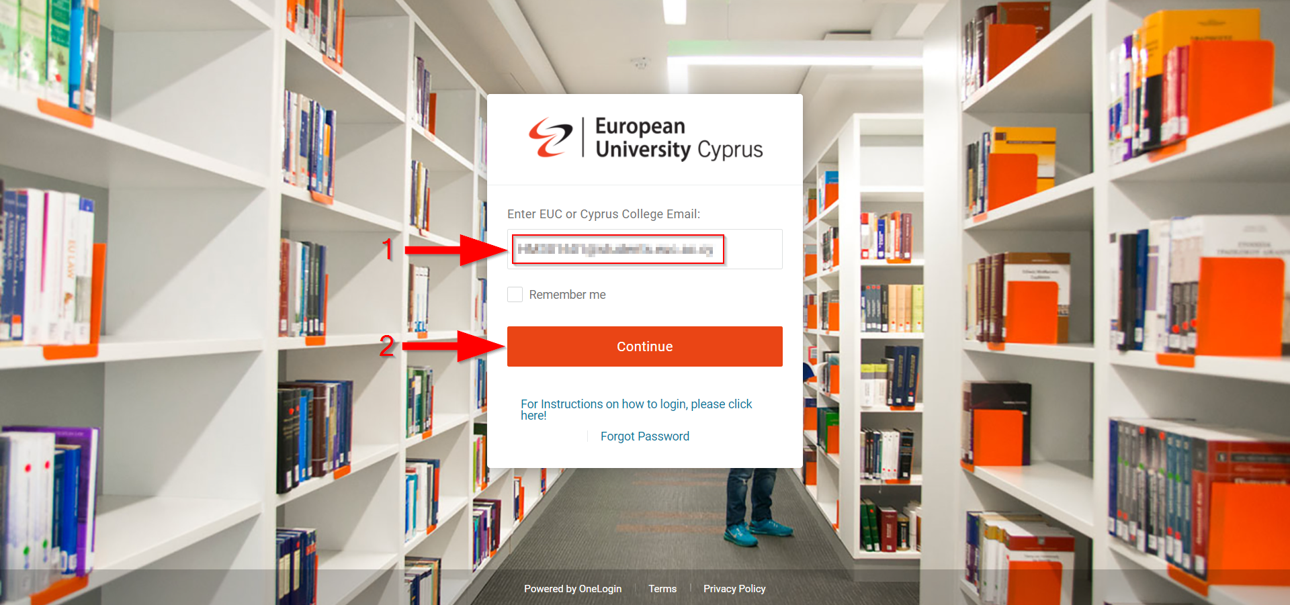

- On the next page enter your EUC/CC email account password (Arrow 1).
- Click “Continue” (Arrow 2).

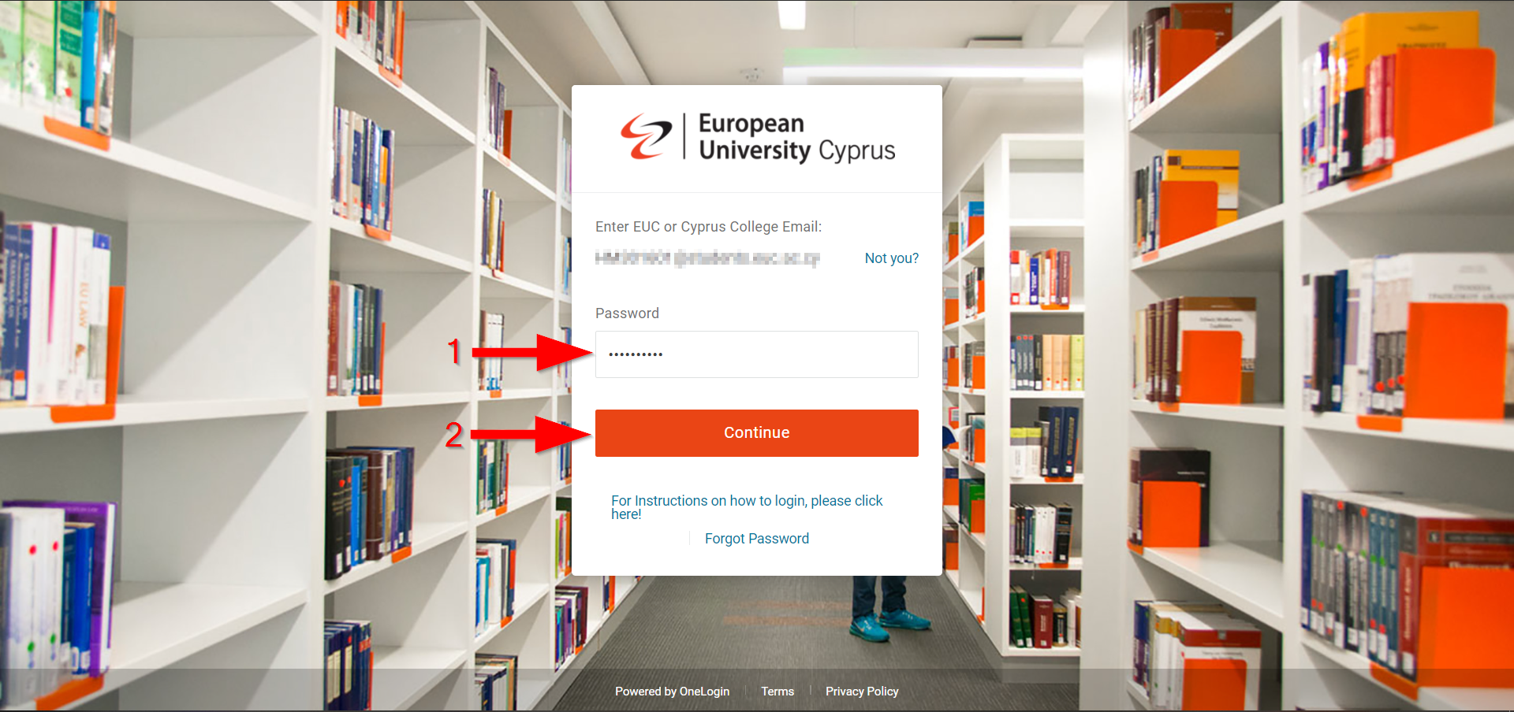
- If the next screen appears, click on “skip” (Arrow 1). If not go directly to the next step.

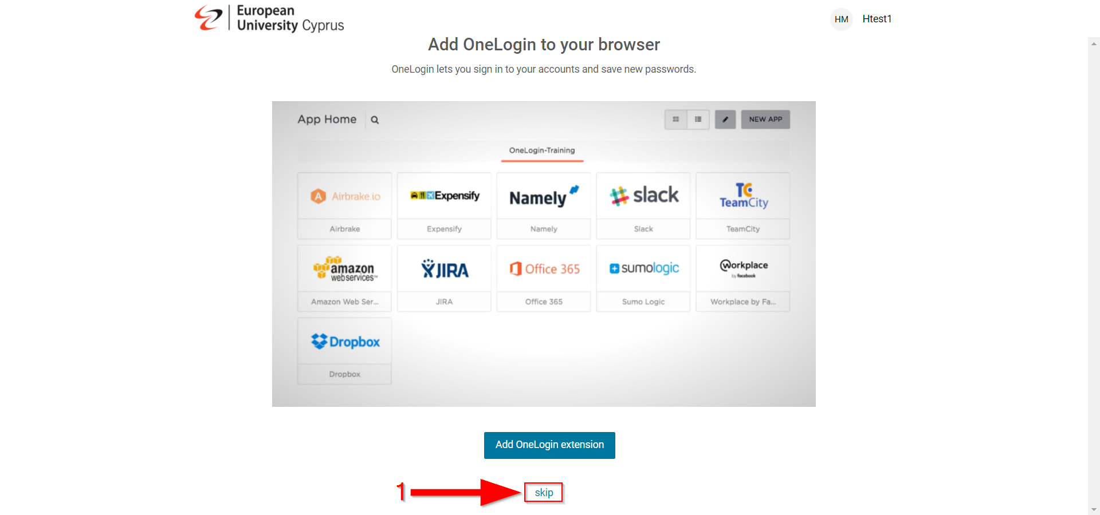

- On the next page click “All My Portals: Everything” (Arrow 1).
- Then click on “BlackBoard Learn” (Arrow 2).

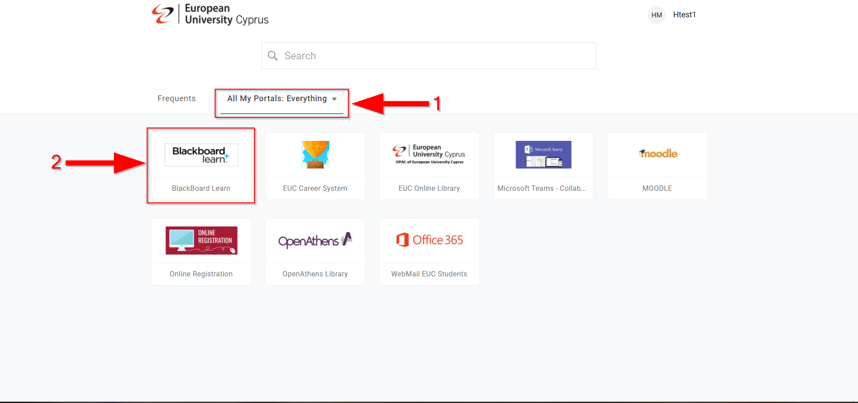

Find your Courses
- On the left side menu click on “Courses” (Arrow 1).
- You will be greeted with the following webpage where you can find all courses that you are enrolled.

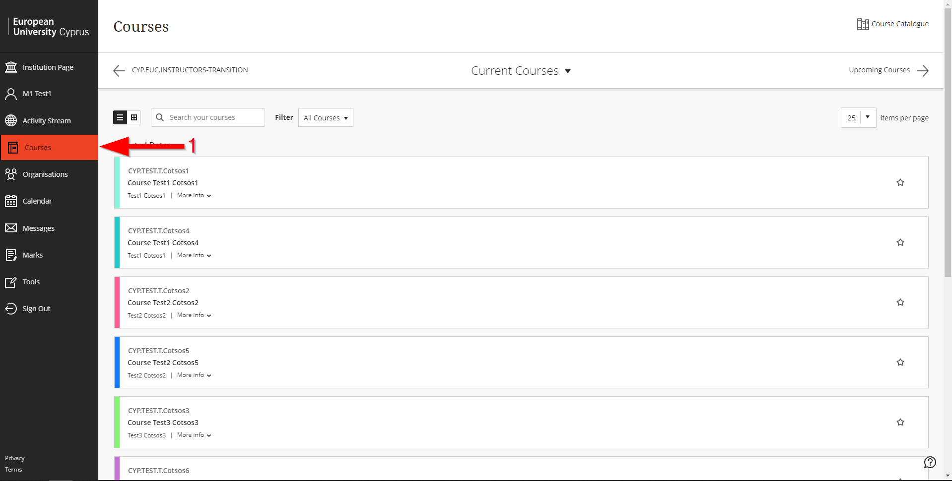

Add/Remove Courses from Favorites
- If you want some courses appeared first, click on the star to add them in “Favorites” (Arrow 1).

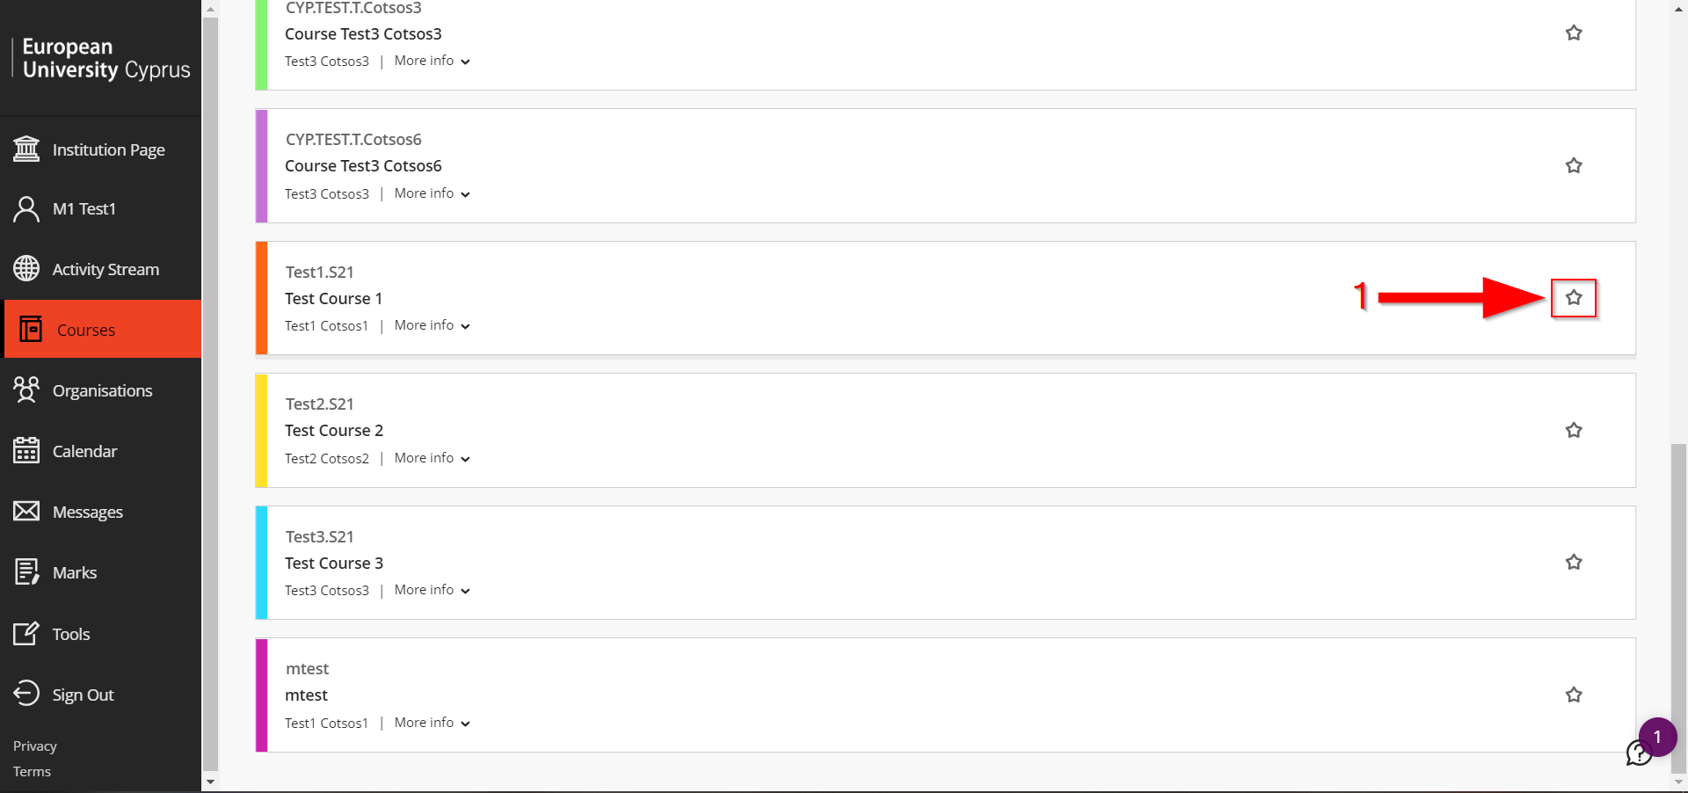

- If you want to remove a course from “Favorites” click on the star (Arrow 1).

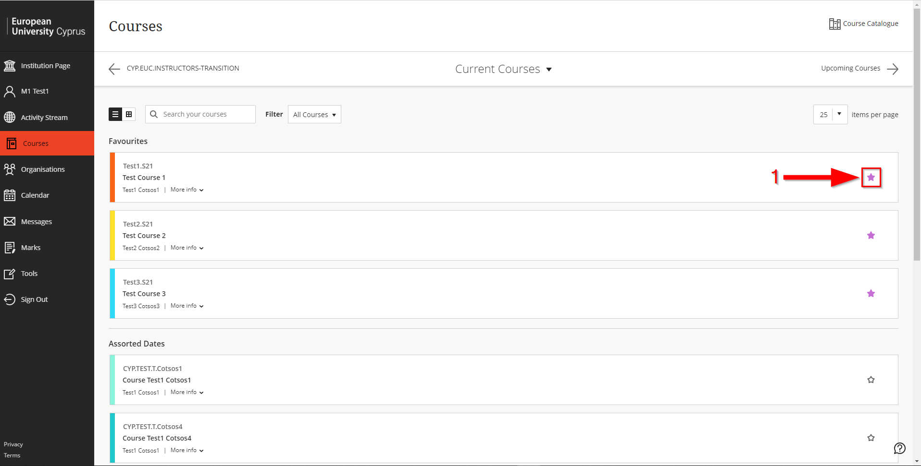

View Course Content
- Click on your course (Arrow 1).

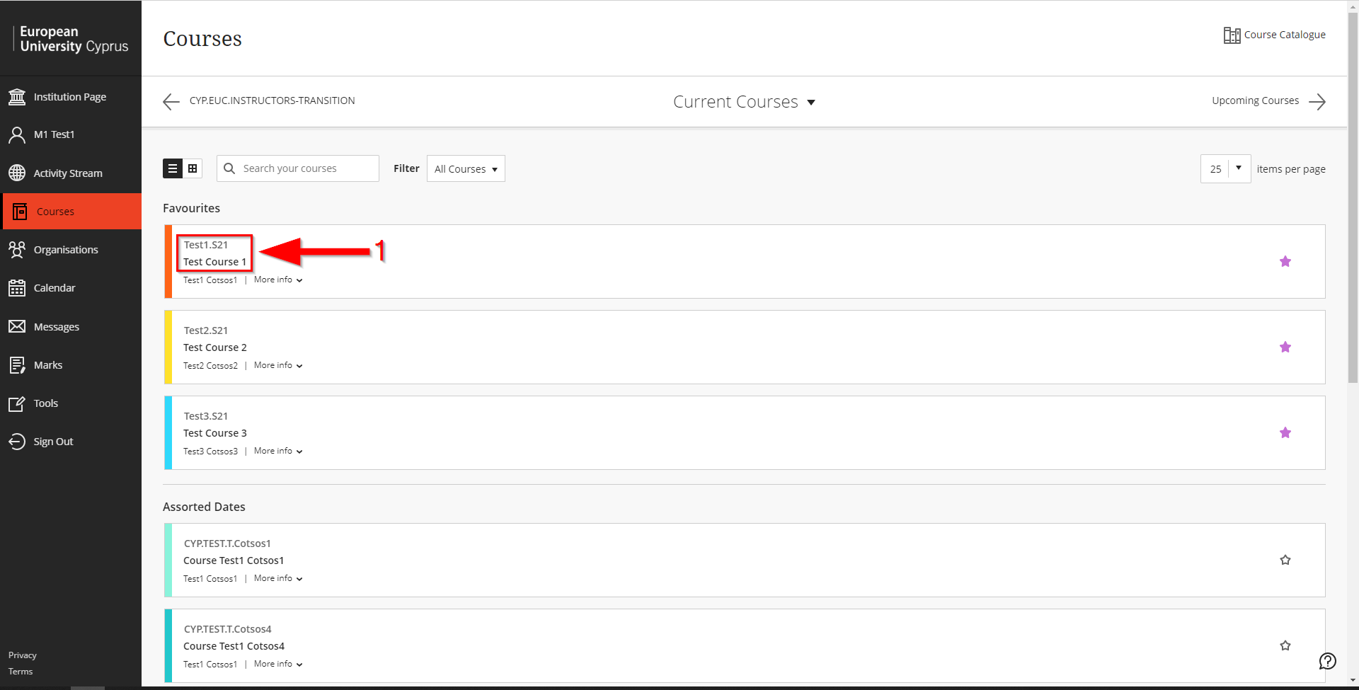

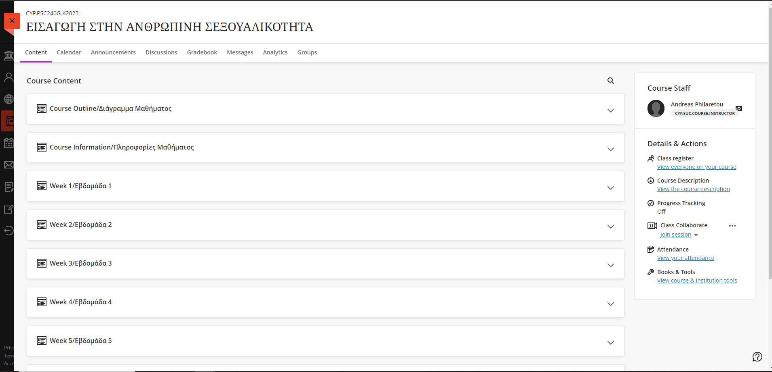
- You will be greeted with the following webpage where you can find the available content of your course. Scroll down to see all available content of your course.

View or Download Course Material
- Course content is usually divided in modules. Therefore, to find first week’s material click on “Week 1/Εβδομάδα 1” (Arrow 1) to find second week’s material click on “Week 2/Εβδομάδα 2” etc.

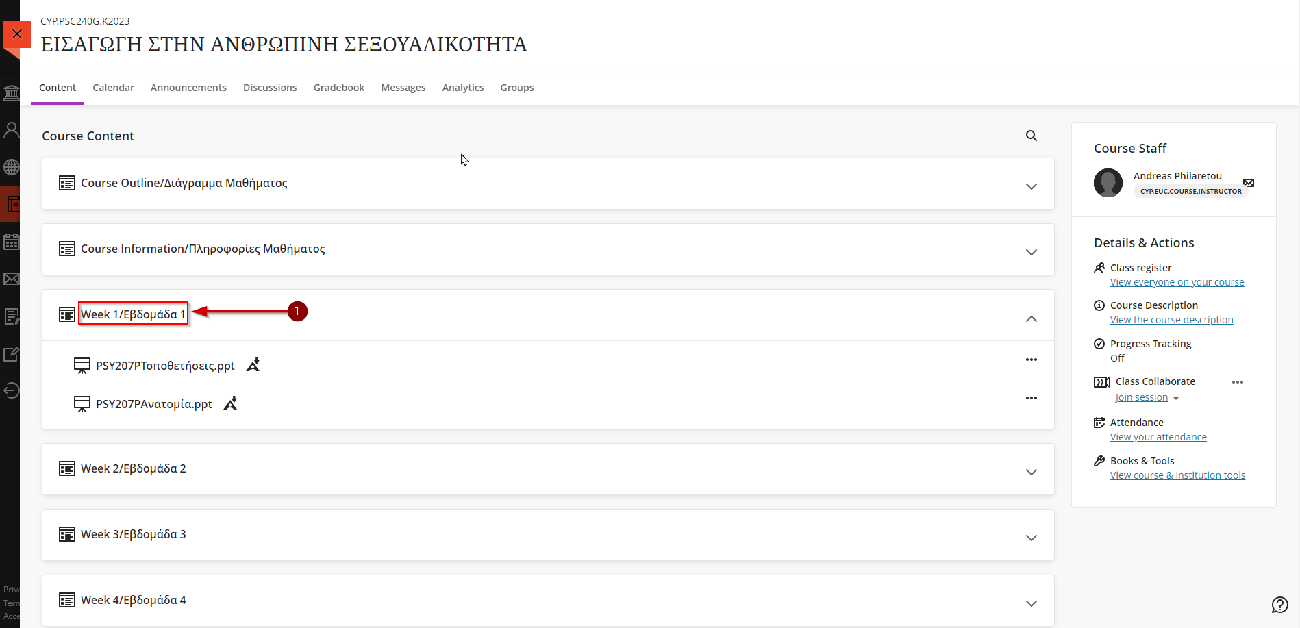

- Click on the file that you want to read (Arrow 1). If the file is a pdf by clicking on it will automatically open in a new tab on your browser and you can download it using right click on any of the document pages and then click on “Save as…”. If the file is a word, excel or PowerPoint file then by clicking on it will be automatically downloaded on your computer.

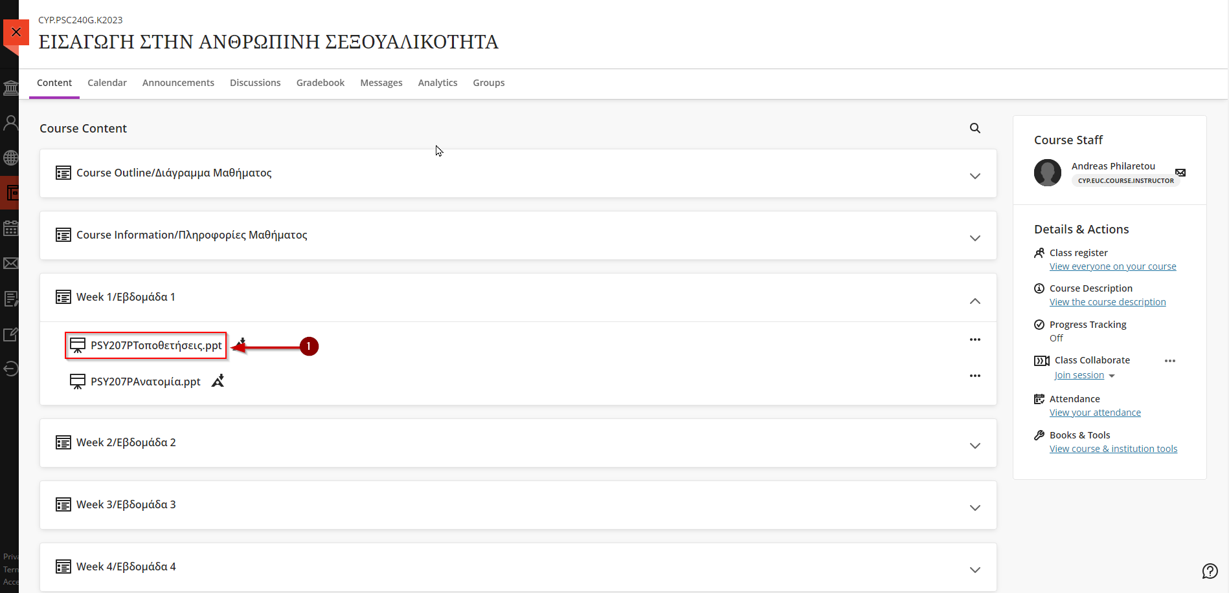

Joining a Session
- Go to your course. Follow the steps described in section “4. View Course Content”.
- Click on “Join Session” (Arrow 1).
- Click on the proper Session name (Arrow 2).

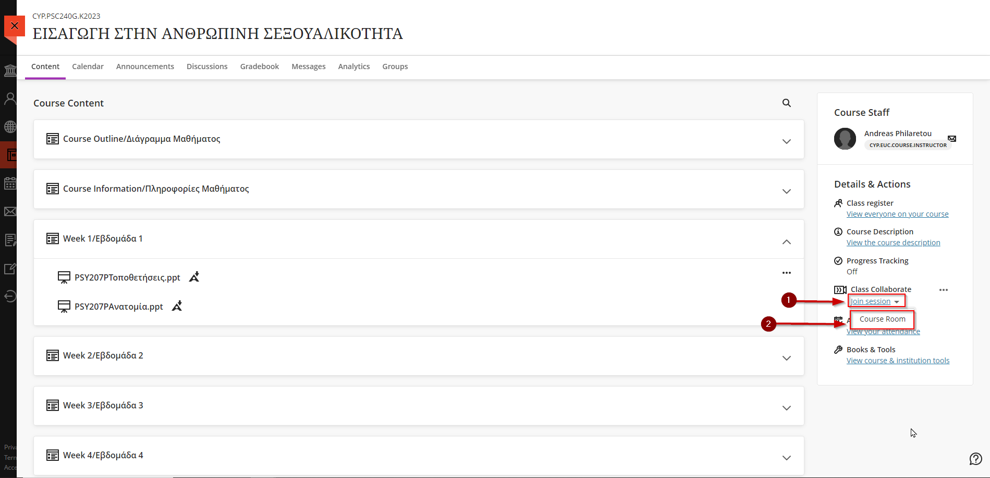

- A new window will open up. The first time that you are joining a session you will be asked for microphone and camera permission.
- A window asking for microphone access will pop up. Click on “Allow” to give blackboard access use your microphone (Arrow 1).

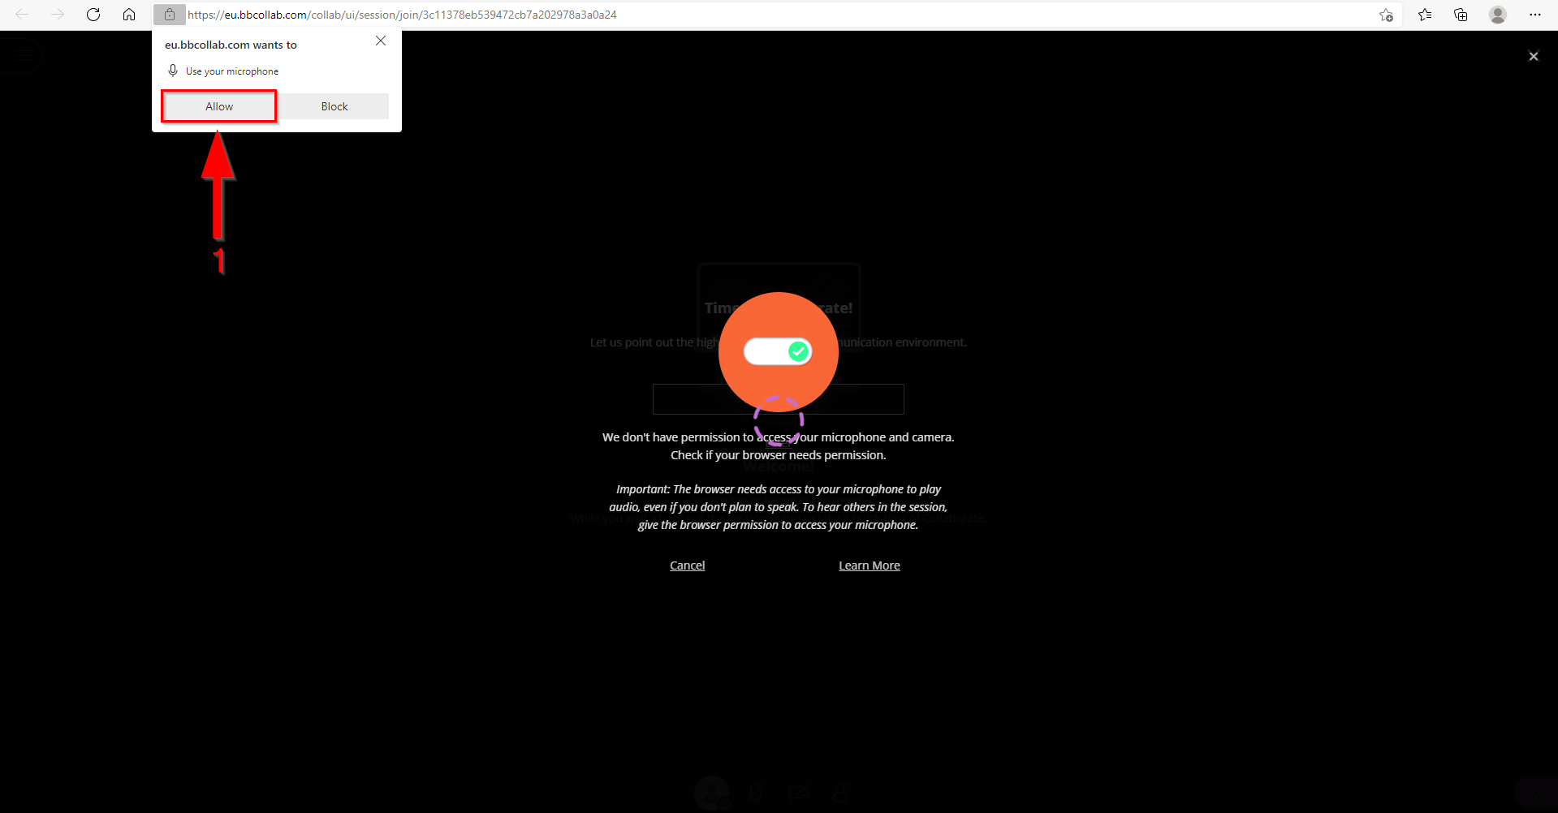
- Check if your microphone is working properly (Arrow 1).
- If so, click on “Yes, Audio is working.” (Arrow 2).

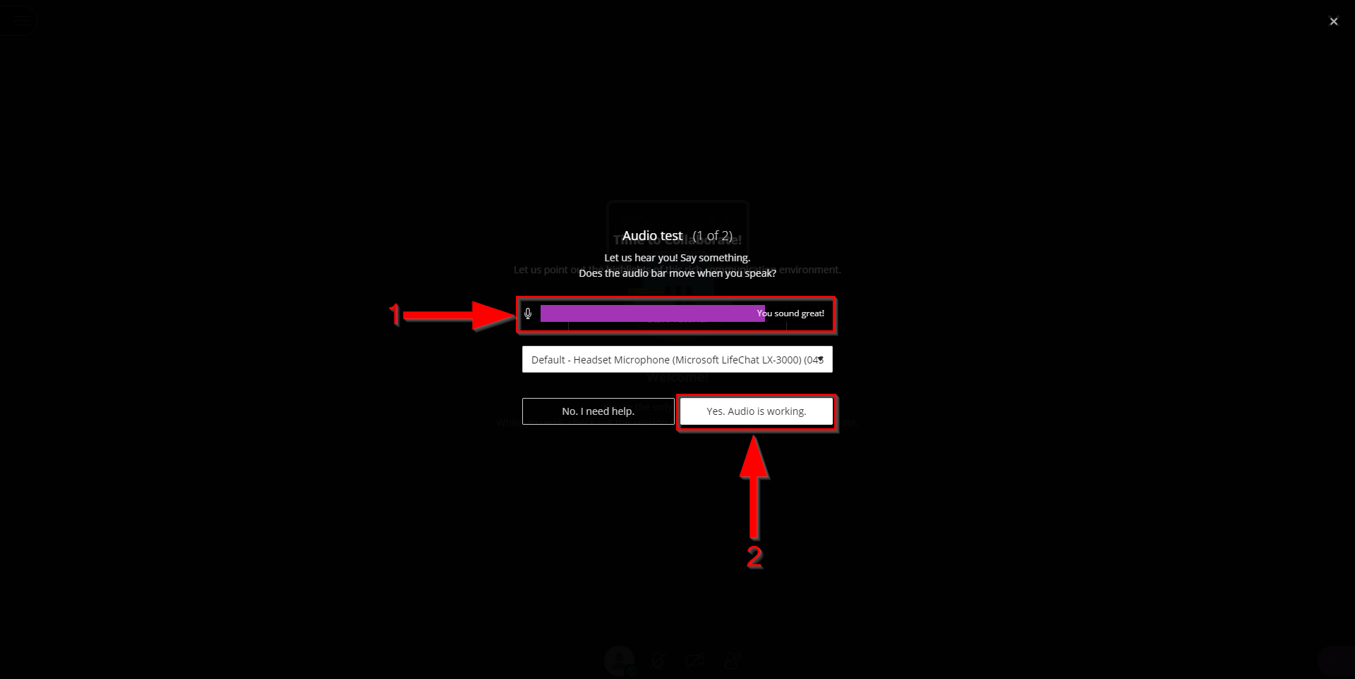

- A window asking for camera access will pop up. Click on “Allow” to give blackboard access use your camera (Arrow 1).

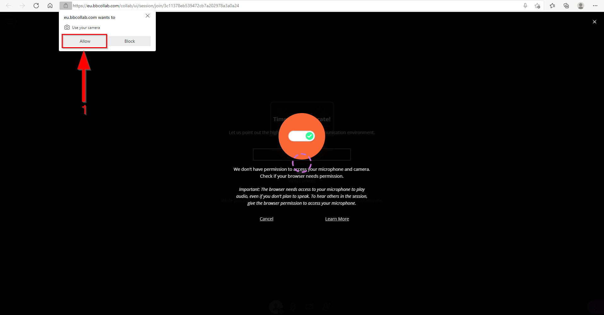

- Check if your camera is working properly (Arrow 1).
- If so, click on “Yes, Video is working.” (Arrow 2).

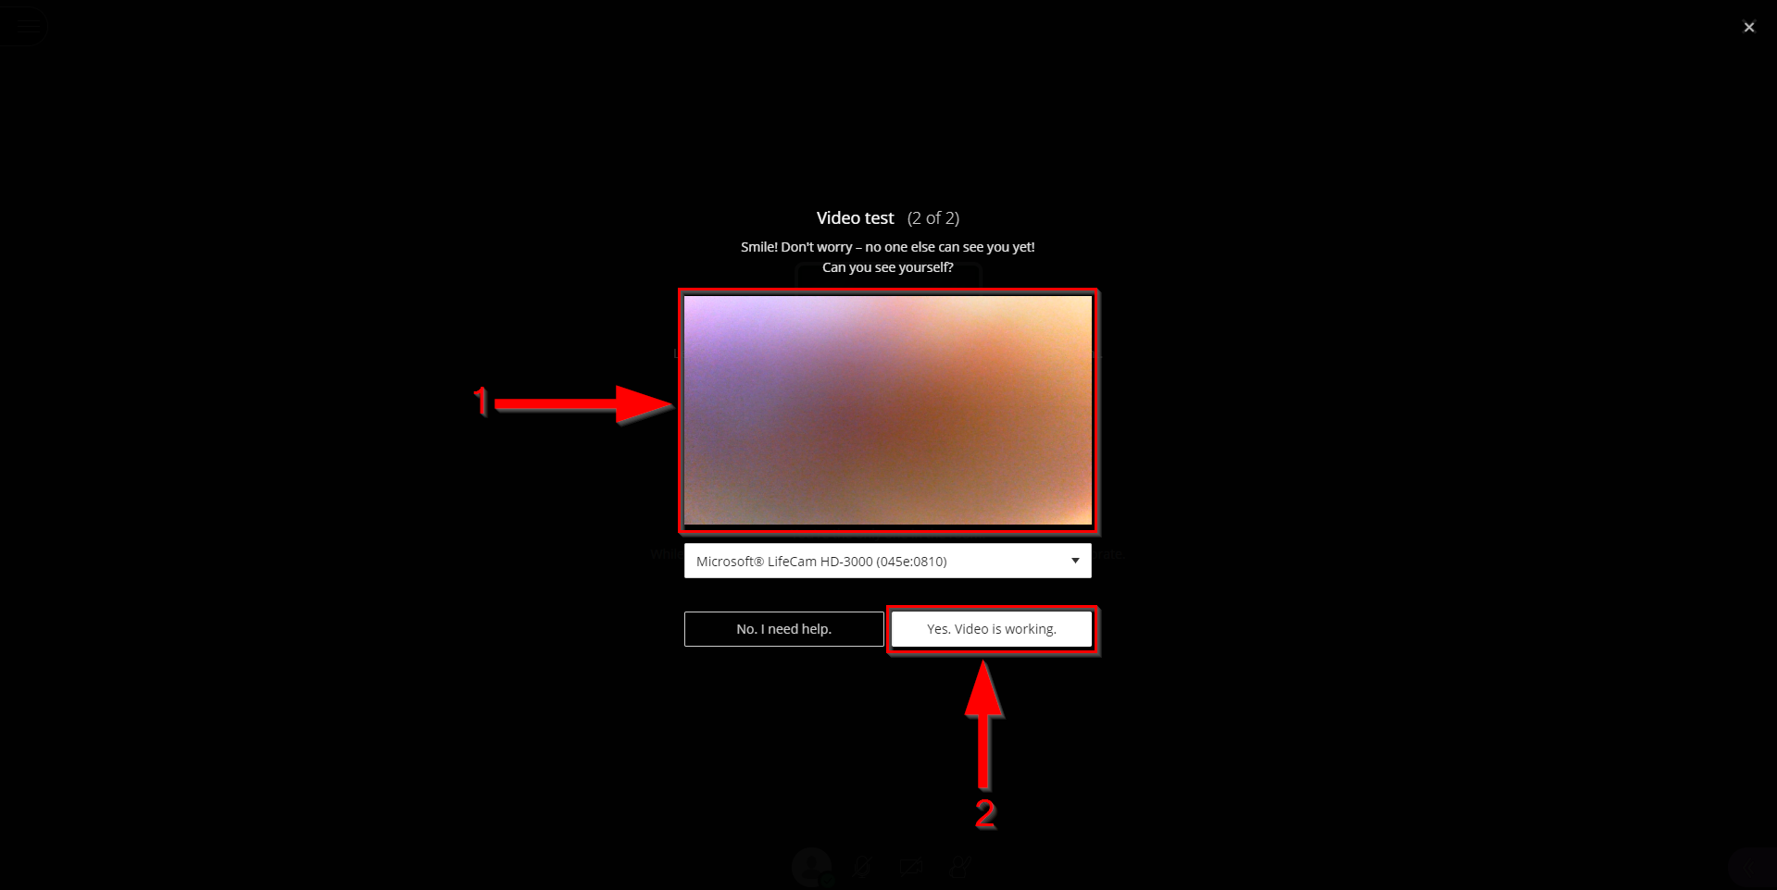

- You will be greeted with a session welcome message. You can choose to start a tutorial (Arrow 1) or click “Later” to bypass the tutorial (Arrow 2).

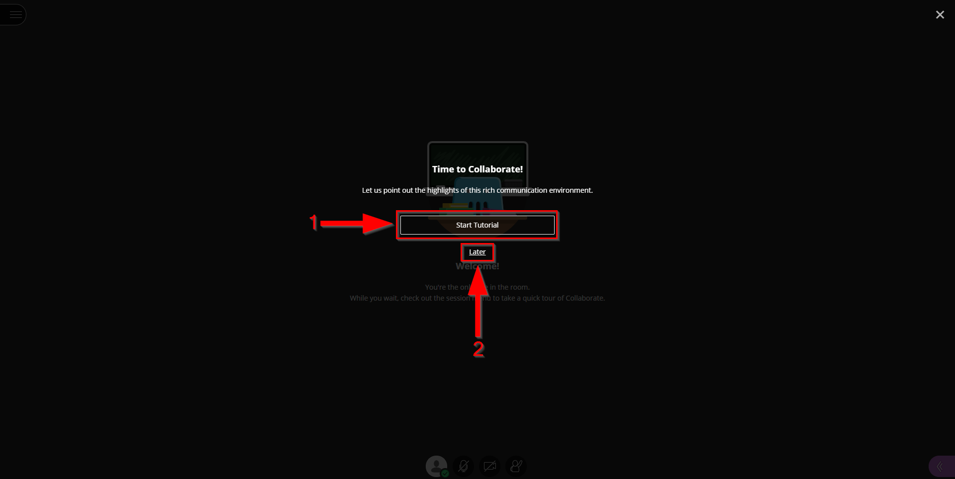

Blackboard Collaborate Ultra’s Interface
- After joining the session, you will be greeted with the following interface from where you will participate to the online lecture.

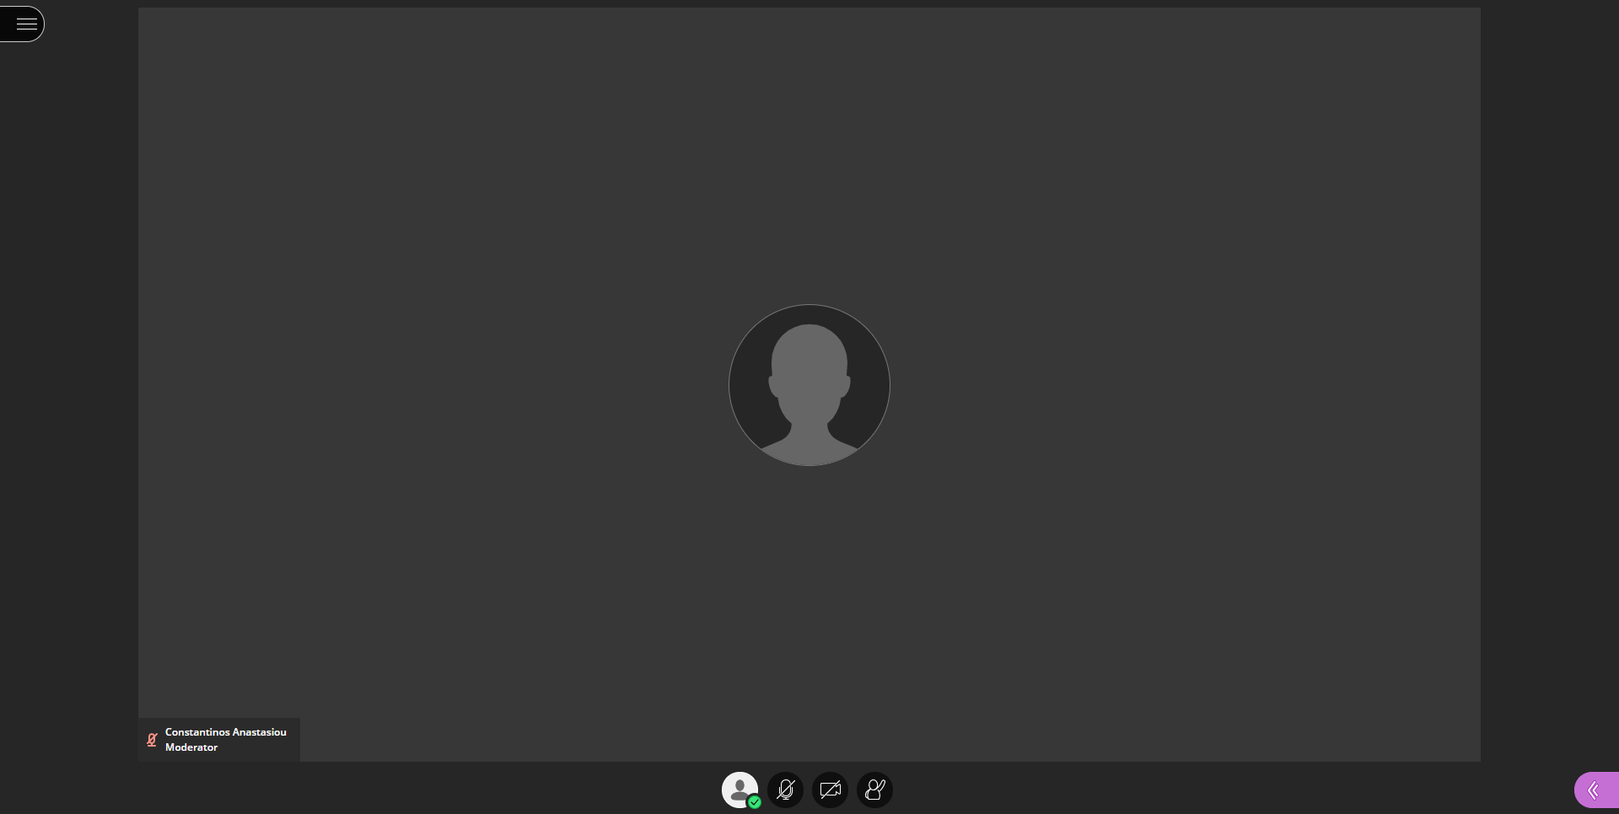

- By clicking the button on the top-left corner of the screen (Arrow 1), a pop-up window will open.

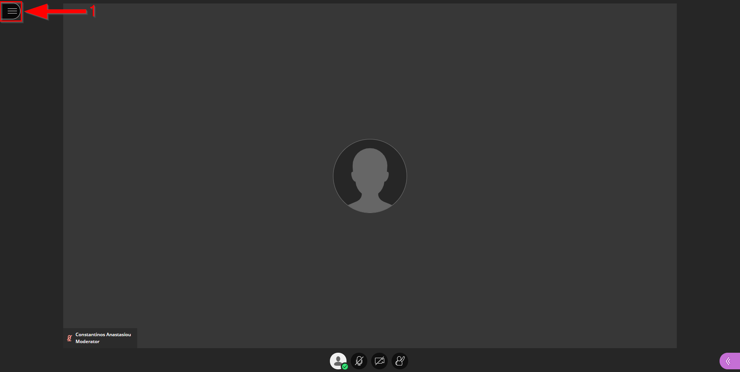
- Click on “X” to return to the session (Arrow 1).
- Click on “Tell me about Collaborate” to start a tutorial about blackboard collaborate ultra (Arrow 2).
- Click on “Leave session” to leave the session (Arrow 3).

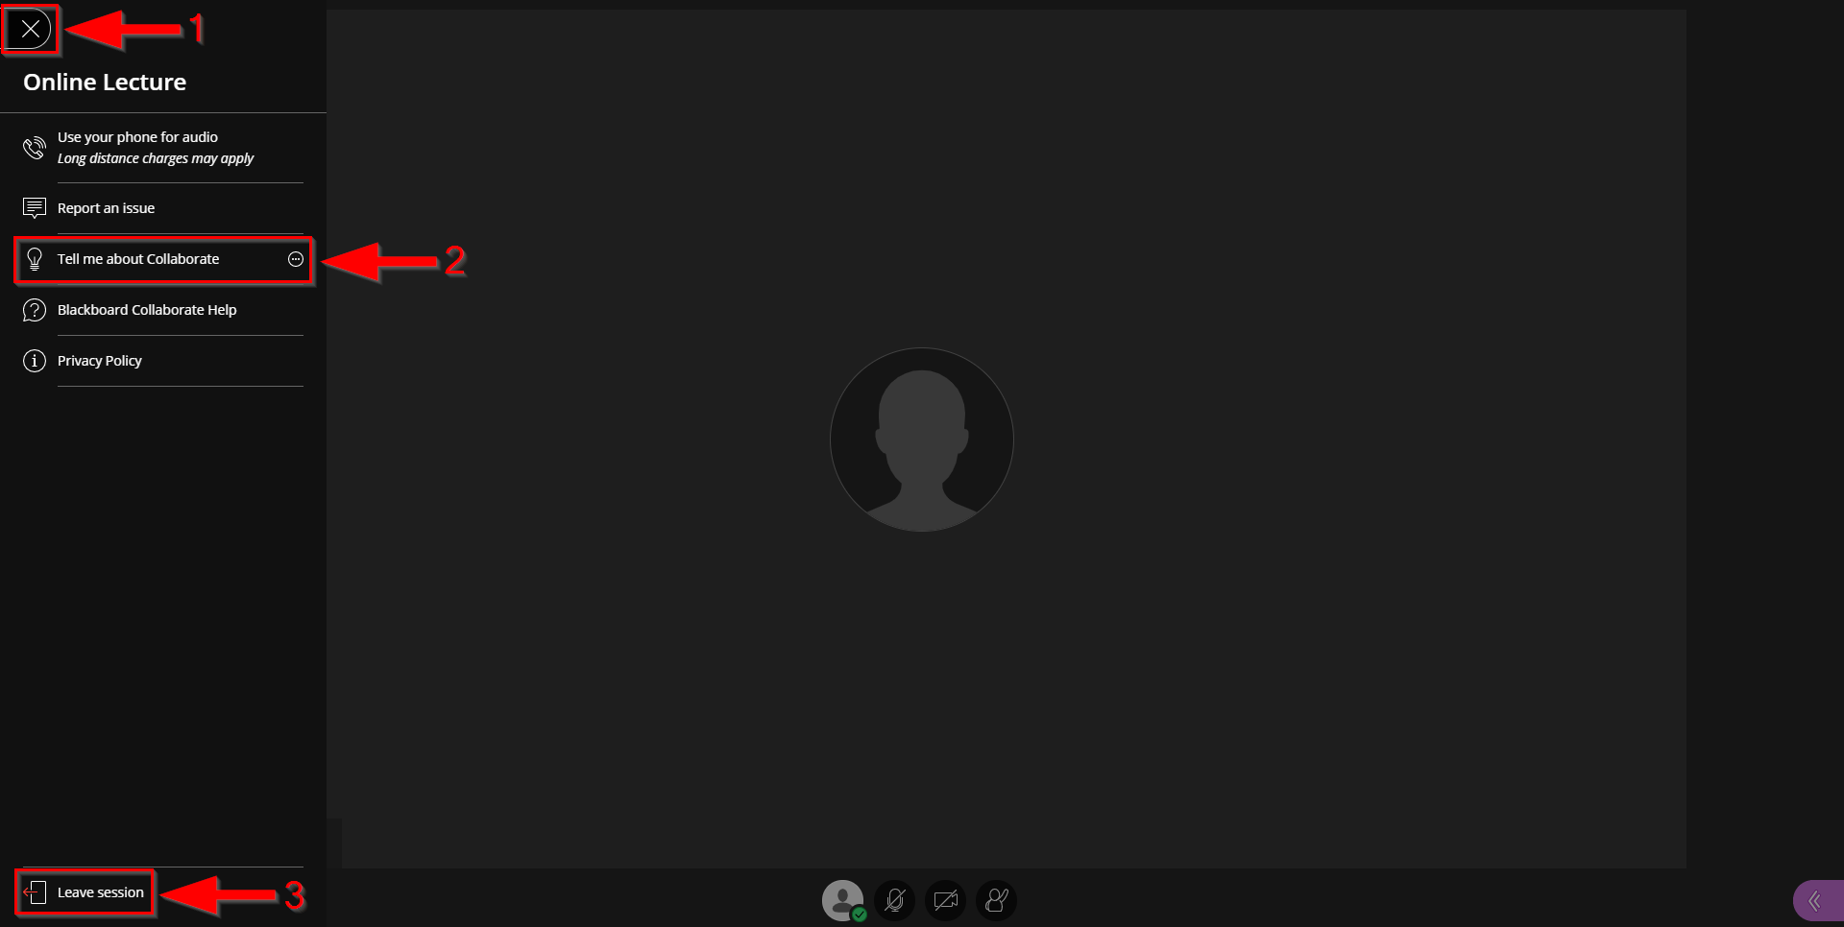

- By clicking the button on the bottom-right corner of the screen (Arrow 1), a pop-up window will open.

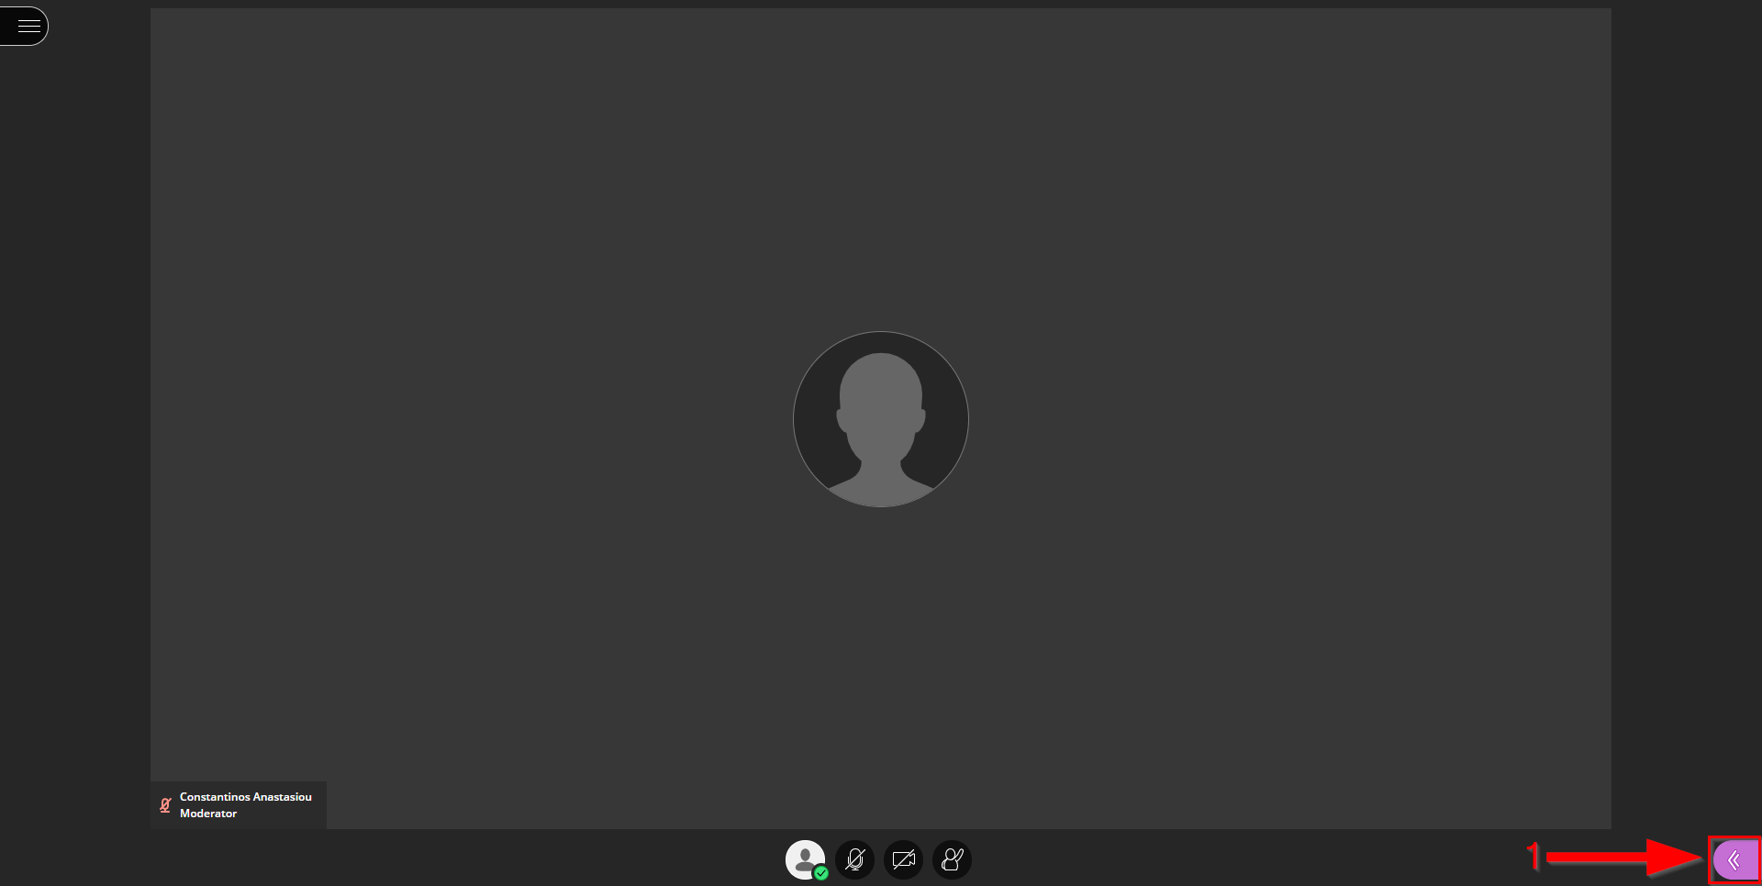
- Click on “Chat” (Arrow 1) to chat with your class. Click on “Everyone” (Arrow 3) to start chatting with everybody in your class or type the name of the one you want to chat privately with on the textbox (Arrow 2).
- Click on “X” to return to the session (Arrow 5).
- Click on “My Settings” (Arrow 4) to set various settings regarding your session window.

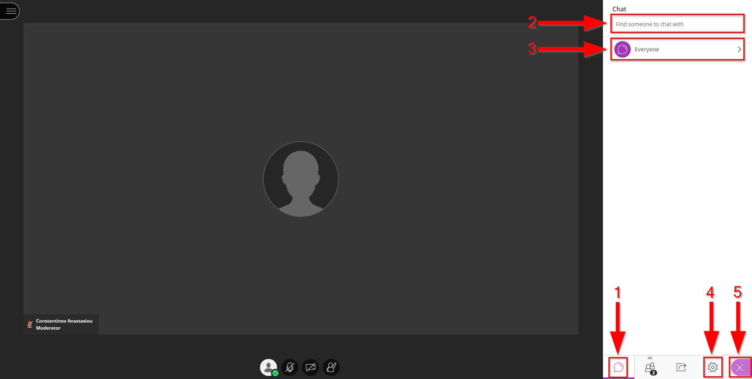

- The most important is the “Set up your camera and microphone” option where you give the necessary permission to Blackboard Collaborate to access your microphone and camera devices. Same windows described in section “6. Joining a Session” e-k, will appeared (Arrow 1).

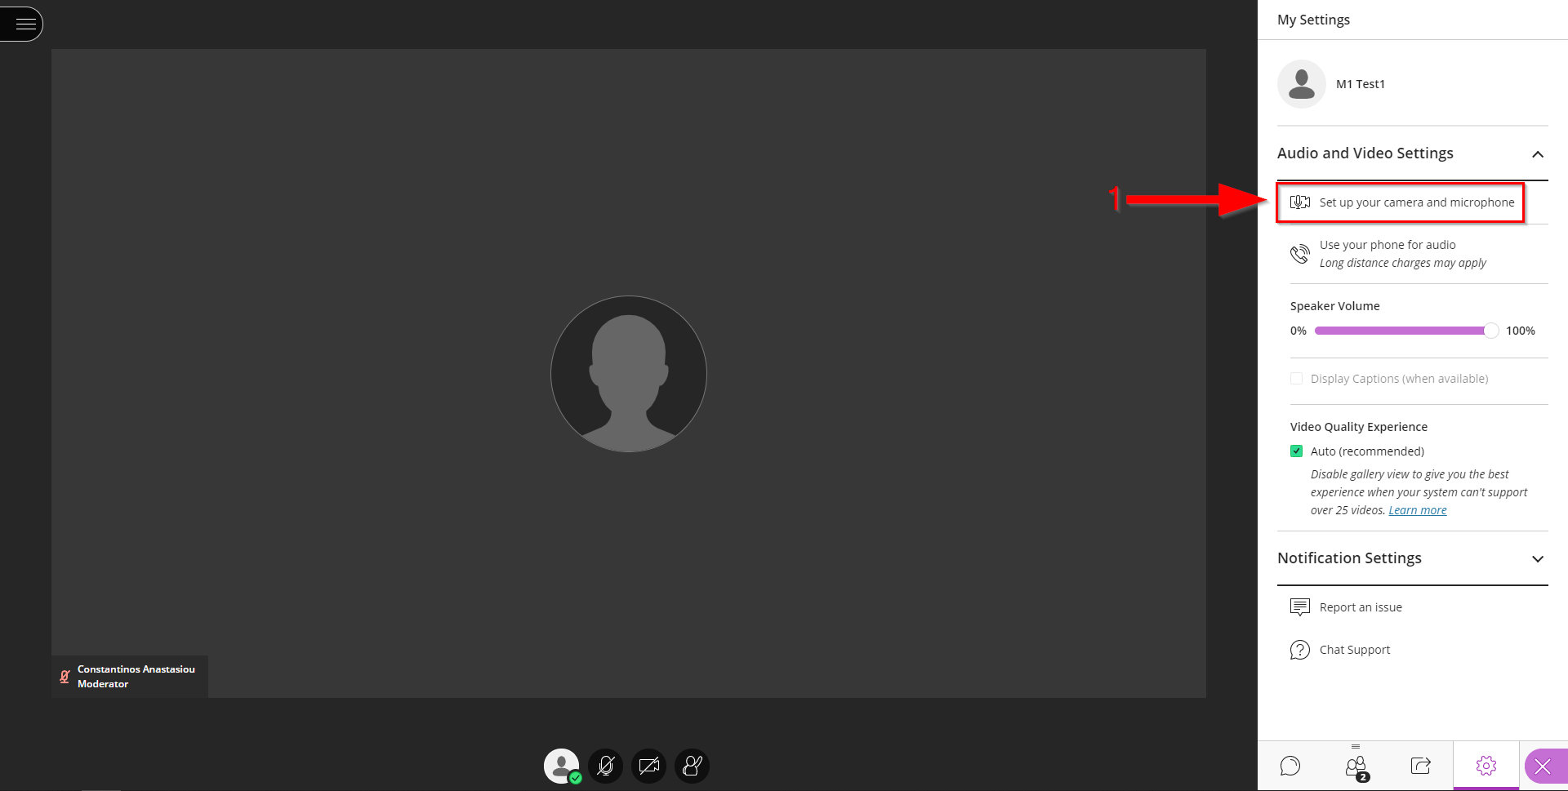
- At the bottom of the session’s main window there are four main buttons.
  - Click on “Raise Hand” to raise your hand (Arrow 4).
  - Click on “Share Video” to activate/deactivate your camera (Arrow 3).
  - Click on “Share Audio” to activate/deactivate your microphone (Arrow 2).
  - Click on “My Status and Settings” will open a pop-up menu (Arrow 1).

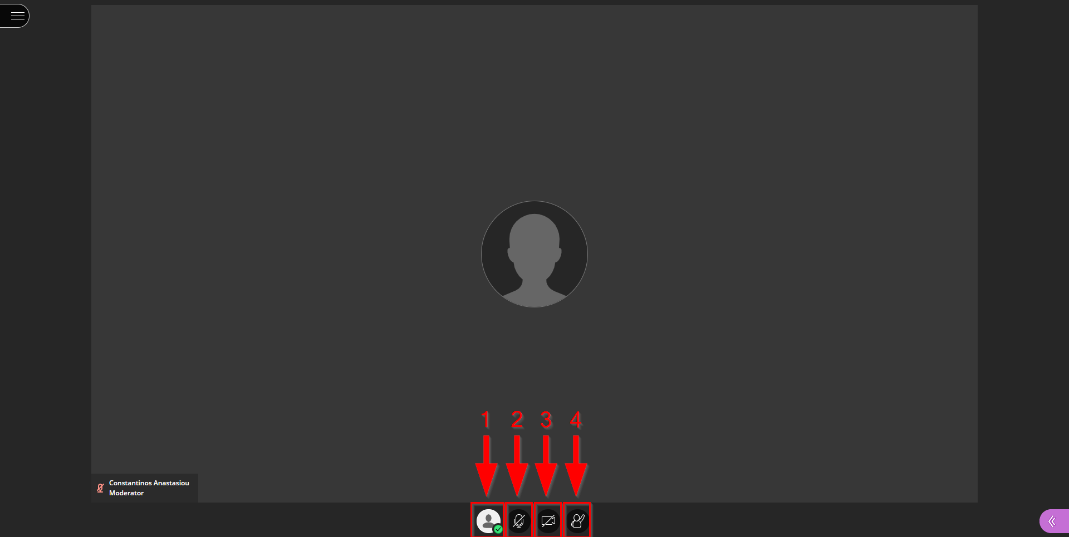

- Through the pop-up menu you can change your status to “Away” if you leave momentarily from your computer.
- You can also leave completely from the session (“Leave Session”).
- You can use the feedback buttons to give the instructor your immediate feedback on the presentation.
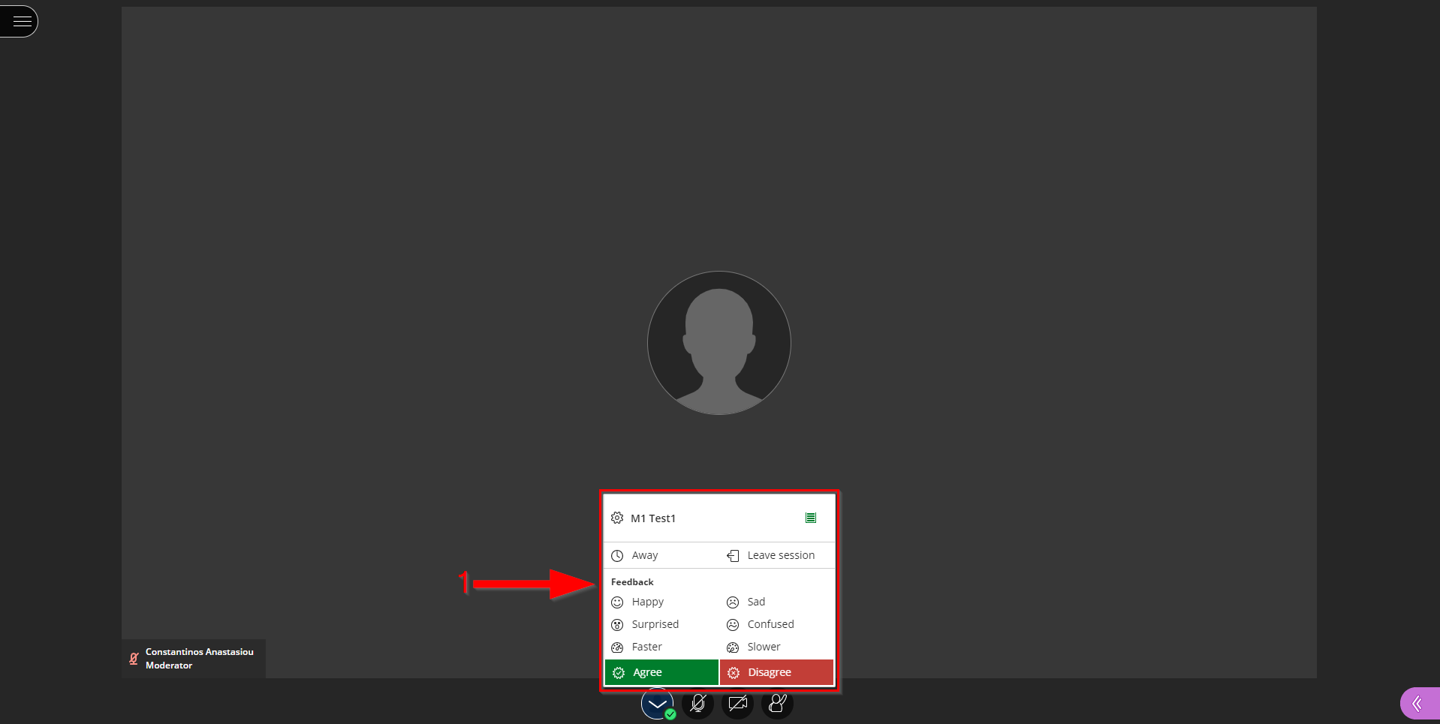

Find Recordings
- Go to your course. Follow the steps described in section “4. View Course Content”.
- Click on the 3 dots that appear on the right of “Class Collaborate” (Arrow 1).

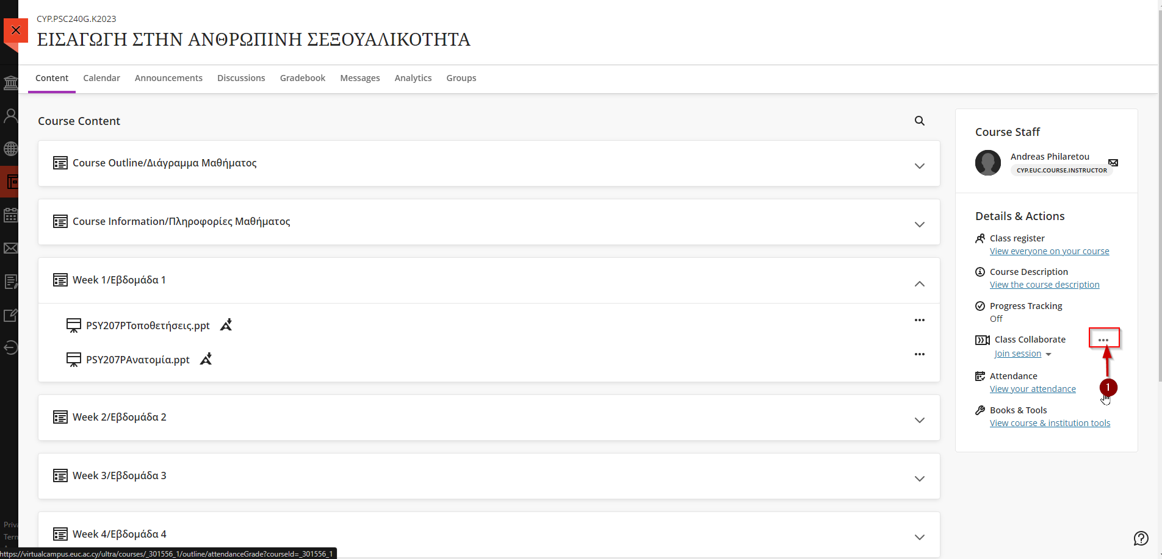

- Click on “View all recordings” (Arrow 1).

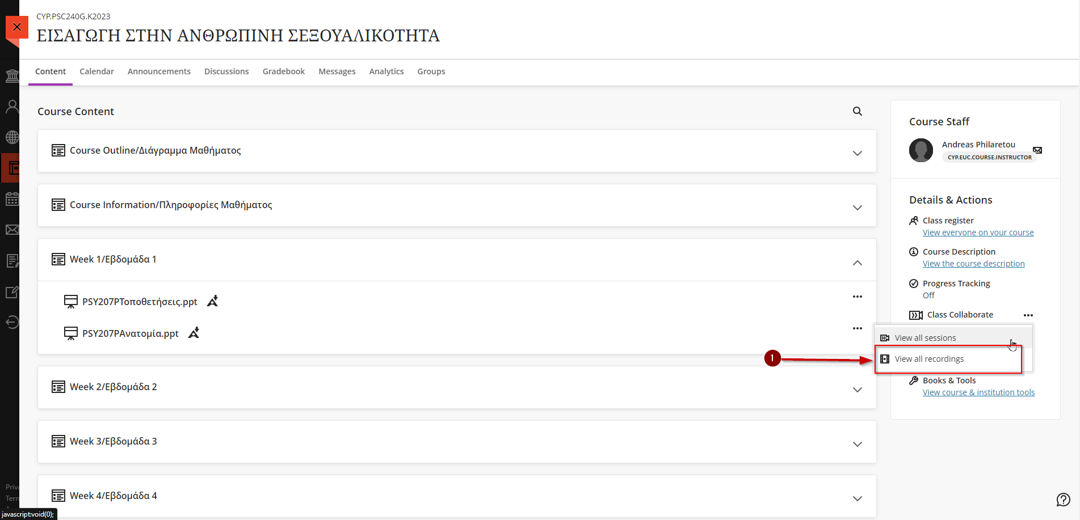

- Click on the drop list next to “Filter by” (Arrow 1) and then click on “Recordings in a Range” (Arrow 2).
- Set the start day as the first day of the current semester or any day before to access all recordings (Arrow 3).
- Click on the recording you want to view (Arrow 4).

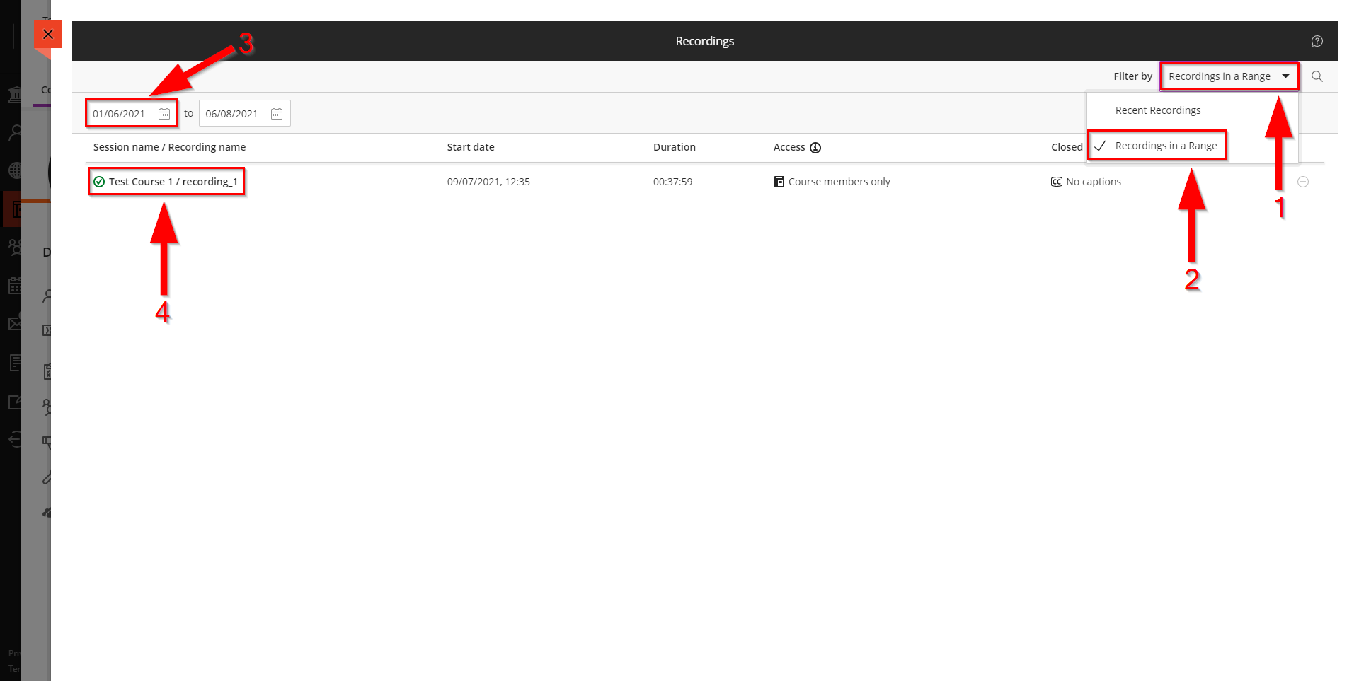

- Click on “Watch now” (Arrow 1). A new window with the recording will open.

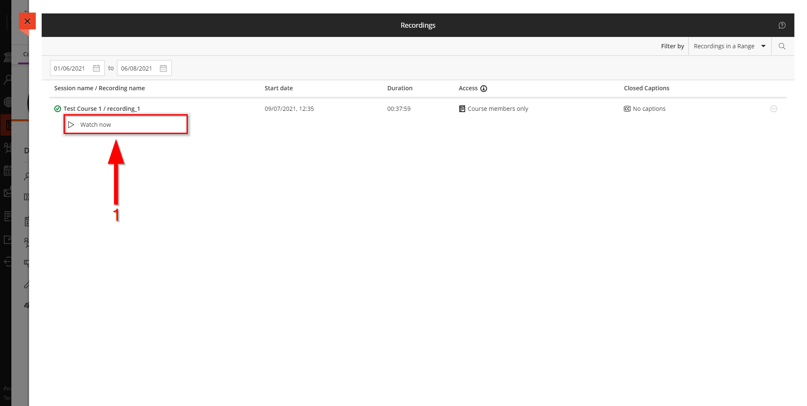

View an Assignment
- Go to your course. Follow the steps described in section “4. View Course Content”.
- Find and click on “Course Assignments/Εργασίες Μαθήματος” module in your course content area.

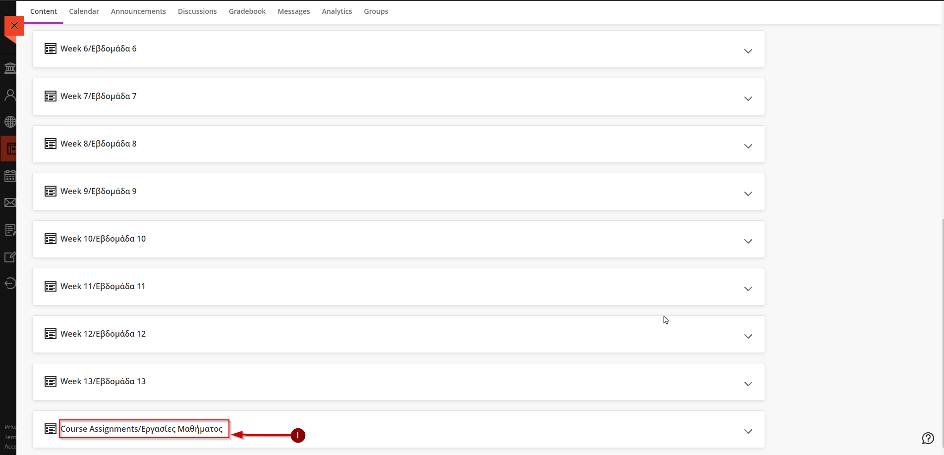

- Then click on your Assignment.

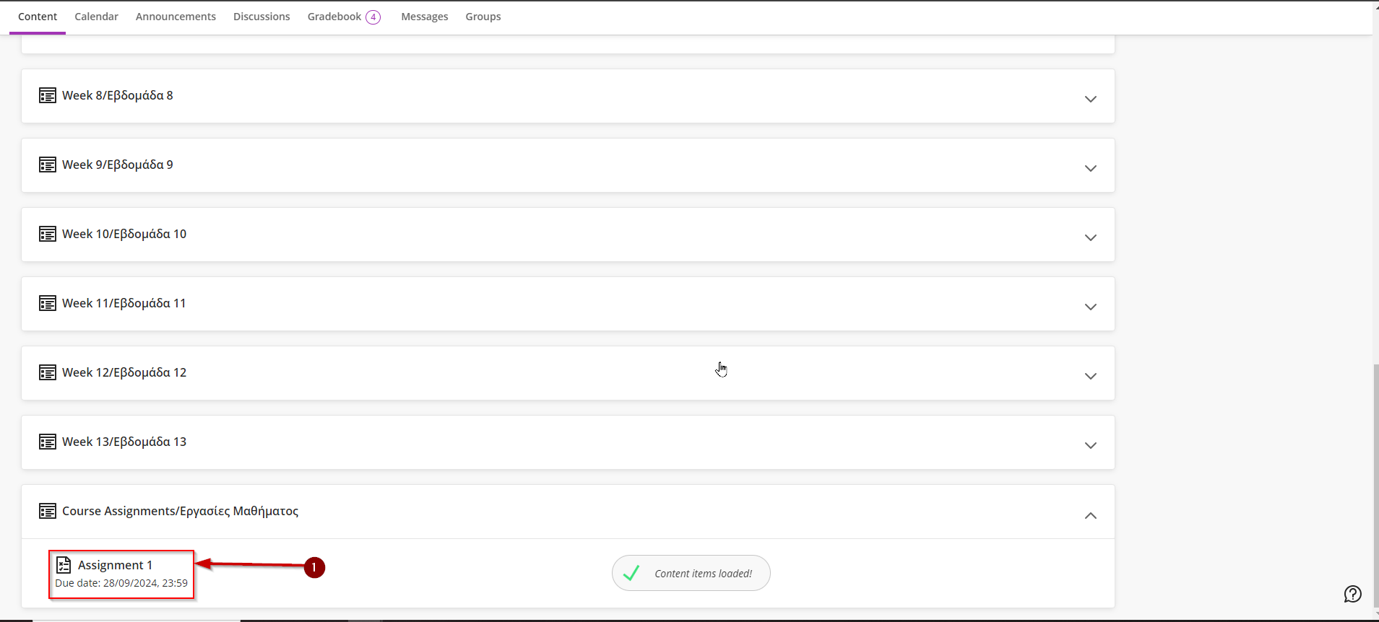

- You will be greeted with the following webpage where you can find details about your assignment.
- “Assignment due date” is the last day of submissions for the specific assignment. Have in mind that with due date 04/08/2021, 00:00 the last minute of accepted submissions is 03/08/2021, 23:59, not 04/08/2021, 23:59 (Arrow 1).
- “Attempts” is the number of submission attempts left for the specific assignment (Arrow 2).
- “Maximum points” is the maximum points that you can achieve for the specific assignment (Arrow 3).
- Click on “View instructions” to open the assignment (Arrow 4).

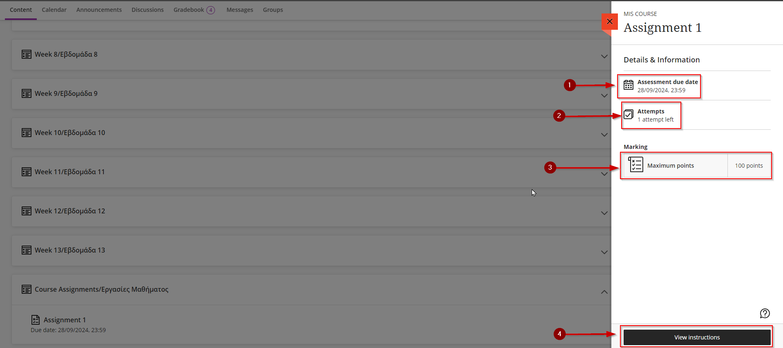

- You will be greeted with the following webpage.
- “Assignment Content” is the subject and the details provided by your instructor regarding the assignment (Arrow 1).

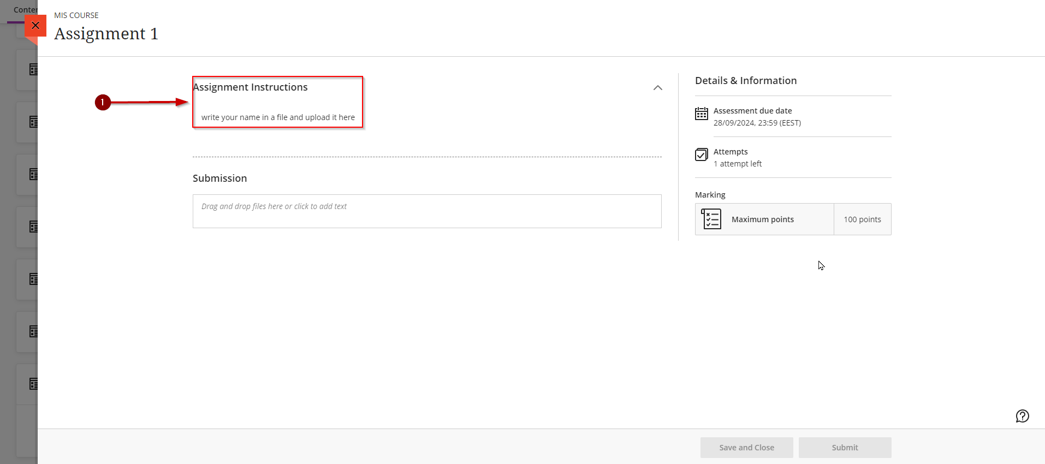

Write and Submit an Assignment
- Follow the steps described in section “9. View an Assignment”.
- Use the text editor on “Submission” area (Arrow 1) to type your answer. If you will upload a file e.g.: pdf, word, powerpoint, excel etc. go to section “11. Upload and Submit an Assignment”.

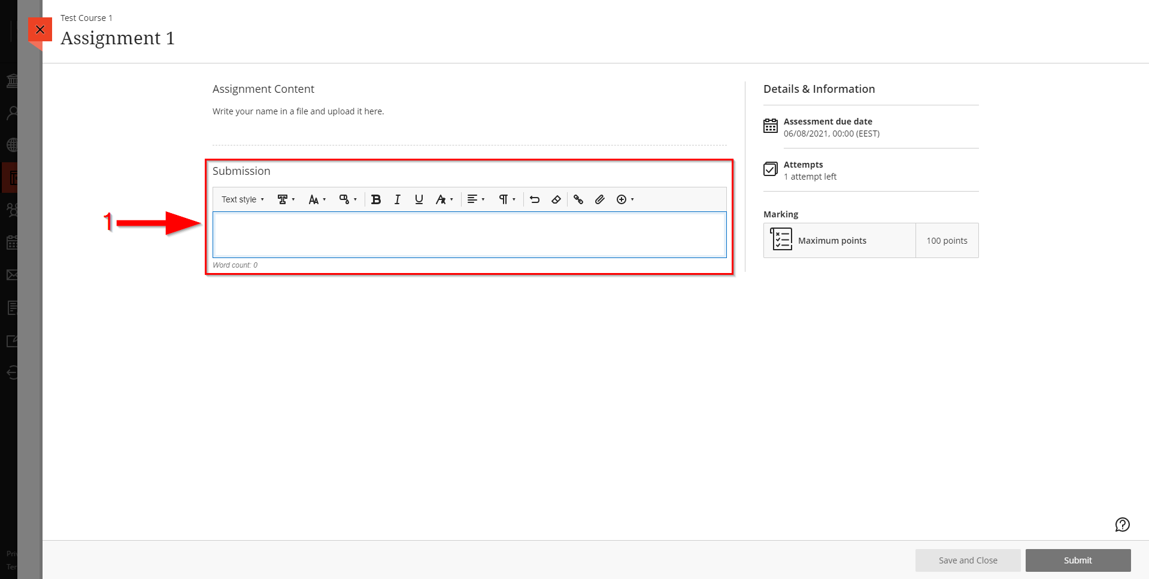

- When you finish your answer, and you want to submit click on “Submit” (Arrow 2) not on “Save and Close” (Arrow 1). Click on Submit only when you have finished your answer.
- If you did not finish your answer and you want to continue later, click on “Save and Close” (Arrow 1) not on “Submit” (Arrow 2).
To continue your answer, click on the textbox (Arrow 3).

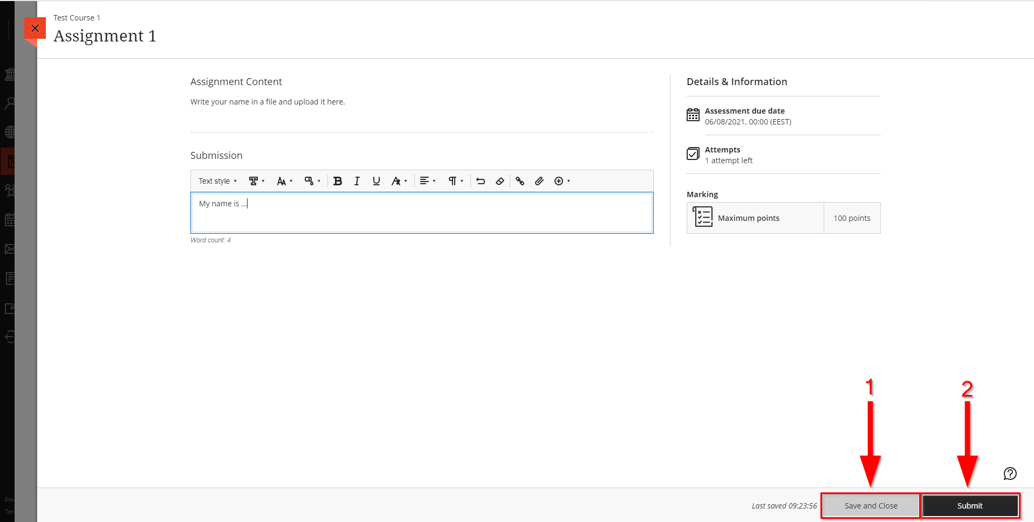

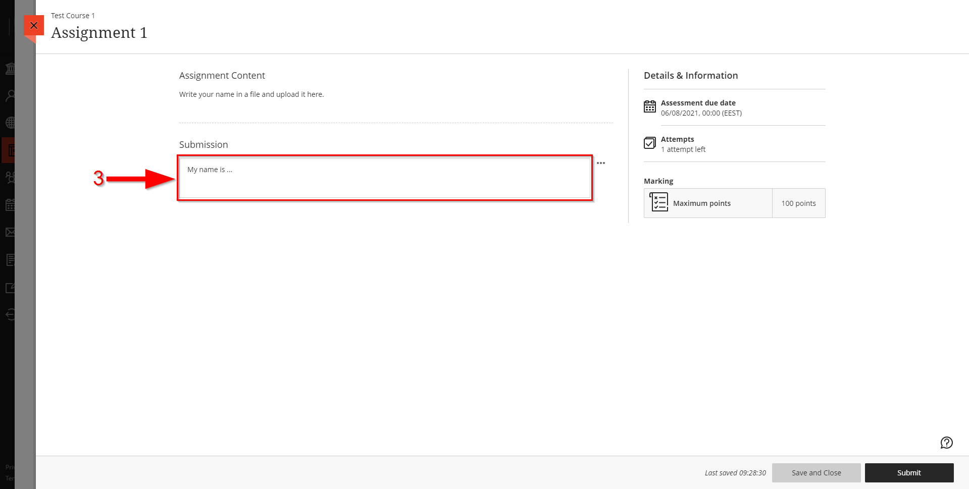

- You will be greeted with the following window. Click on “Submit” (Arrow 1).

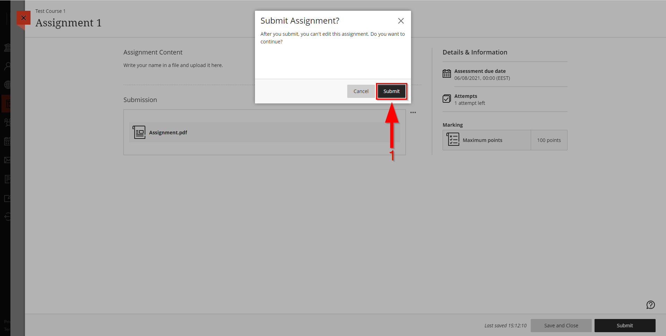

- Your answer has been submitted (Arrow 1).

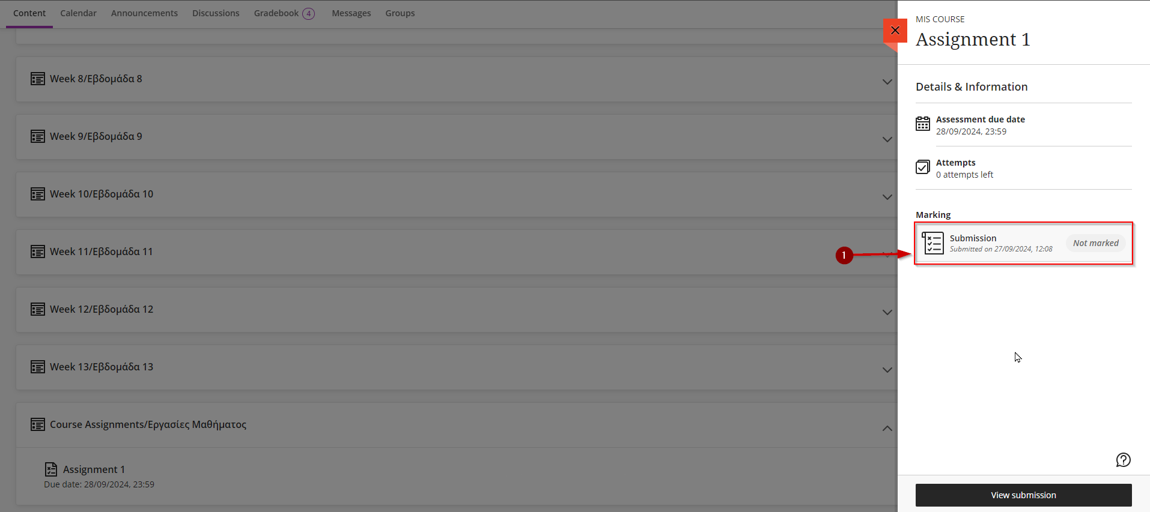

Upload and Submit an Assignment
- Follow the steps described in section “9. View an Assignment”.
- To upload a file e.g.: pdf, word, powerpoint, excel etc. for your assignment, click on “Attachment” (Arrow 1) or drag and drop your file in the textbox (Arrow 2) and skip the step d.

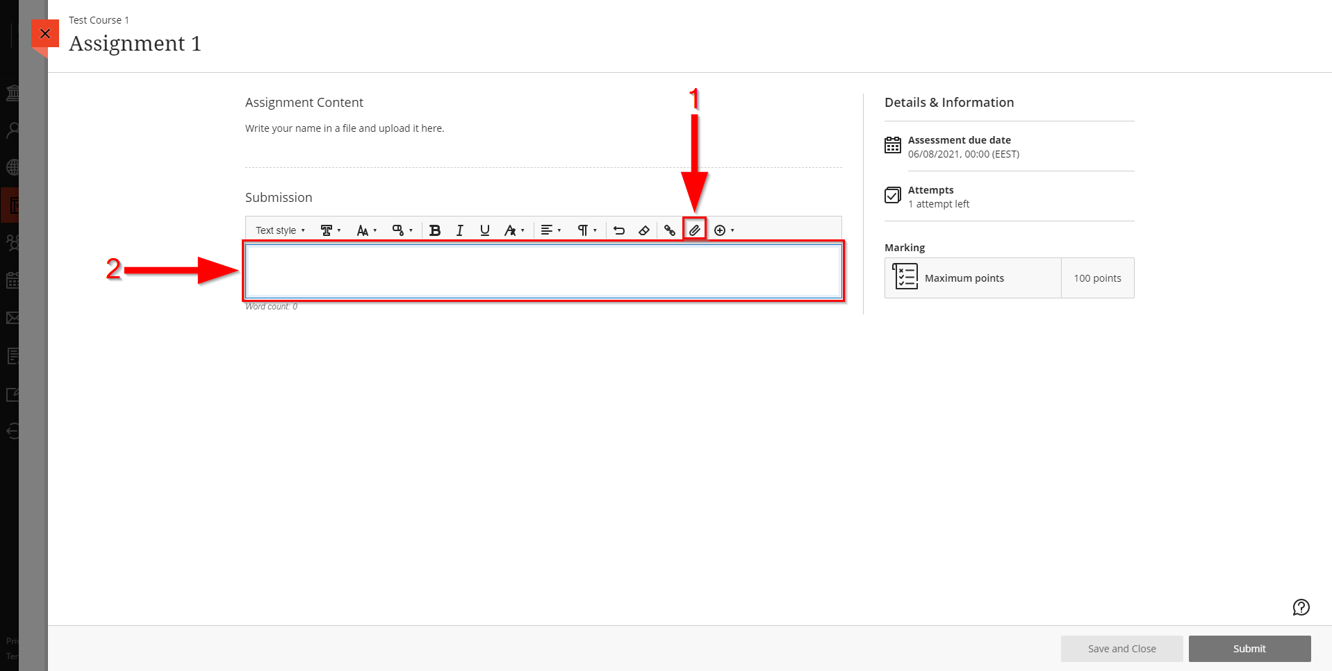
- You will be greeted with the following window.
- Find and click on your assignment file (Arrow 1).
- When you click on your assignment file make sure that appeared on “File name” textbox (Arrow 2).
- Click on “Open” (Arrow 3).

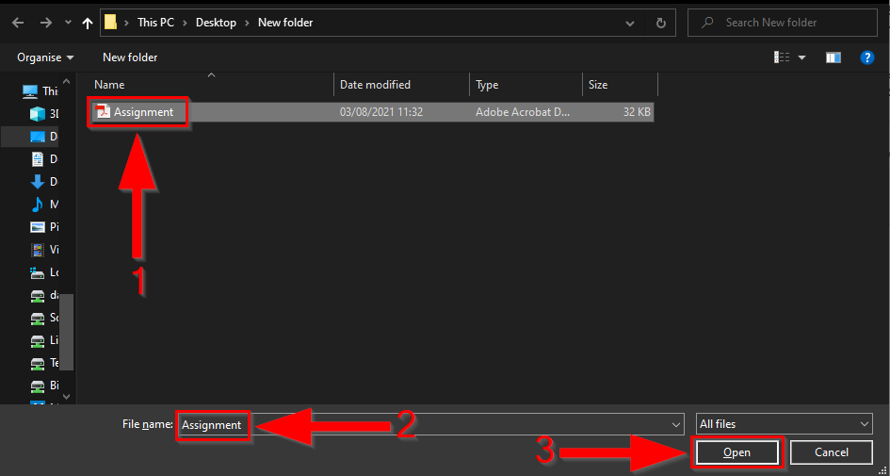

- You will be greeted with the following window.
- Leave the assignment name same with the original file. If you need to change the assignment name change it on the original file before the upload process (Arrow 1).
- Click on “Save” (Arrow 2).

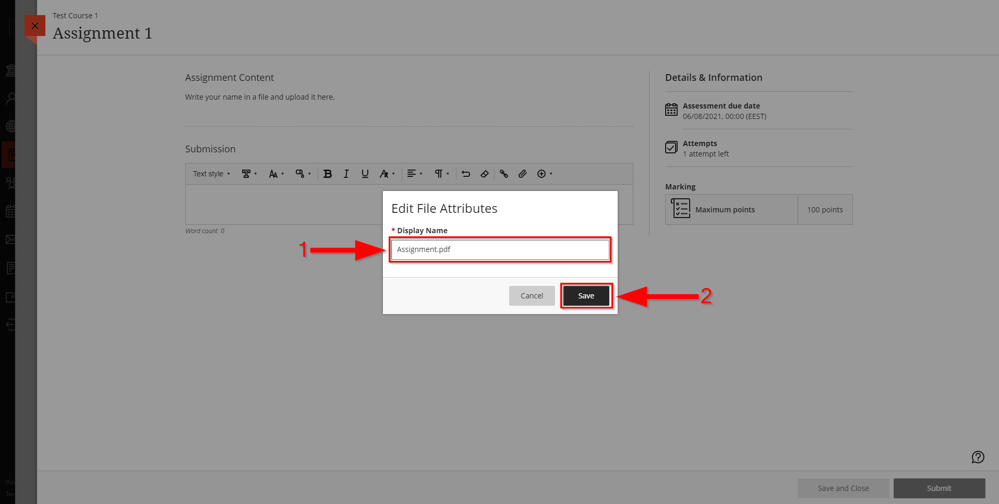
- When your file is uploaded will appear in submission textbox and you are ready to submit (Arrow 1). If you are not planning to make any changes on your answer, click on “Submit” (Arrow 3) not on “Save and Close” (Arrow 2). Click on Submit only when you have finished your answer.
- If you did not finish your answer and you want to continue later, click on “Save and Close” (Arrow 2) not on “Submit” (Arrow 3). To continue your answer, click on the textbox (Arrow 4).

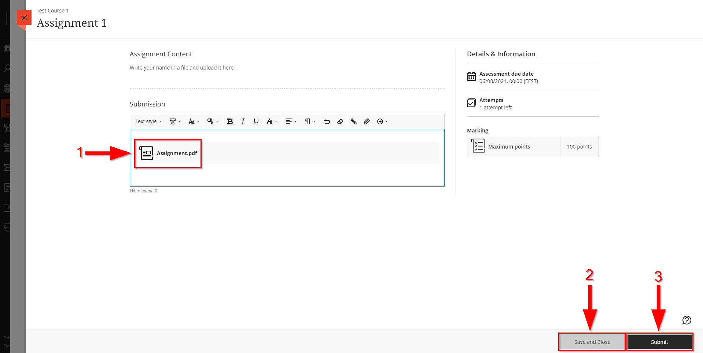

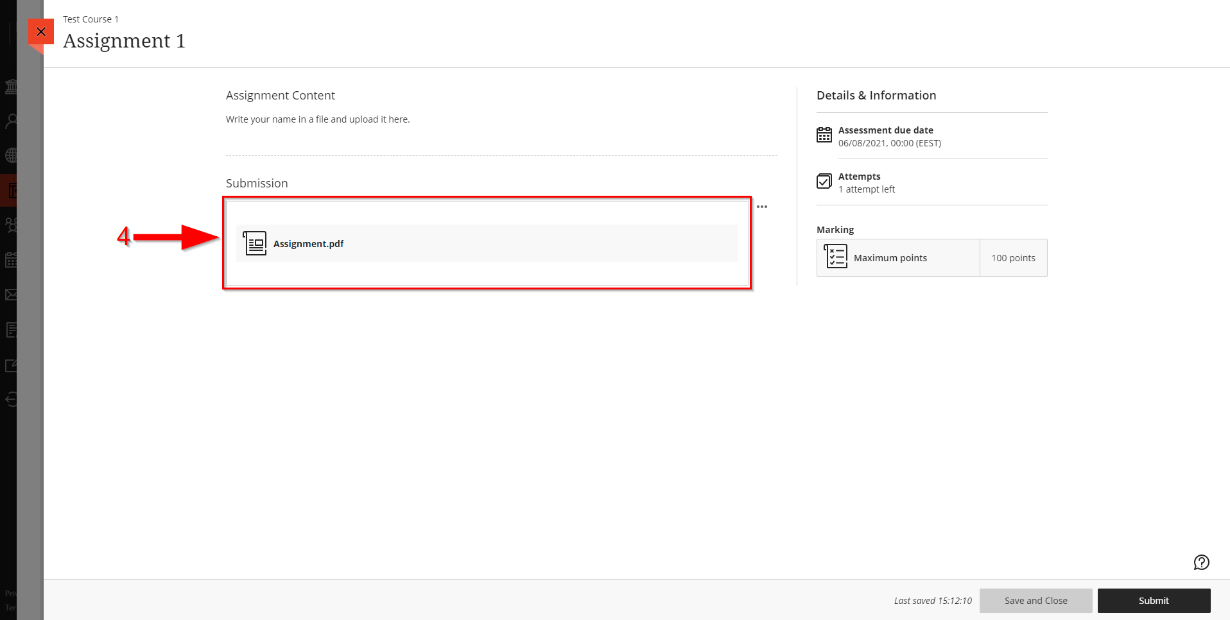
- You will be greeted with the following window. Click on “Submit” (Arrow 1).

- Your answer has been submitted (Arrow 1).

View your Assignment Grade and Feedback
- Follow the steps described in section “9. View an Assignment”.
- When your assignment is marked you can view your grade here (Arrow 2).
- Click “View submission” to view your submission (Arrow 3).

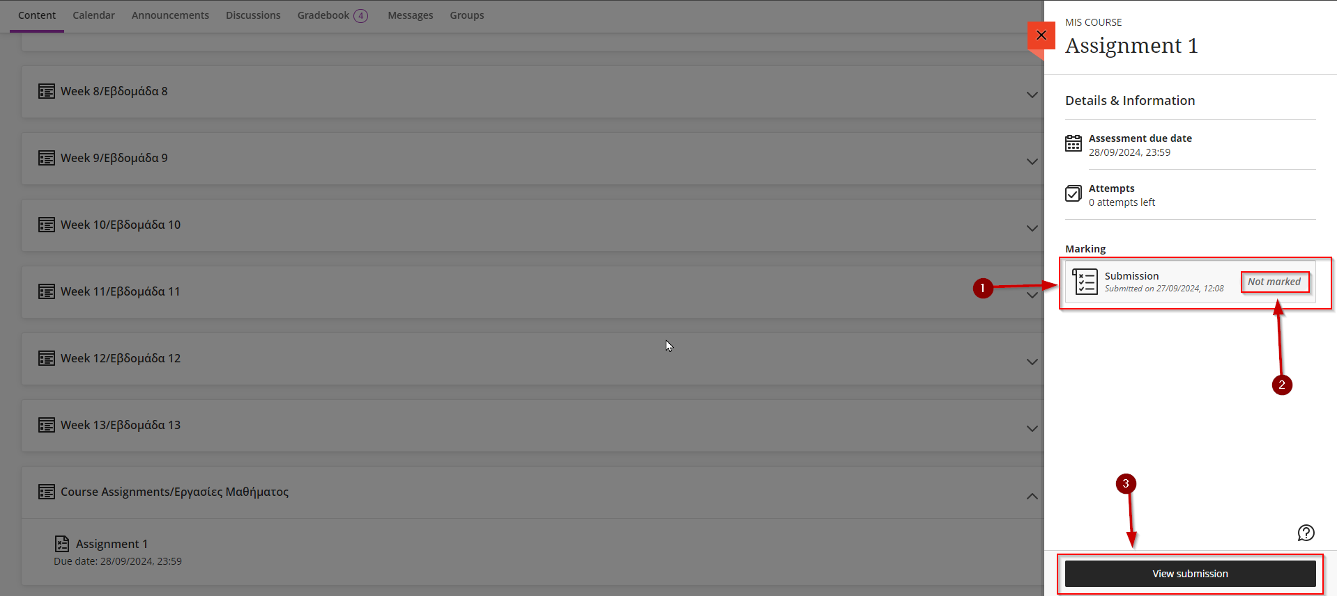

- You will be greeted with the following window.
- You can view your answer at “Submission” area (Arrow 1). If your answer does not appear in that area click on the three dots (Arrow 4), and then click “Download Original File” (Arrow 5).
- If your instructor provides any feedback regarding the assignment, you can view it in “Feedback” area (Arrow 2).
- You can view your grade at the right top of the page (Arrow 3).

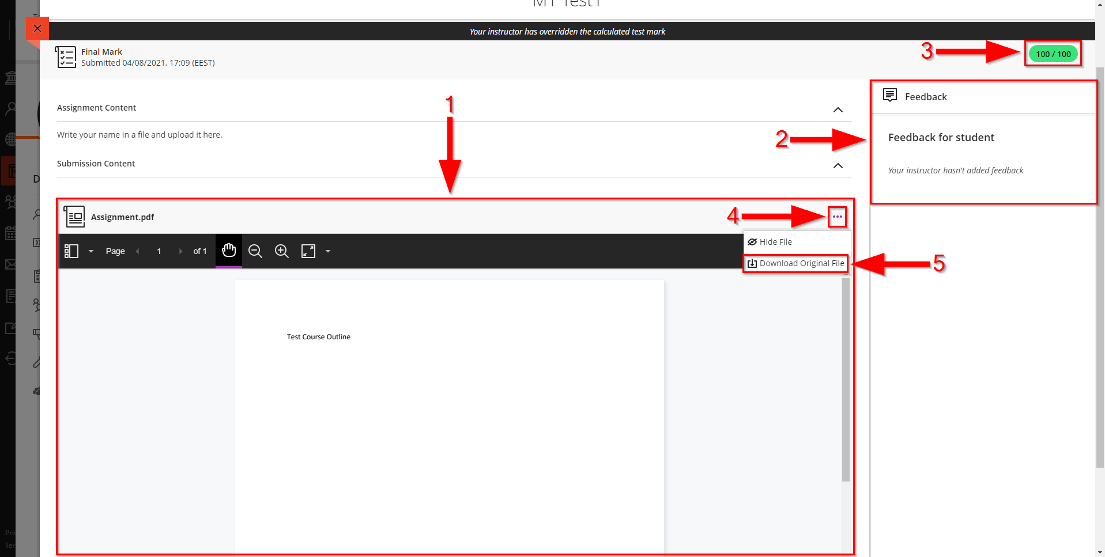

View a Turnitin Assignment
- Go to your course. Follow the steps described in section “4. View Course Content”.
- Find and click on “Course Assignments/Εργασίες Μαθήματος” module in your course content area.

- Then click on your Turnitin Assignment.

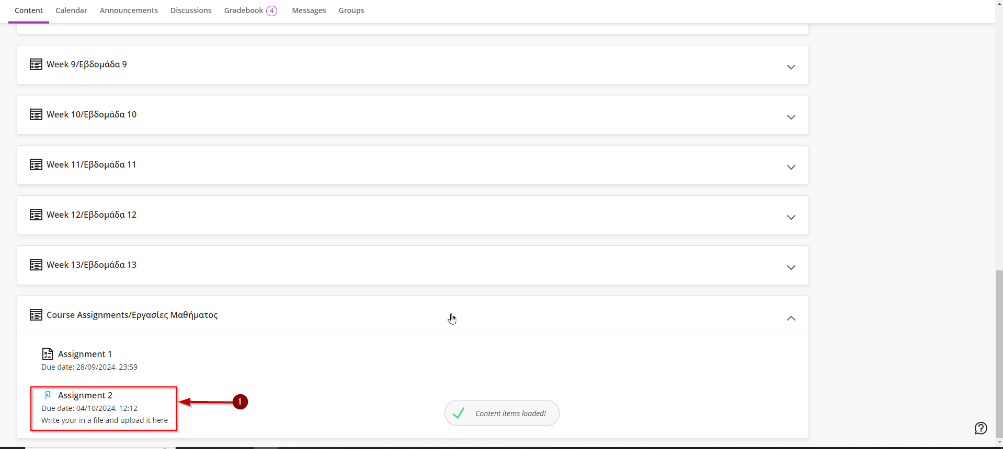

- You will be greeted with the following webpage where you can find details about your assignment.
- “Due Date” is the last day of submissions for the specific assignment. Have in mind that with due date 04/08/2021, 00:00 the last minute of accepted submissions is 03/08/2021, 23:59, not 04/08/2021, 23:59 (Arrow 1).
- “Your Submissions” you can see details of your last submission (Arrow 2).
- Click on “Launch” to open the assignment (Arrow 3).

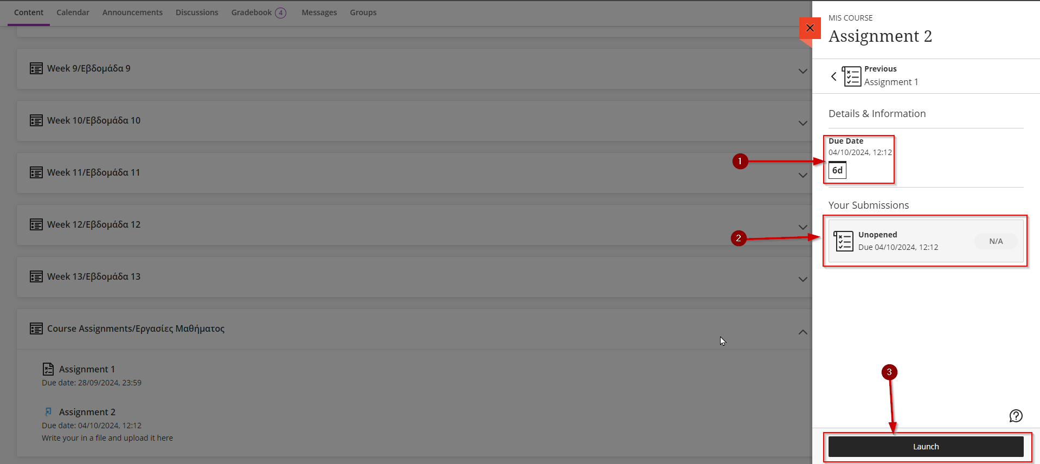

- You will be greeted with the following webpage. Click on the assignment title to view the assignment (Arrow 1).

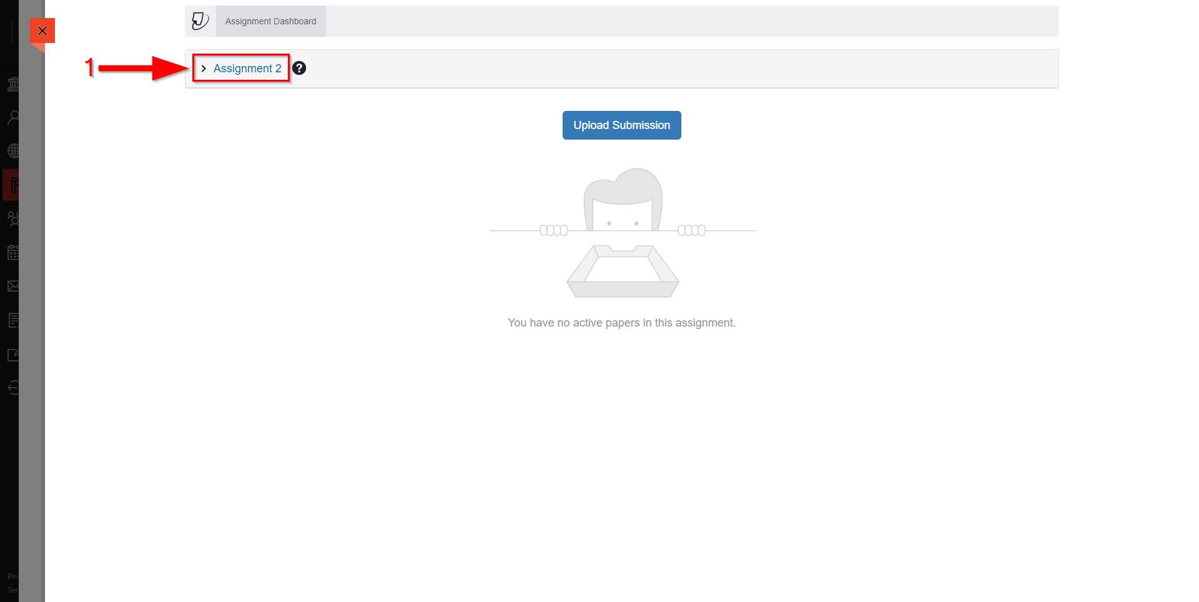
- You will be greeted with the following webpage.
- “Instructions” is the subject and the details provided by your instructor regarding the assignment (Arrow 1).
- “Start Date” is the date that the assignment will open for submissions (Arrow 2).
- “Due Date” is the last day of accepted submissions (Arrow 3).
- “Feedback Release Date” is the date when your instructor feedback will be released (Arrow 4).
- “Max Points” is the maximum points that you can achieve for the specific assignment (Arrow 5).
- “Additional Settings” is when similarity report will be available, if you can resubmit or not and if late submissions are allowed or not (Arrow 6).

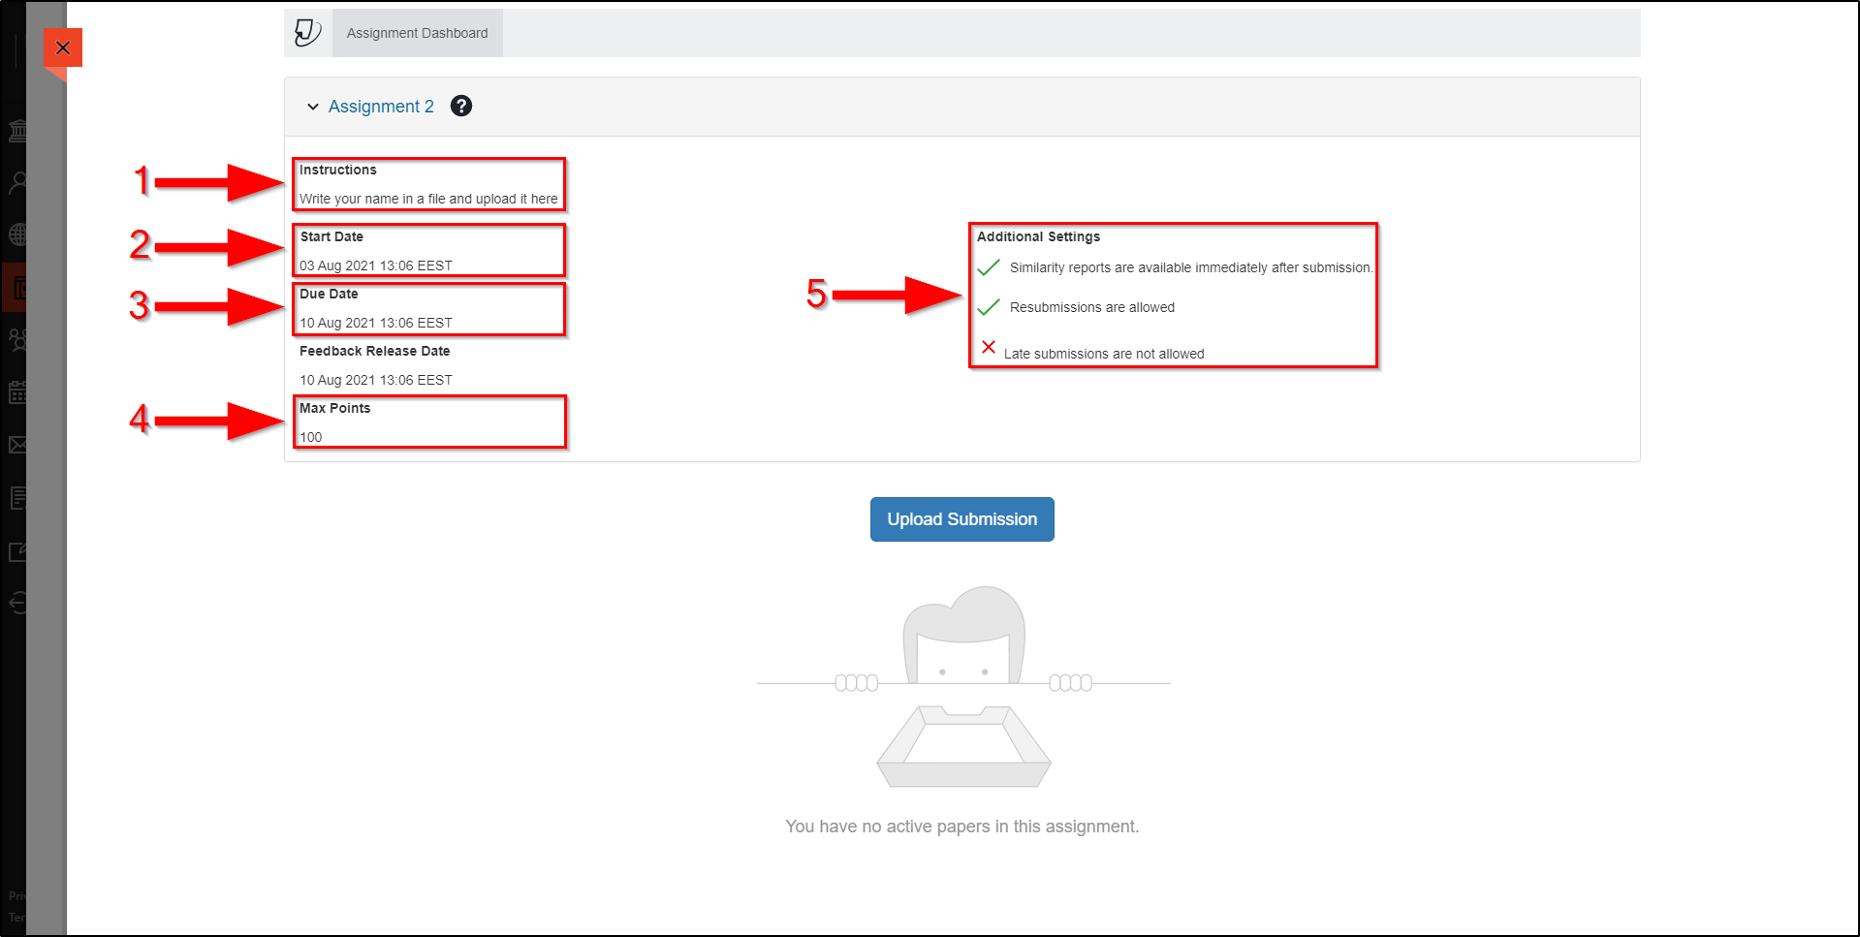

Upload and Submit a Turnitin Assignment
- Follow the steps described in section “13. View a Turnitin Assignment”.
- Click on “Upload Submission” (Arrow 1).

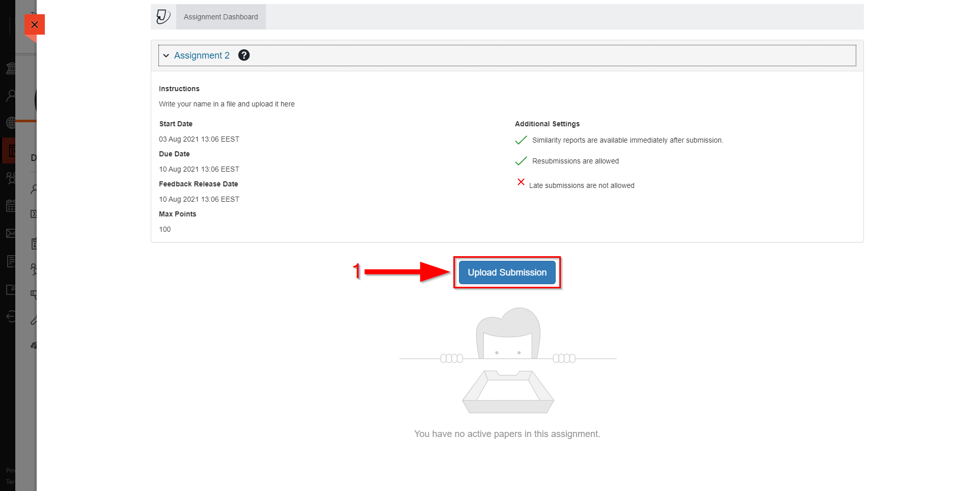

- You will be greeted with the following window. To upload a file, click on “Choose File” (Arrow 1) or drag and drop your file in the “Submission Title” textbox (Arrow 2) and skip the step d.

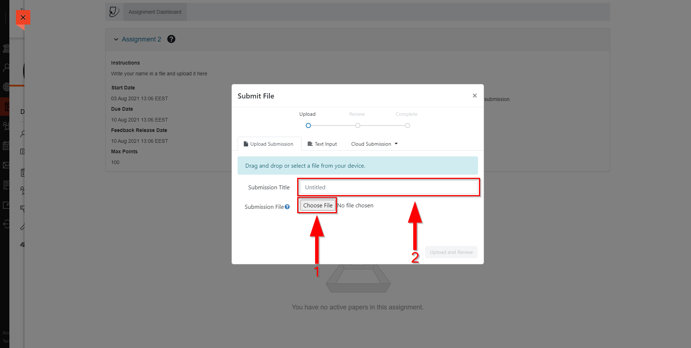
- You will be greeted with the following window.
- Find and click on your assignment file (Arrow 1).
- When you click on your assignment file make sure that appeared on “File name” textbox (Arrow 2).
- Click on “Open” (Arrow 3).

- Click on “Upload and Review” (Arrow 1).

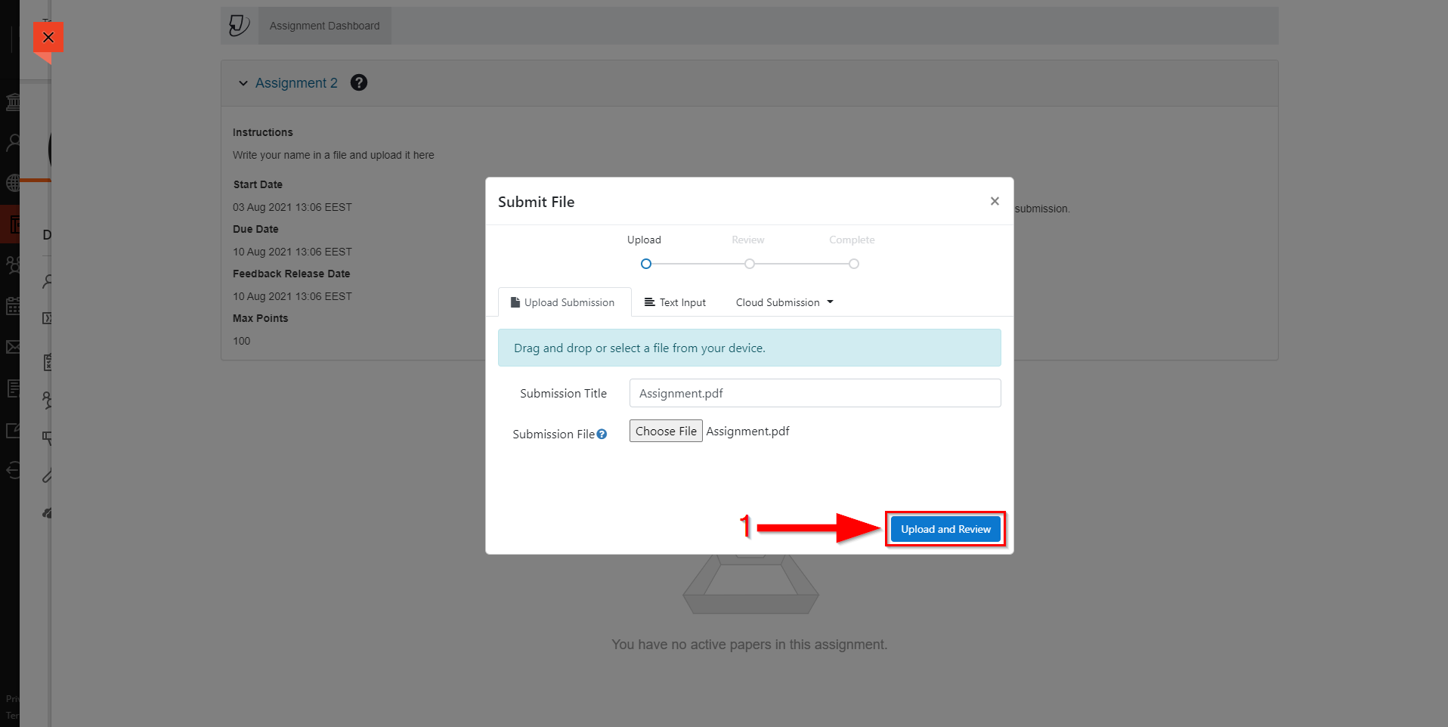
- Click on “Confirm” to complete your submission (Arrow 1).

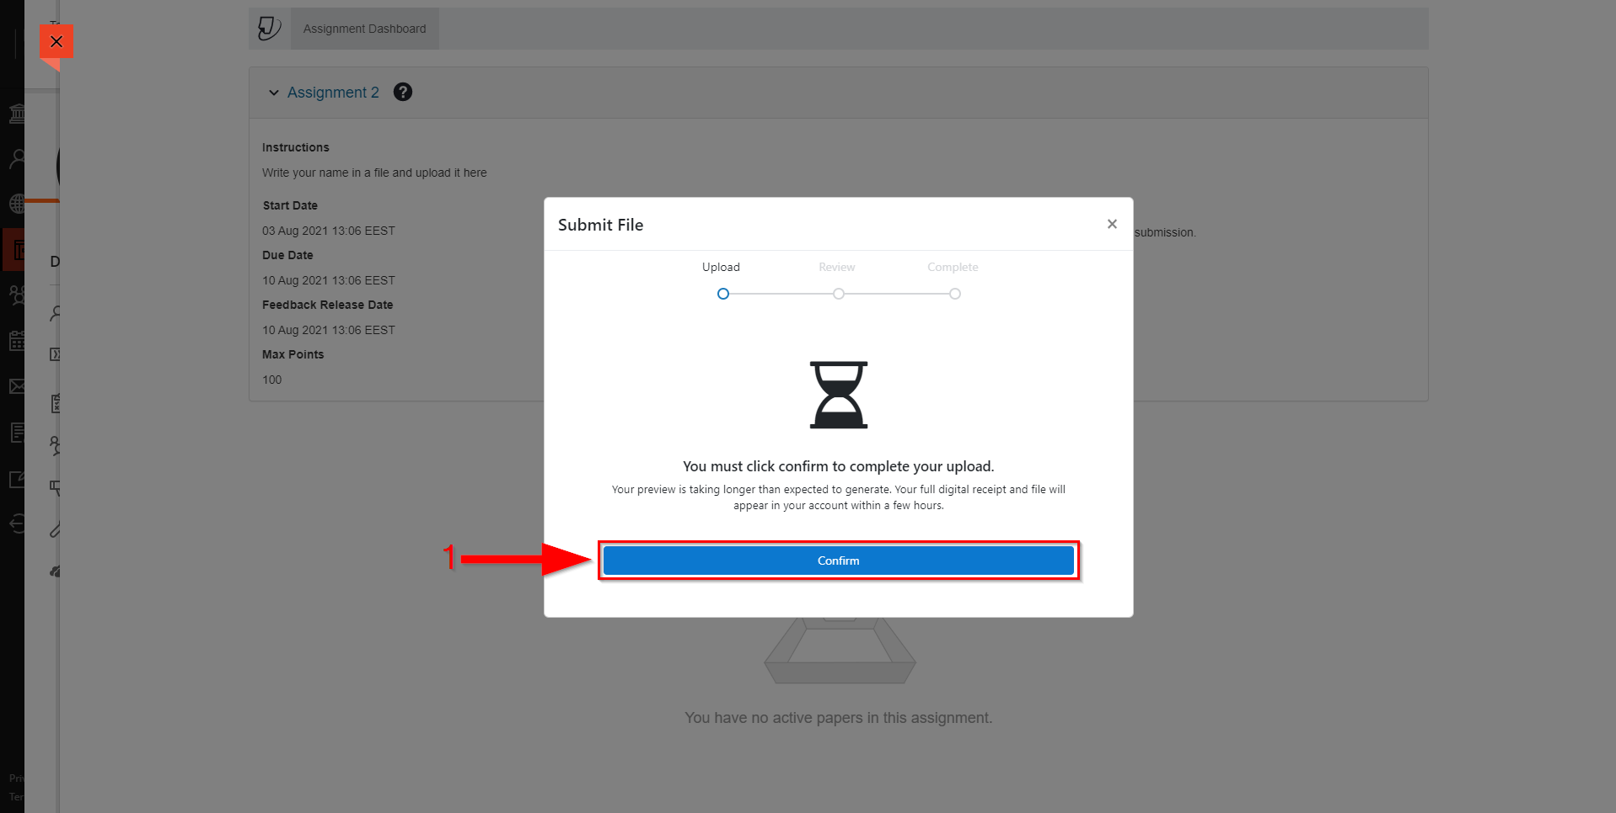

- Your answer has been submitted (Arrow 1).

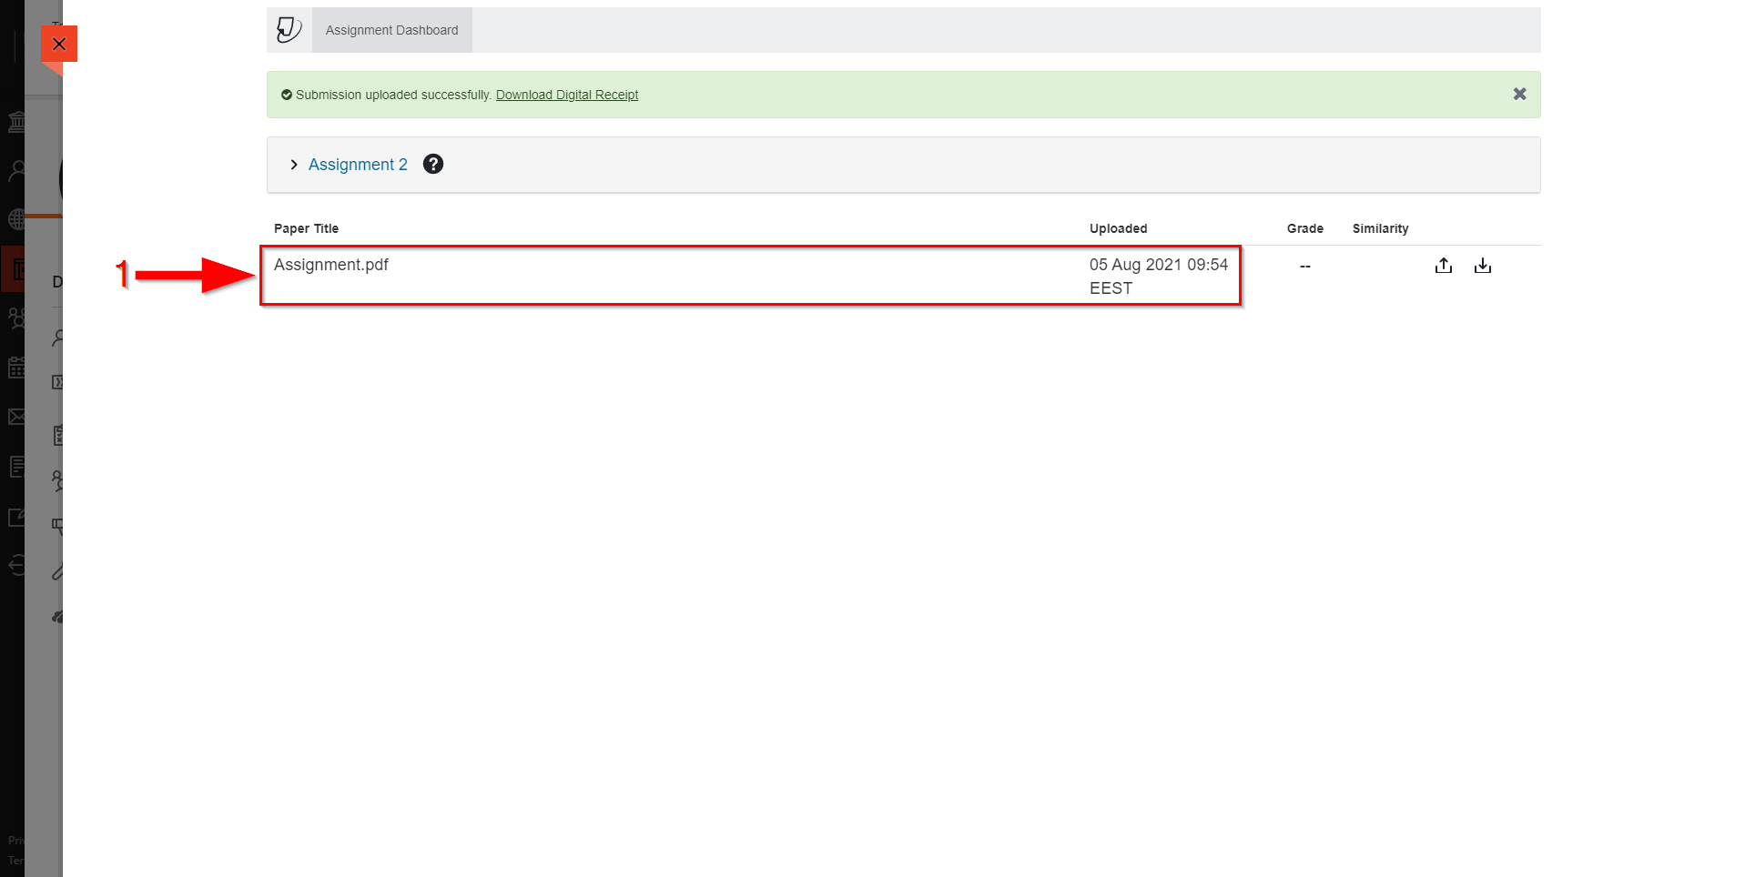

Resubmit Turnitin Assignment
- Follow the steps described in section “13. View a Turnitin Assignment”.
- Click on “Resubmit paper” (Arrow 1).

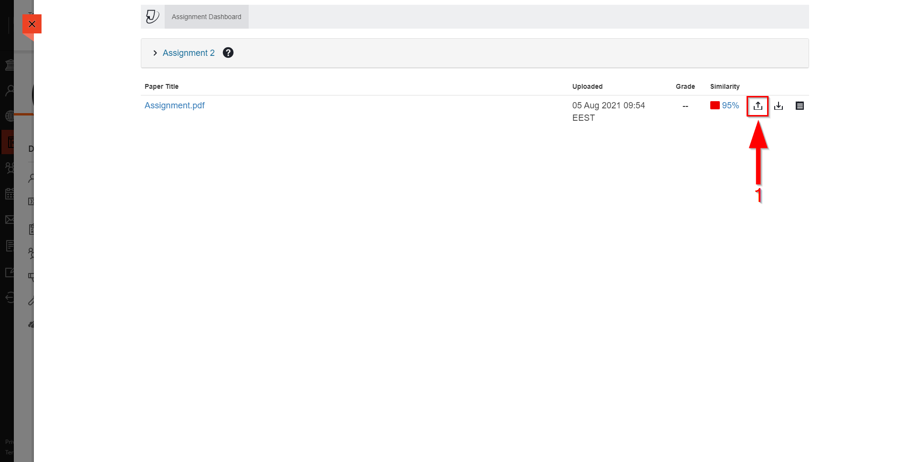

- Click on “Confirm” (Arrow 1).
- Follow the steps described in section “11. Upload and Submit a Turnitin Assignment” step c – g.

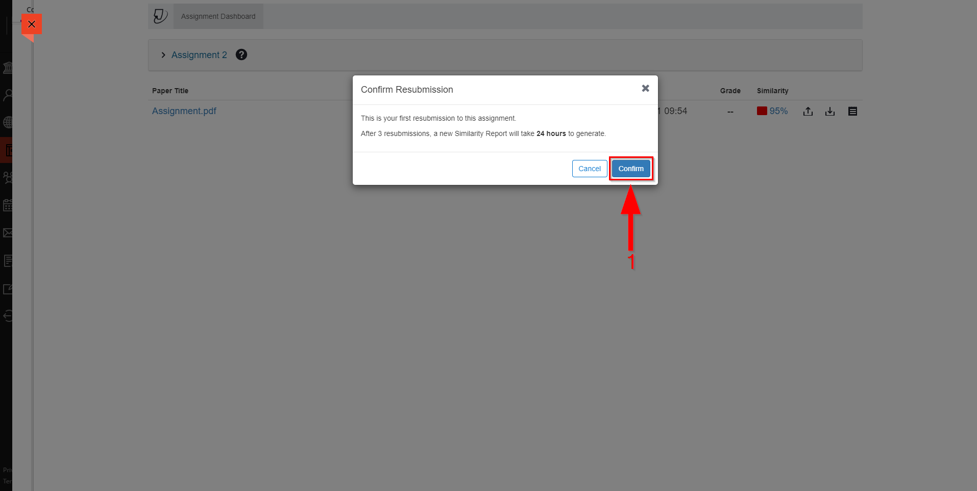

View Similarity Report for Turnitin Assignment
- Follow the steps described in section “13. View a Turnitin Assignment”.
- View the similarity percentage of your assignment with other sources under “Similarity” column (Arrow 2). Have in mind that similarity report might need 24 hours until becomes available.
- Click on your assignment title under “Paper Title” column (Arrow 1) or at the similarity percentage under “Similarity” column (Arrow 2) to view a detailed report of similarity.
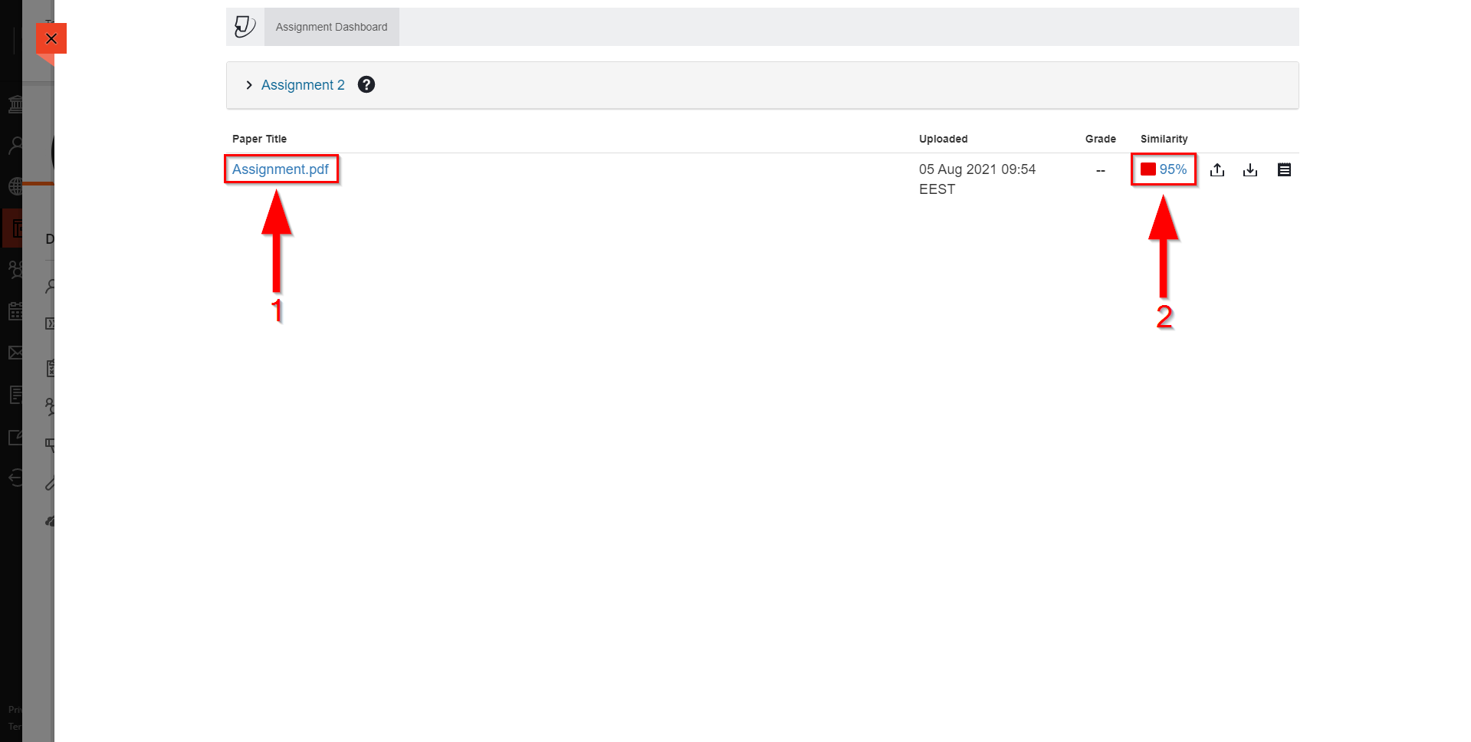

- Your answer will open in a new window.
- Click on “All Sources” to view all sources that have similar content with your answer (Arrow 1). The similar text will also be highlighted in your answer.
- You can download the similarity report by clicking on “Download” (Arrow 2).

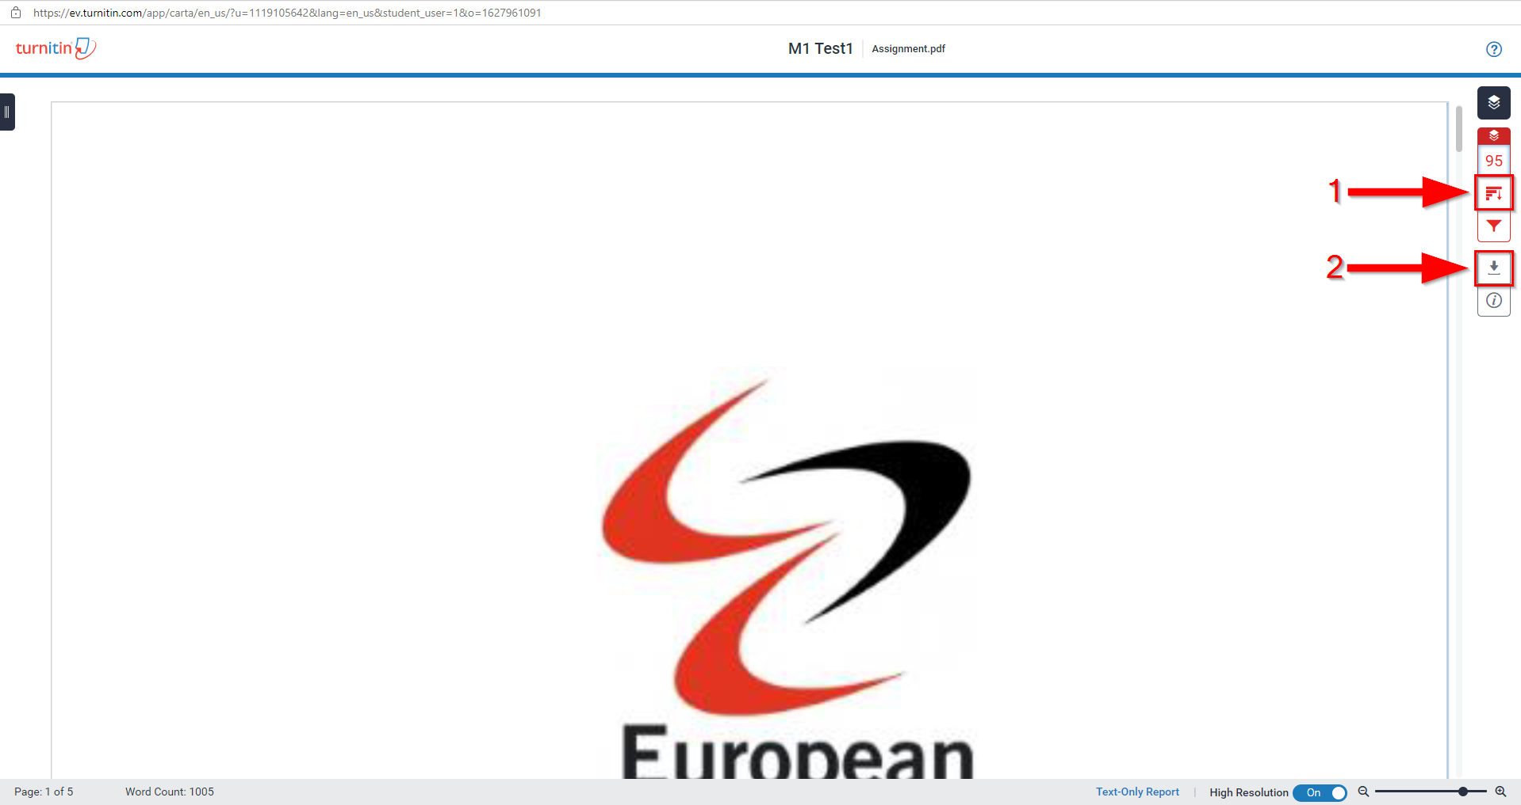

View your Grades
- Go to your course. Follow the steps described in section “4. View Course Content”.
- Click on “Gradebook” (Arrow 1).
- Your grades will appear on your screen (Arrow 2).

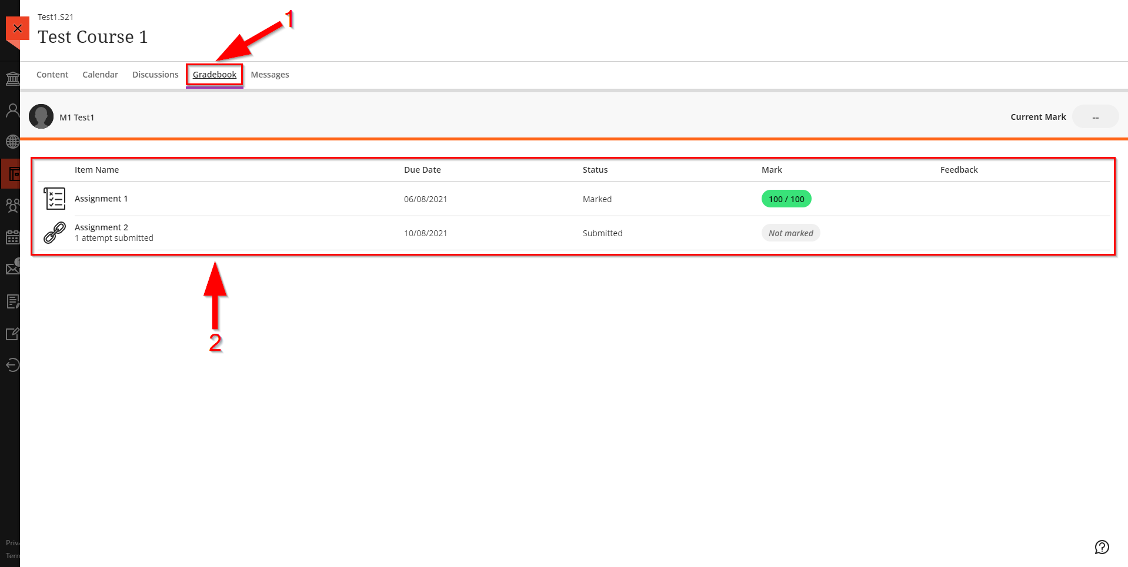

View your Messages
- Go to your course. Follow the steps described in section “4. View Course Content”.
- Click on “Messages” (Arrow 1).
- Your messages will appear on your screen (Arrow 2).

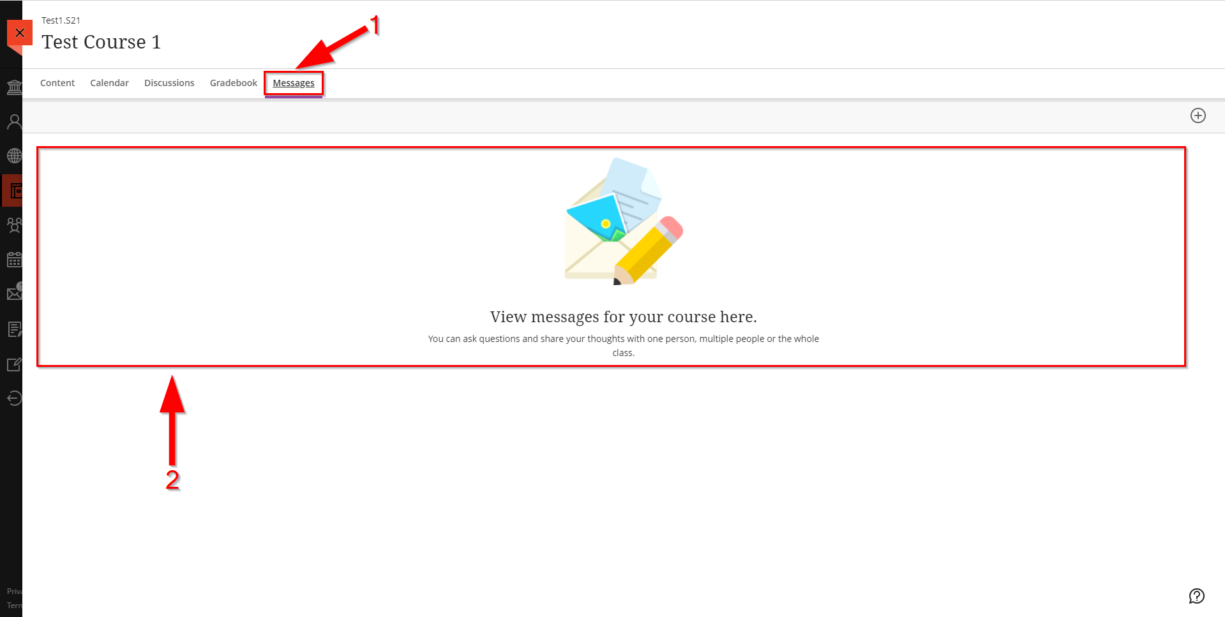

Send Message
- Go to your course. Follow the steps described in section “4. View Course Content”.
- Click on “Messages” (Arrow 1).
- Click on “New Messages” (Arrow 2).

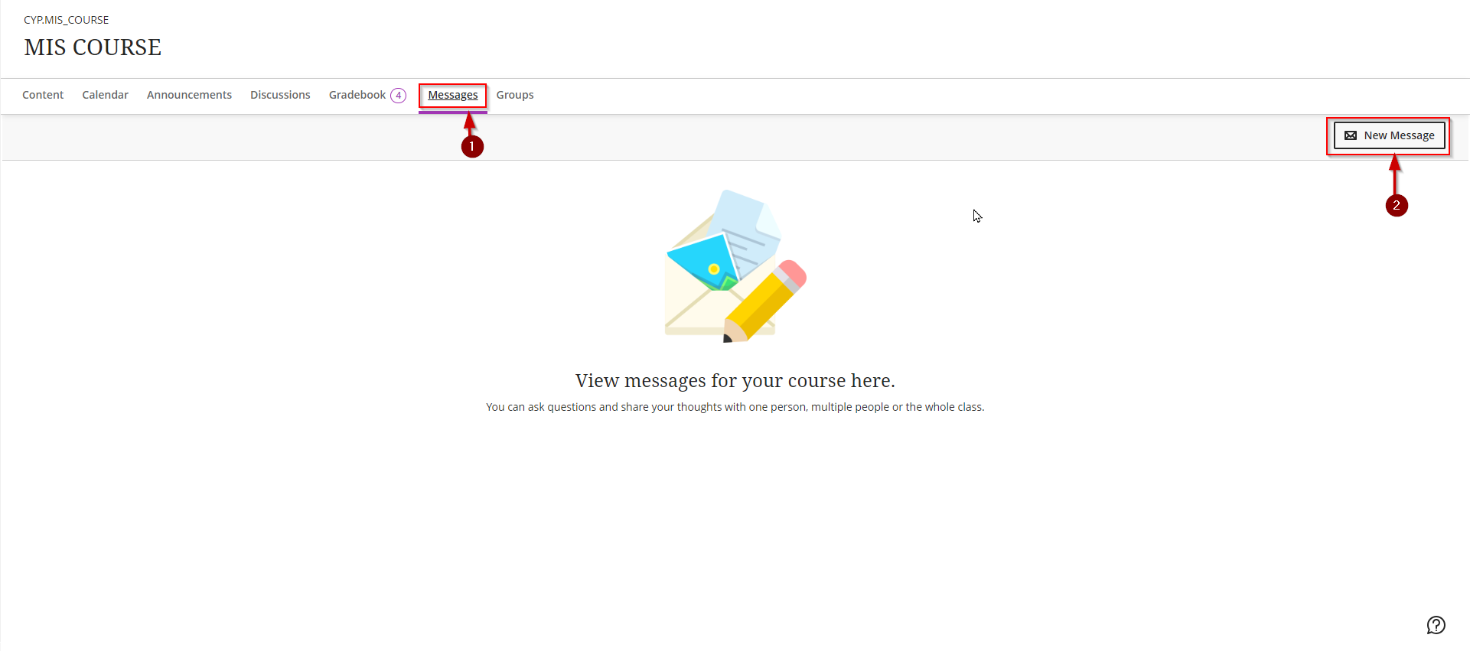

- Write the name of the Recipients that you want to receive your message (Arrow 1).
- Write your message (Arrow 2).
- Click on “Send” (Arrow 3).

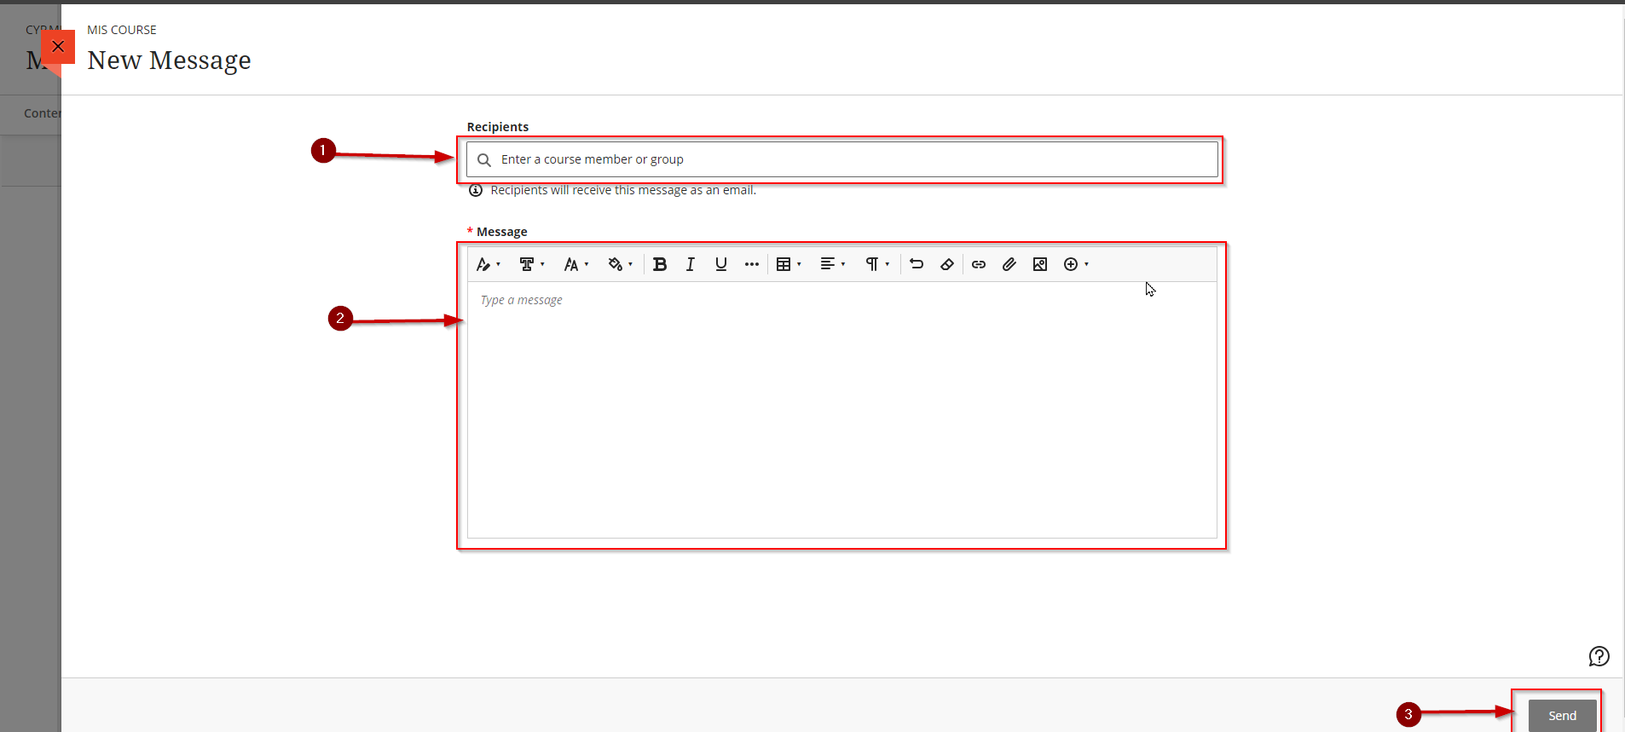

Change Language to Greek
- Go to your profile page (Click on your name) (Arrow 1).
- Click on “Language”. (Arrow 2).

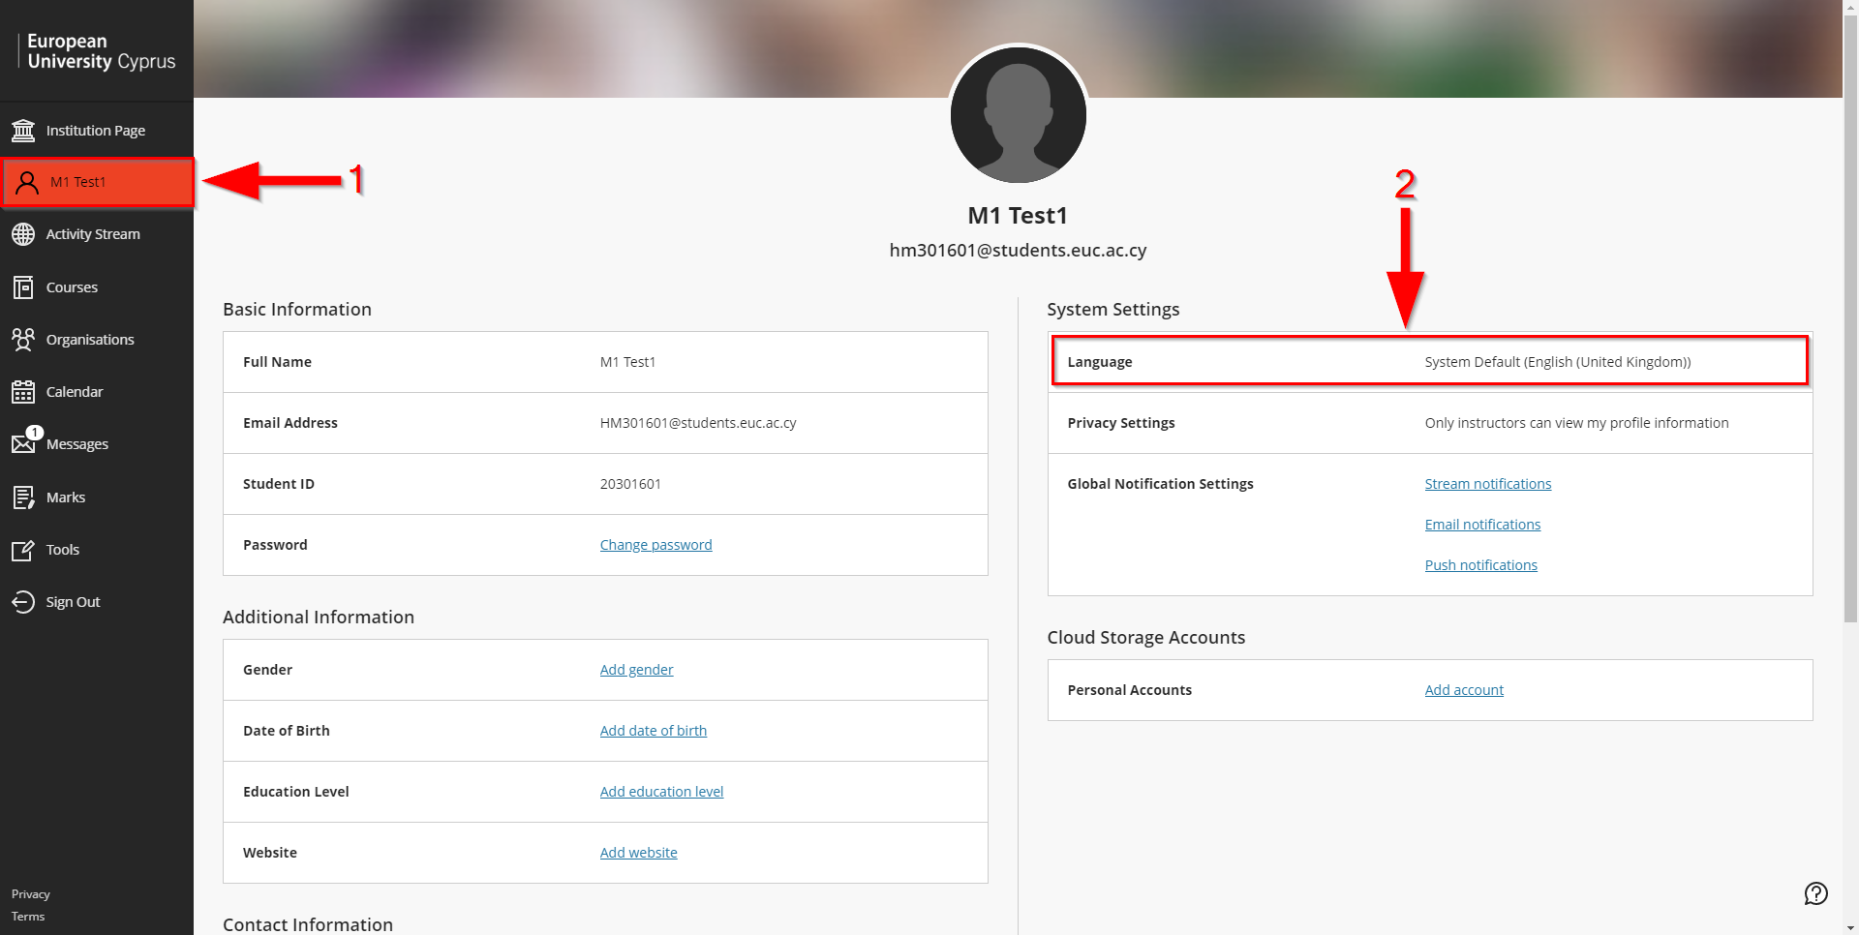

- Click on the “Default Language” drop down list (Arrow 1).
- Click on “Greek (EUC)” (Arrow 2).
- Click on “Save” (Arrow 3).

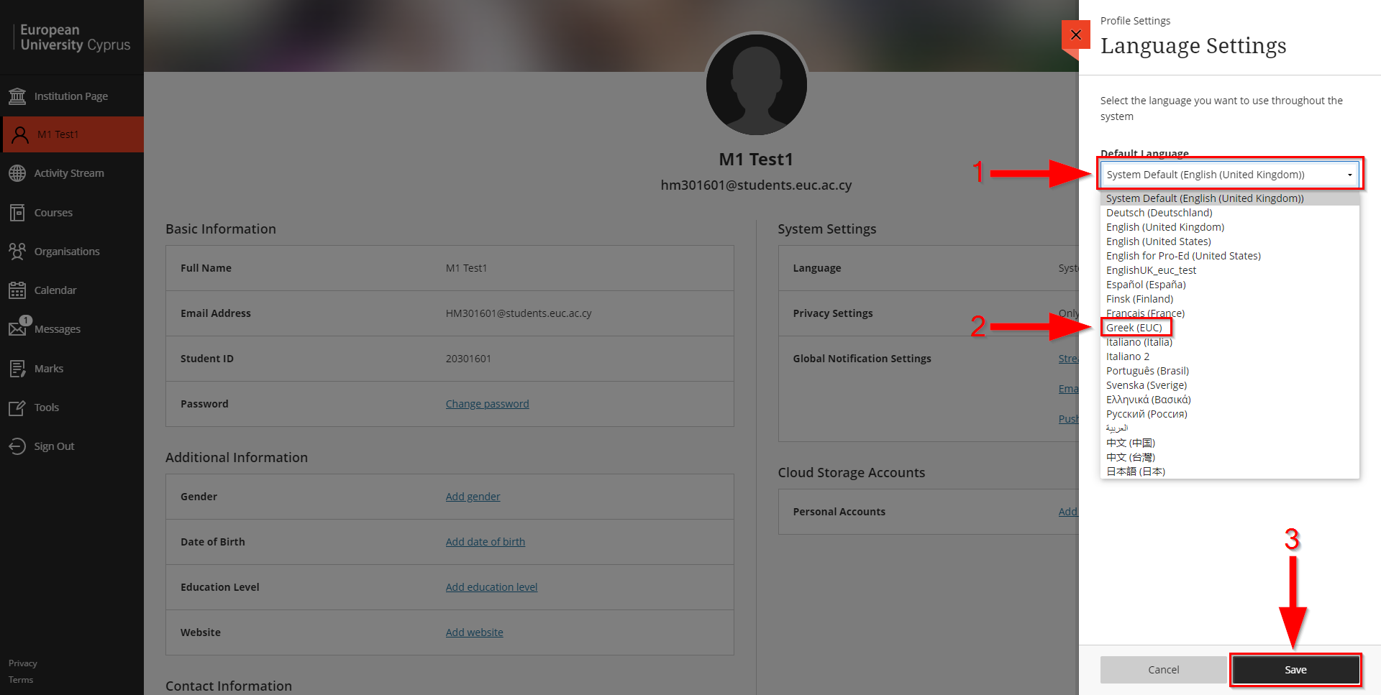

Setup email notifications
- Go to your profile page (Click on your name) (Arrow 1).
- Click on “Email notifications”. (Arrow 2).

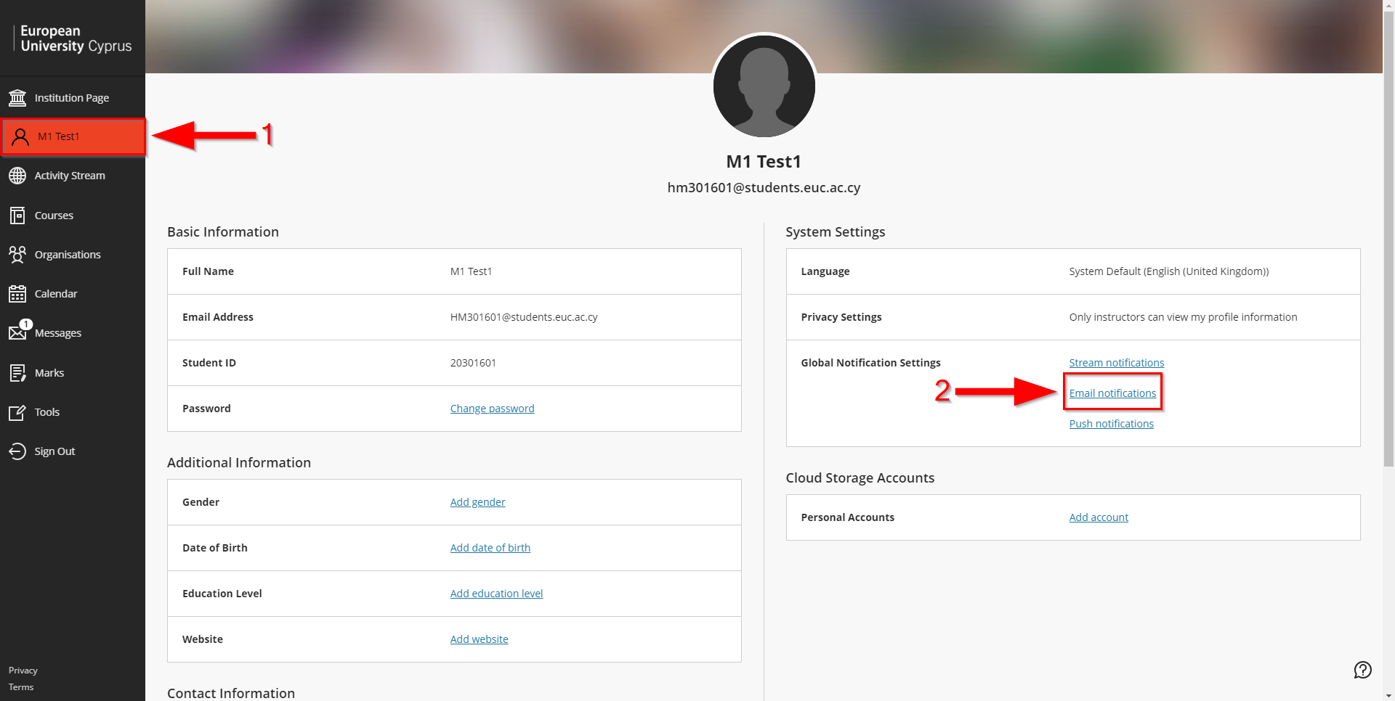

- Click on “Email me straight away” (Arrow 1).
- Click on “Save” (Arrow 2).

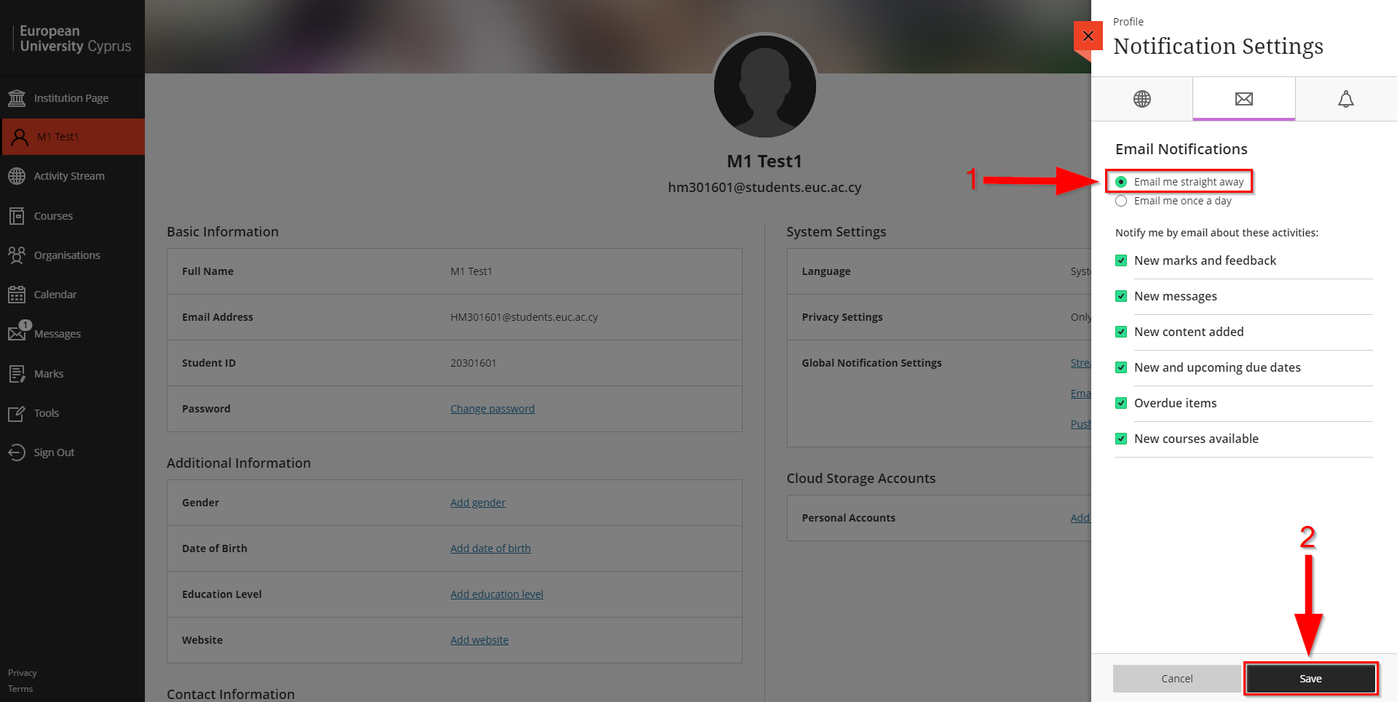

Change Profile Picture
- Go to your profile page (Click on your name) (Arrow 1).
- Move the mouse on your profile picture and click on the pencil. (Arrow 2).

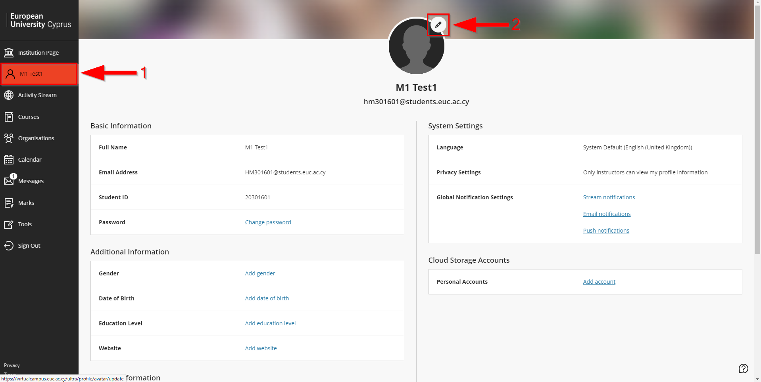

- Click on “Upload new profile picture”, find and upload the new picture.

