Blackboard Course – Access attendance

The following steps show how you can access attendance to mark your student’s attendance from within your Blackboard Learn Ultra course.

Steps on how to access attendance:

1. Go to your Blackboard course.
2. On the left “Details and Action” menu click on “Mark attendance”.
3. When you access the attendance feature for the first time, you decide if you want to add attendance to your gradebook by clicking “Add Attendance”.

1. A setting panel will open with the default settings. You can only change the late settings value in the grade schema.

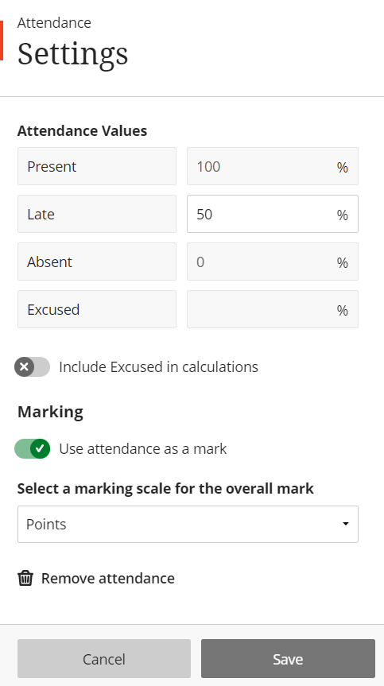

1. Save your settings or close the panel if you don't want to make changes. An attendance column appears in the gradebook. As you mark students’ attendance their attendance grades are posted automatically.