Blackboard Course – Create blackboard collaborate session.

The following steps show how you can create blackboard collaborate sessions from within your Blackboard Learn Ultra course.

Steps on how to create blackboard collaborate sessions:

1. Go to your Blackboard course.
2. On the left side menu “Details and Action” click on the 3 dots that appear on the right of “Blackboard Collaborate”.

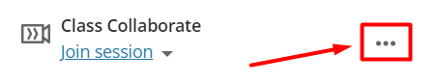

1. Click on “Manage all sessions”.

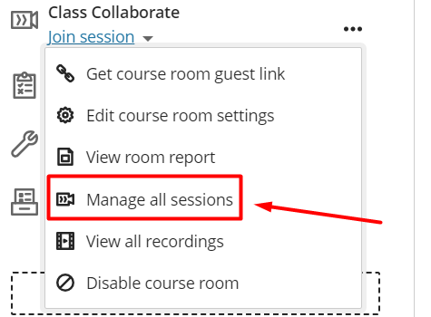

1. Click on “Create Session” to create a new session.

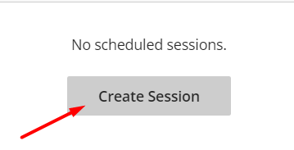

1. On the right side a setting panel will open which you can define the properties of the new session like name, start, end, no end, repeat session, and guest access. After you set up the settings click “Create”

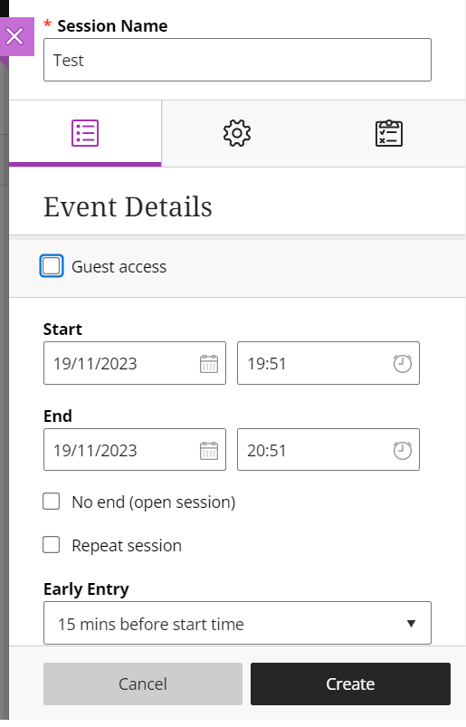

1. Now the new session will be available for everyone to see by clicking “Join session” under the “Class Collaborate”.

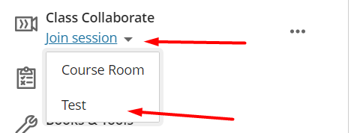

1. By going to “Manage all sessions” and clicking on the 3 dots that appear on the right of the newly created session, you can view and edit the settings for that session.

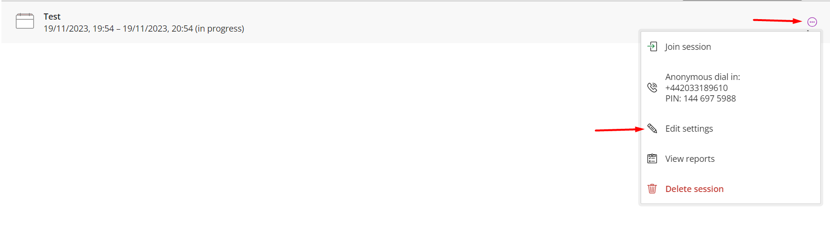

1. In order to copy the link of the session and share it with external guests you have to enable it first by going to the “Edit settings” of the session.

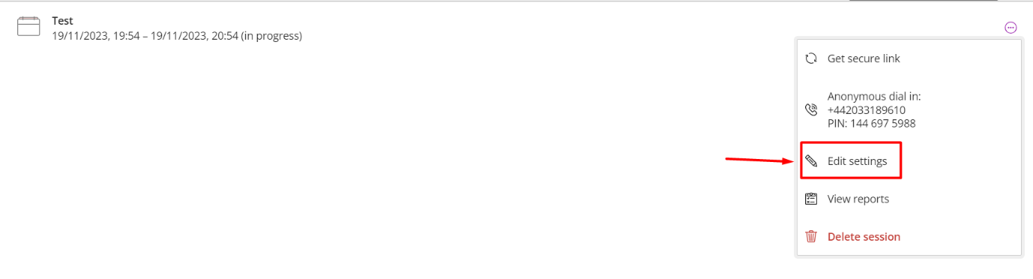

1. Tick “Guest access” select guest role and click “Save”. By clicking “Save” a guest link will appear.

