Copy selected content

The following sections shows how you can copy selected content from a blackboard course to another blackboard course.
You can use the following steps to also copy content within the same Blackboard Learn Ultra course, and also, for copying content from an old course to a new course.

Steps for copying selected content from one Blackboard course to another:
- Go to the Blackboard course you want to copy content into.
- In the course’s main area, click on the cross (+) symbol.
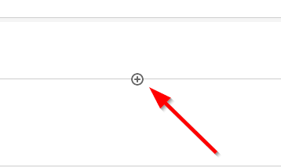
- Select “Copy Content”
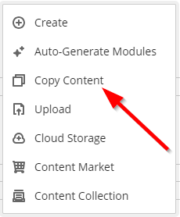
- Use the search bar, or the area below, to search for the course you want to copy content from.
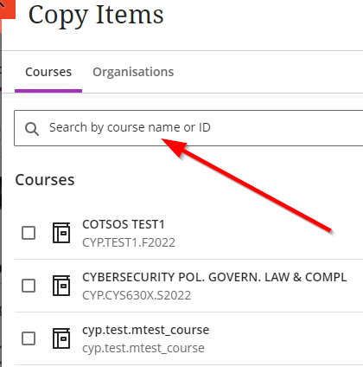
- Click on the arrow next to the course (right side) to view its contents.
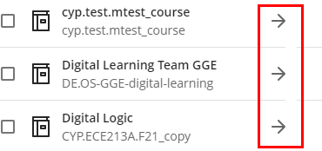
- Click on the check box (left side) to select the folder you want to copy, in case you want to copy all its contents, or click on the arrow next to the folder (right side) to view its contents.
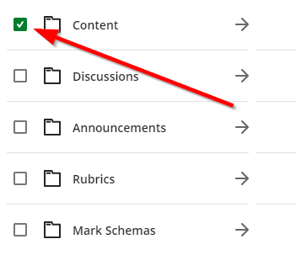
- Click on the check box next to the content (left side) you want to copy or keep expanding until you find the content you want to copy.
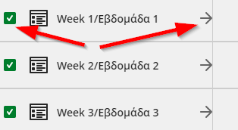
- Once you are done click “Start Copy”
