Create an announcement

The following sections show how you can create an announcement in a blackboard course.

Steps for creating an announcement in a blackboard course.

1. Go to your Blackboard course.
2. From the menu bar at the top click on “Announcements”.

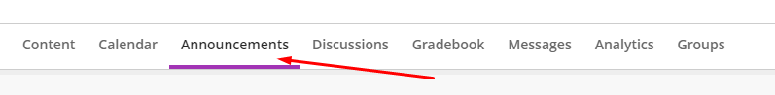

1. Click on the cross symbol (+) on the top right of your screen to create a new announcement.

1. Give a title to the announcement.
2. Choose the recipients from the \*Recipients filed.
3. Write the message in the \*Message field.

1. Click on “save” and the announcement will be posted in the announcement column.

