Blackboard Learn Ultra – Create Discussion

The following steps show how you can create a discussion within your Blackboard Learn course.

- Go to your Blackboard Learn course.
- Click on the cross symbol (+) right where you want to create the discussion.
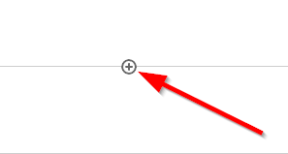
- Click on “Create”.
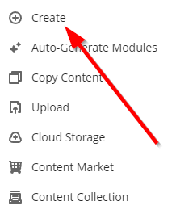
- Scroll all the way down and select “Discussion”.
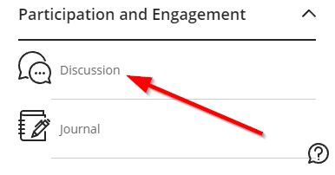
- Give a name to the Discussion.
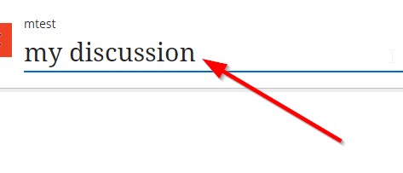
- Use the dedicated space to write the topic of the discussion.
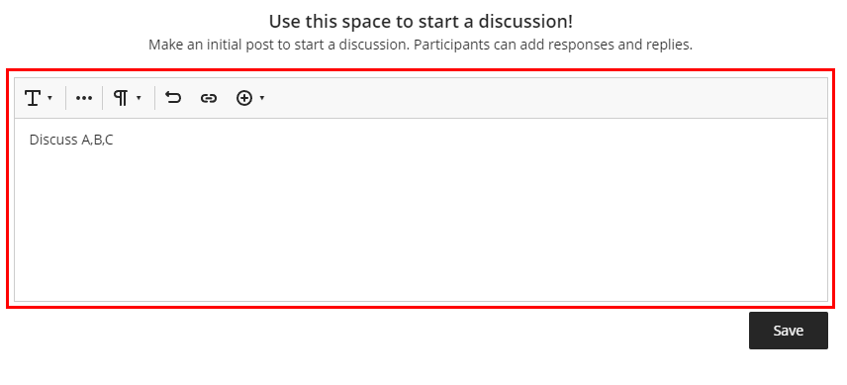
- Click on “Save”
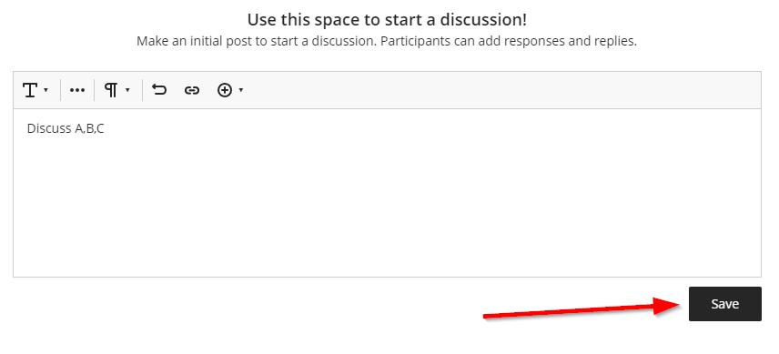
- Be sure to make the discussion visible to the students.
