Blackboard Learn Ultra – How to Create a Journal

The following steps show how you can create a journal within a blackboard learn course.
Steps to create a journal:
- Go to your course on Blackboard.
- Click on the cross icon (+) right where you want to create the journal.
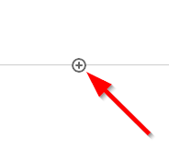
- Select “Create”
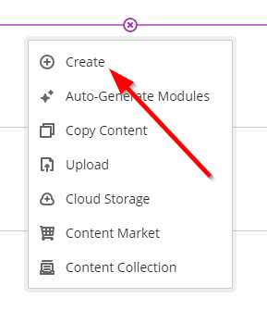
- From the pop-up menu on the right, scroll all the way down.
- Click on “Journal”.
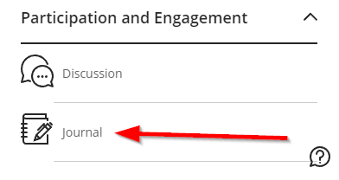
- Give a name to the Journal.
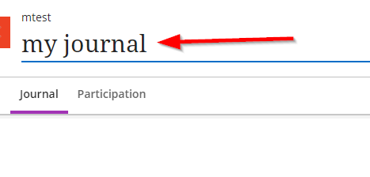
- Use the dedicated space to inform the students what they should focus on.
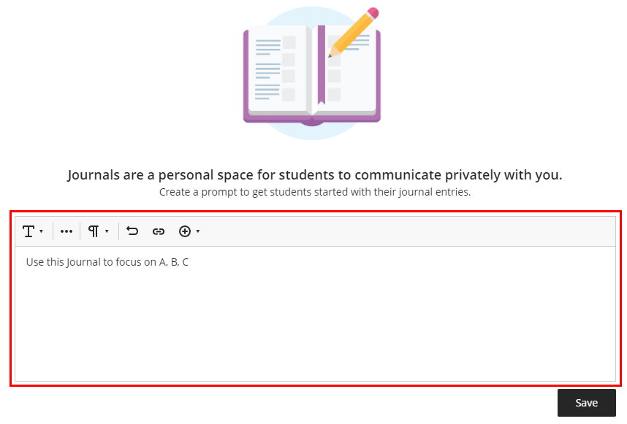
- Click on “Save”
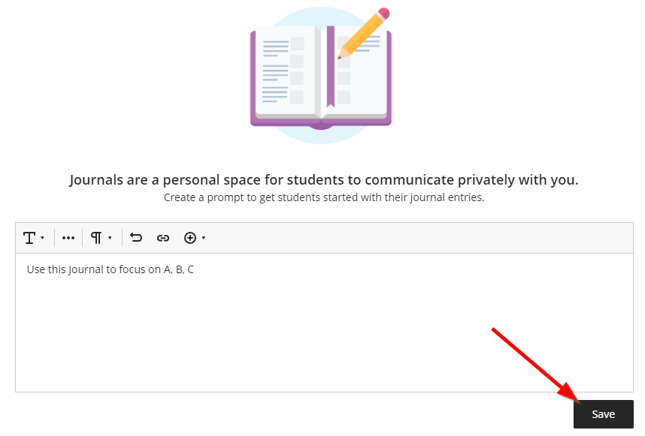
- Use the “Participation” button on the top left corner to see which students participated.
- From the top right corner of the screen, make the Journal visible so that the students can see it.
