Blackboard Course – Turnitin Assignment

The following steps show instructions on how you can create a Turnitin Assignments within a Blackboard Learn course.

Steps for creating a Turnitin assignment:

1. Go to your Blackboard course.
2. Place your mouse right where you want to create the Assignment and click on the cross (+) symbol.

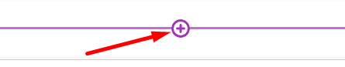

1. Select the option “Content Market”

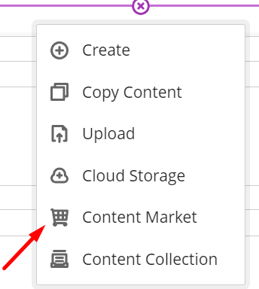

1. Select the option “Turnitin GGE”

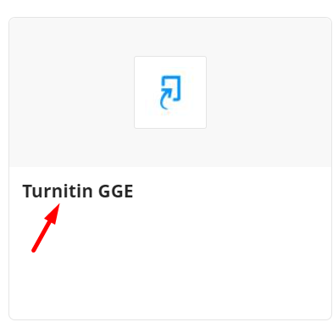

1. To set your assignment, you must set a Title, Max Grade, Start Date, Due Date, Feedback Release Date (if it is needed), Instructions (if it is needed). After setting these simple settings select “Optional Setting.”

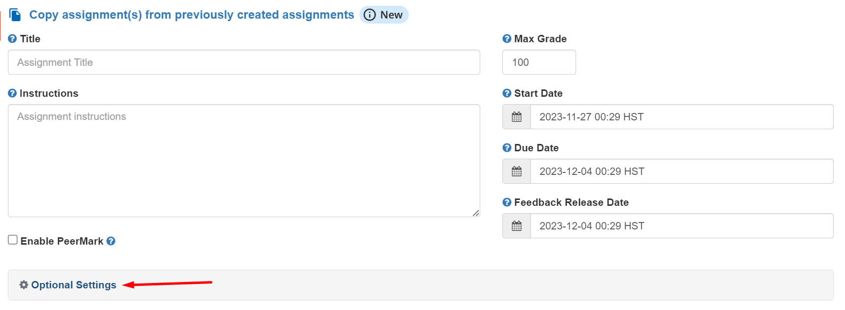

1. “Submission settings” enable or disable the setting that you need for the assignment and click on the dropdown list “Submit papers to”.

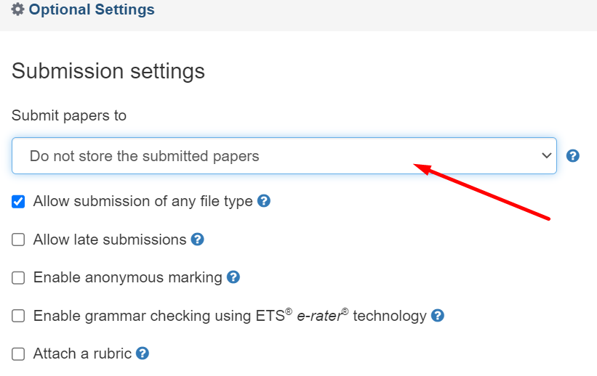

1. From the drop-down list select “Do not store the submitted papers”

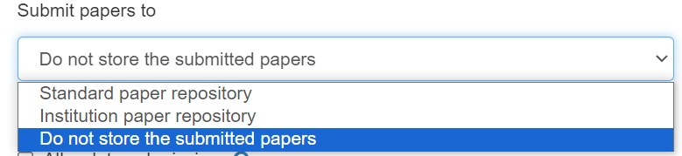

1. “Similarity Report” and “Compare against” sections make the appropriate settings that are needed for the assignment and then select the drop-down list.

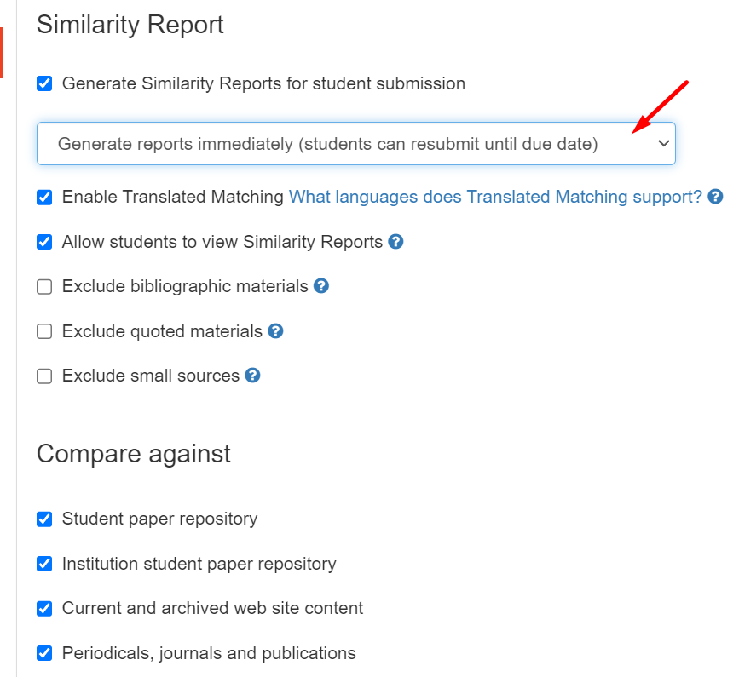

1. From the drop-down list select “Generate reports immediately (students can resubmit until due date): After 3 resubmissions, reports generate after 24 hours”

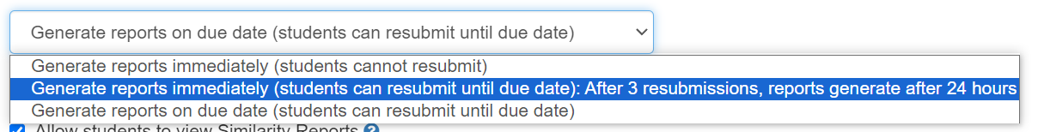

1. “Exclude assignment template” section make the appropriate settings that are needed for the assignment. “Additional settings” enables the section “Save these settings for future use” to have the same setting ready for future use and then click submit.

