How to create Course Groups

The following sections show how you can create a course group.

Steps for creating a course group in a blackboard course.

1. Go to your course in Blakcboard.
2. From the menu bar at the top click on “Groups”.



1. Click on the cross symbol (+) on the top right of your screen to create a course group.

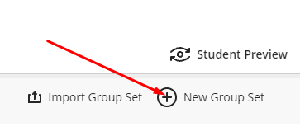

1. Give a name to the course group.
2. Select the students you want to put in that group.

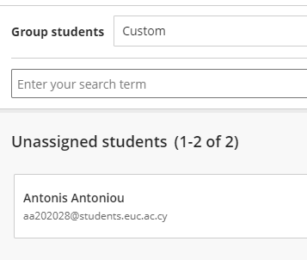

1. Click save and the group will be listed in the group's column



