**Joining a session**

The following steps show how you can join a collaborate session from blackboard.

* Go to your course in Blackboard.
* On the left under “Details & Actions” click on “Join session”.

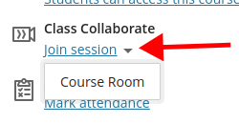

* In the dropdown menu that appears click on the session you want to join.

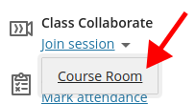

* A new window will open with the session.
* Click “Allow” on any pop-up messages that may appear.

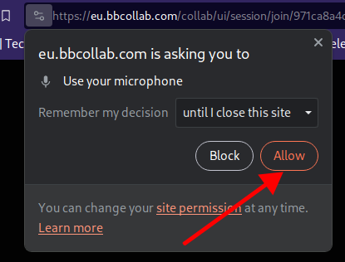

* When you see “Audio test” and a purple bar moving, click “Yes. Audio is working.”

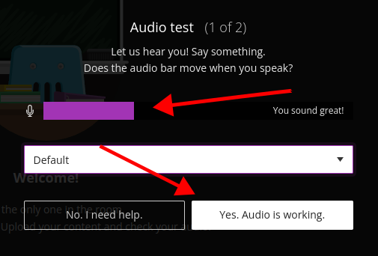

* When you see “Video test” and your webcam image, click “Yes. Video is working.”

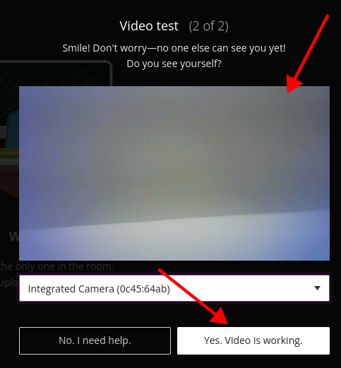

* When it asks you to Start Tutorial, click “Later”.
* Click “Close” on the next message about the Collaborate sessions.