Manage groups.

The following sectons show how to manage groups in a blackboard course.

Steps to manage groups in a blackboard course.

1. Go to your Blackboard course.

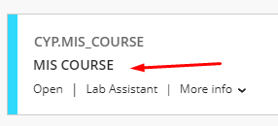

1. From the menu bar click on groups.



3. Go to your group and click on the three dots (…).

4. Click on edit.

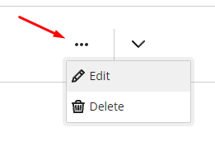

5. Click on the plus sign (+) to create a new group.

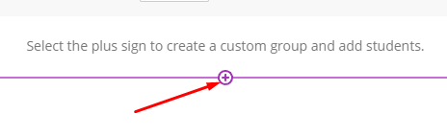

6. Click on the three dots from the student tab to assign them.

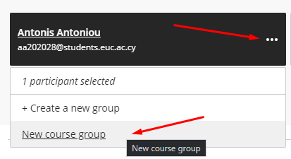

7. Click save

8. From your group set click on the three dots (…) and delete to delete a group.

