Blackboard Course – Send Message

The following steps show how you can send messages to your students from within your Blackboard Learn Ultra course.

Steps on how to send messages:
- Go to your Blackboard course.
- Click on “Messages” on the top menu bar.
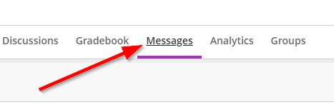
- Click on “New Message”.
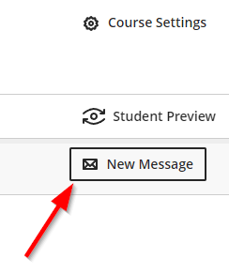
- Select who you want to be the recipients of the message.
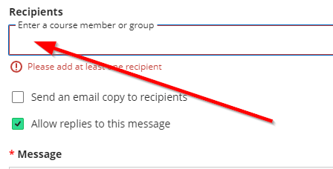
- You can choose to also send the message as an email by clicking on the dedicated check box.
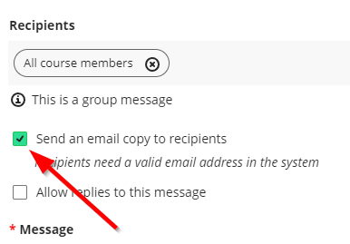
- Use the dedicated space to write your message.
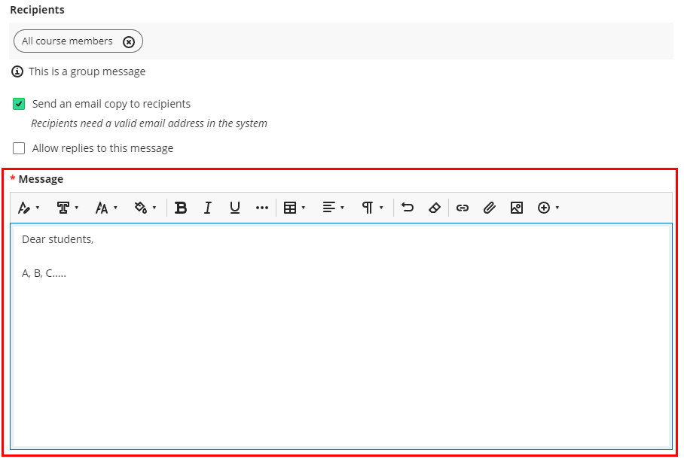
- Click “send” at the bottom right of the screen.
