Upload Files from PC to Blackboard Learn Course

The following steps show how you can upload a file from your PC to your course on Blackboard Learn.
The supported file types include OC, DOCX, HTM, HTML, MP3, MPG, PDF, PPT, PPTX, XLS, XLSX, RTF, TXT, ZIP, and most image types.

How to upload a file from PC to your Blackboard Learn Ultra course:
- Go to your course on Blackboard.
- In the course’s main area, click on the cross (+) symbol.
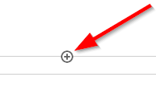
- Click on “Upload”.
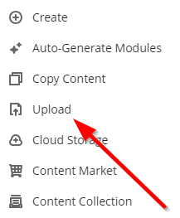
- Browse your PC to find the file you want to upload.
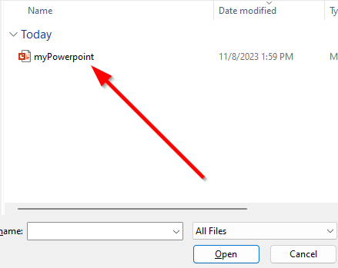
- Double click on the file to select it.
- Give a name to the file.
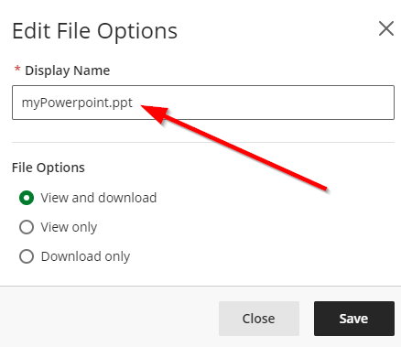
- Click “Save”.
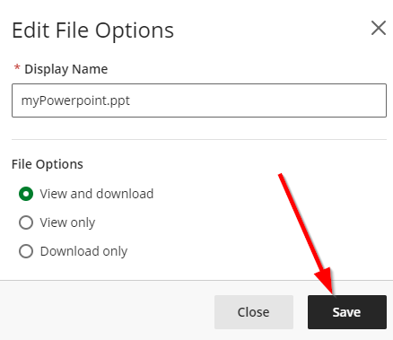
- Make the file visible for the students.
