Blackboard Learn Ultra– View blackboard collaborate recordings

The following steps show how you can view blackboard collaborate recordings from within your Blackboard Learn course.

Steps on how to view blackboard collaborate recordings:

1. Go to your Blackboard collaborate course.
2. On the left side menu “Details and Action” click on the 3 dots that appear on the right of “Class Collaborate”.

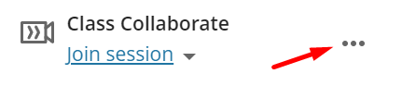

1. Click on “View All Recordings”.

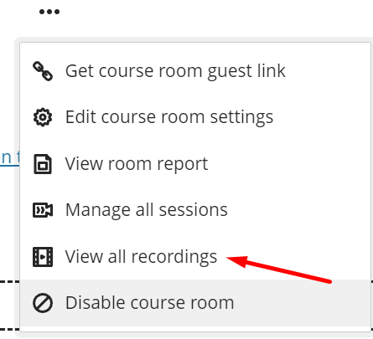

1. On the right side “Filter by” click on the dropdown list “Recent Recordings” and select “Recording in a Range”

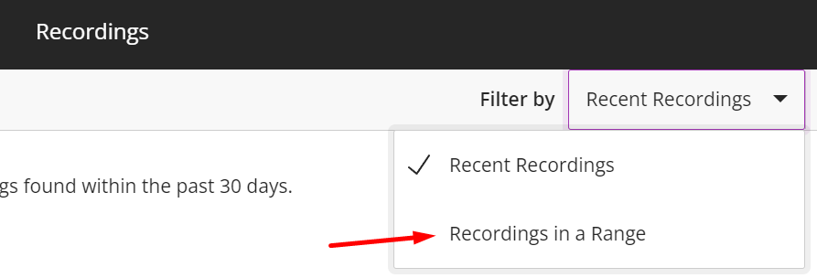

1. On the left side change the first date to the day that your course started.

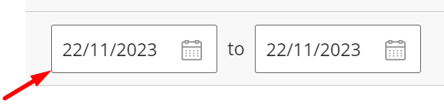

1. After changing the date, the recordings are visible and on the right side click the 3 dots that appear and select “Watch now” to watch the recording.

