Anonymous Grading

The following steps show how you can anonymously mark assignments on blackboard

- Click on the exam or test
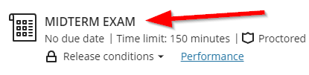
- Click on “Settings”
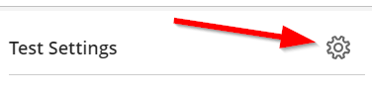
- Scroll down to find “Hide Student names” and enable it.
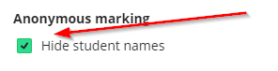

Setting NOT compatible with anonymous grading
- Peer review.
- Post assessment grades automatically.

