Blackboard Course – Create Assignments

The following steps show instructions on how you can create Assignments within a Blackboard Learn course.

Steps for creating an assignment:
- Go to your Blackboard course.
- Place your mouse right where you want to create the Assignment and click on the cross (+) symbol.
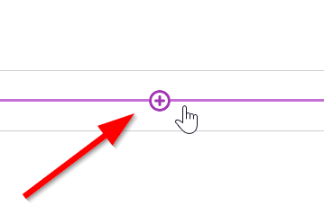
- Select “Create”
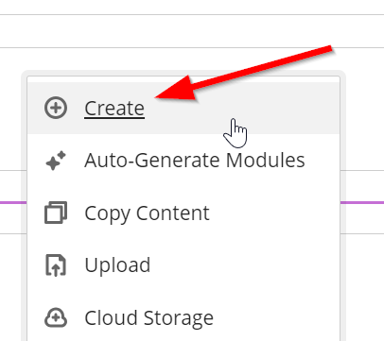
- Click on the “Assignment” option in the right panel.
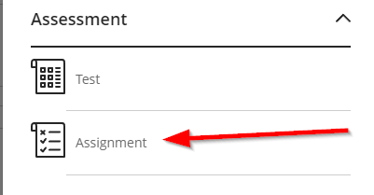

- Give a name to your Assignment.
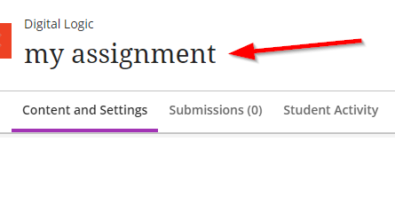
- Click on the gear icon on the right to set the various settings of the assignment.
- Make sure to set the due date of the assignment as well as its total marks.
- Click on “save”
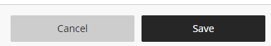
- On the assignment’s main window, click on the cross (+) symbol
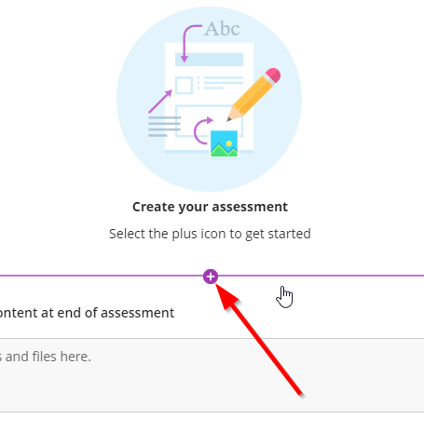
- Click on the “Add local file” option if you want to upload a file from your PC
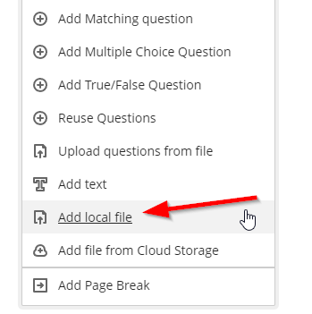
- You can also choose to add questions to the assignment yourself or use the “Auto-Generate Questions” to have Blackboard create questions based on the course’s content.
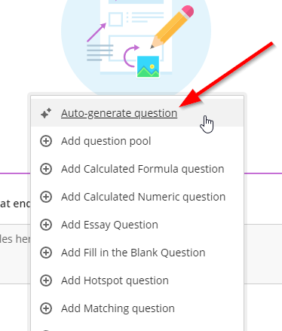
- Make the assignment visible to the students (top right corner).
