Blackboard Course – Create Documents

The following steps show instructions on how you can create Documents within a Blackboard Learn course.

Steps for creating a document:
- Go to your Blackboard course.
- Place your mouse right where you want to create the document and click on the cross (+) symbol.
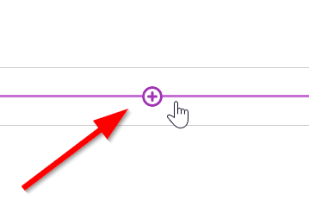
- Select “Create”
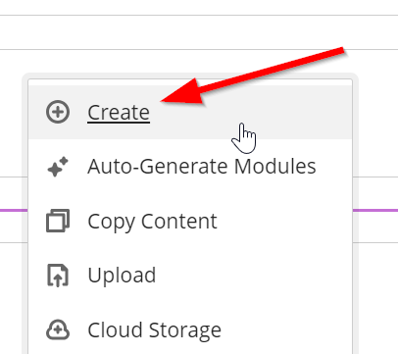
- Click on the “Document” option on the right panel.
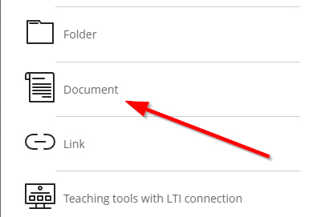
- Give a name to your document.
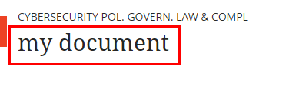
- Don’t forget to make it visible so that the students can see it (upper right corner).
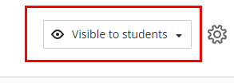
- You can add content to your document by clicking on the “Add Content” option.
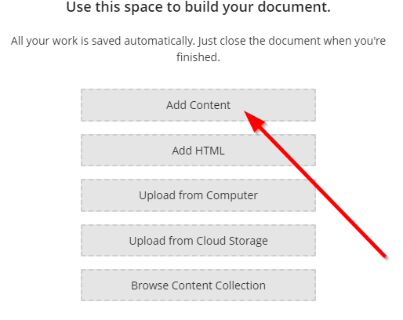
- If you want to upload a document from your computer, you can select the “Upload from Computer” option.
