Blackboard Course – Create Learning Module

The following steps show instructions on how you can create learning modules within a Blackboard Learn course.
Learning modules are useful for organizing your content.

Steps for creating a learning module:
- Go to your Blackboard course.
- Place your mouse right where you want to create the learning module and click on the cross (+) symbol.
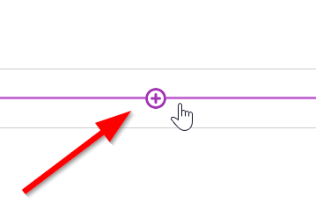
- Select “Create”
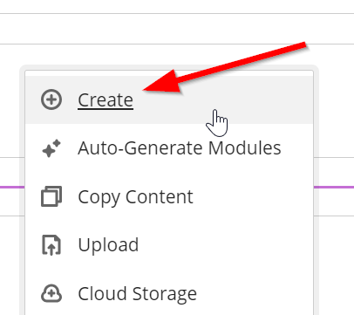
- Click on the “Learning Module” option in the right panel.
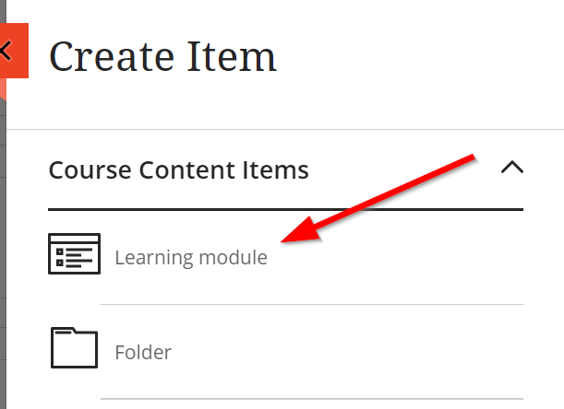
- Give a name to your Learning Module
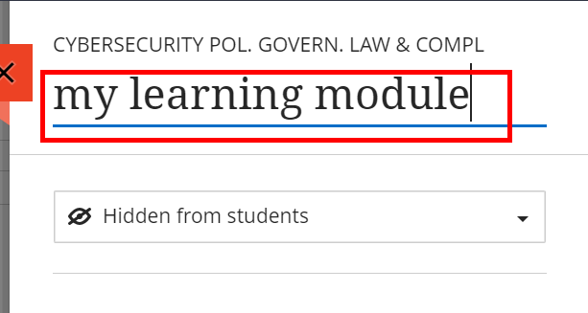
- Don’t forget to make it visible so that the students can see it.
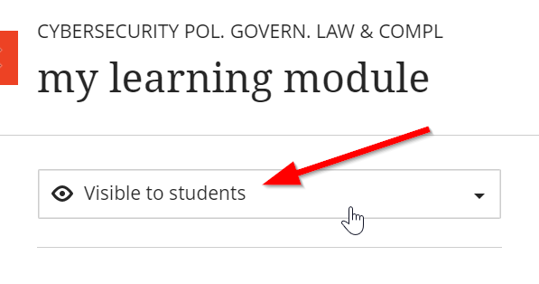
- You can also insert a picture to the learning module to make it a bit more pleasing to the eye.
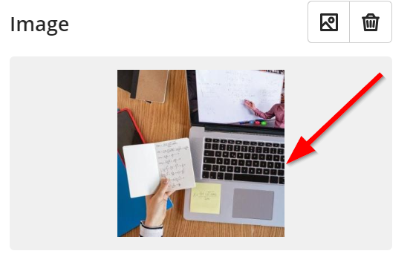
- Click on “Save”
