Blackboard Course – Create Links

The following steps show instructions on how you can create Links within a Blackboard Learn course.

Steps for creating a Link:
- Go to your Blackboard course.
- Place your mouse right where you want to create the link and click on the cross (+) symbol.
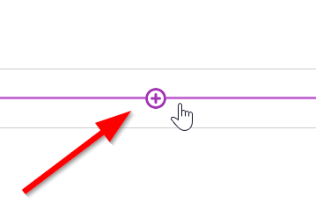
- Select “Create”
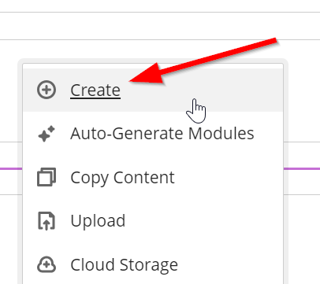
- Click on the “Link” option in the right panel.
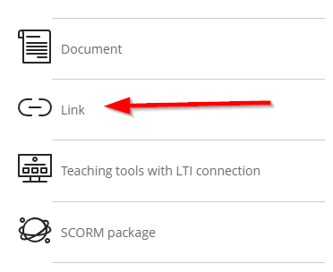
- Give a name to your Link.
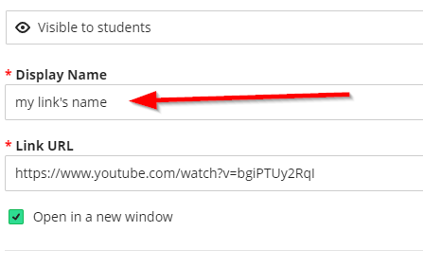
- Paste the link you want to insert to your course in the dedicated text box (“Link URL”)
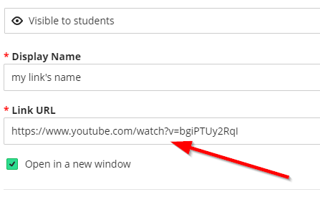

- Don’t forget to make it visible so that the students can see it.
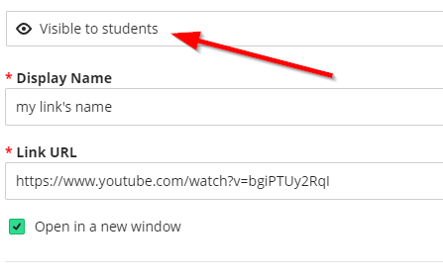

- Click on “Save” (bottom right corner)
