Blackboard Course – Create Folders

The following steps show instructions on how you can create Folders within a Blackboard Learn course.

Steps for creating a Folder:
- Go to your Blackboard course.
- Place your mouse right where you want to create the folder and click on the cross (+) symbol.
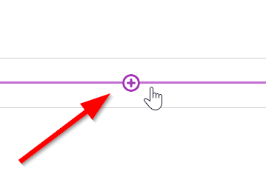
- Select “Create”
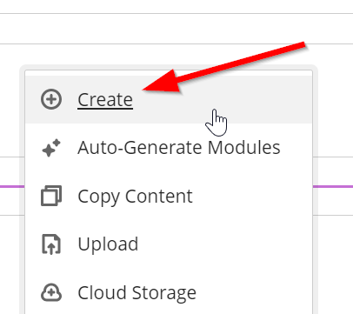
- Click on the “Folder” option in the right panel.
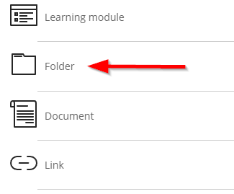
- Give a name to your Folder.
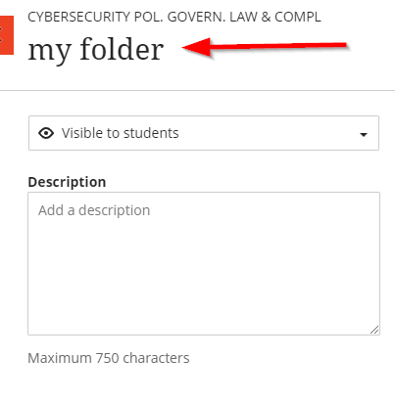

- Don’t forget to make it visible so that the students can see it.
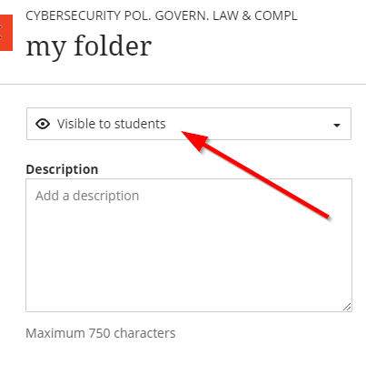

- Click on “Save” (bottom right corner)
