Show hide modules documents and folders

This following document describes how an instructor can make visible, or hide documents, folders, files, and modules within a blackboard learn ultra course.
By default, every content that you upload or create within a blackboard learn ultra course is hidden. So, the instructor must make the content visible so that the students can see it.

Steps for making content visible to students within a blackboard learn course:
- Go to your Blackboard course.
- Find the file, module, or folder that you want to make visible.
- Click on the “Hidden from students” option which you can see just right beneath its name.
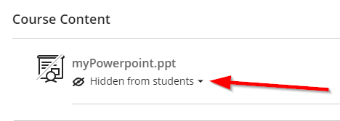
- In the dropdown menu that will pop-up, select the “Visible to students” option.
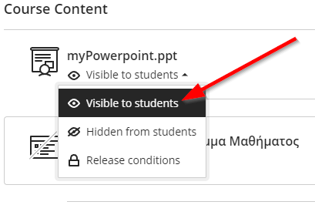
- You can follow the same procedure for hiding content.
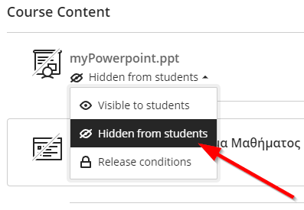
- You can also use the “Release conditions” option to show or hide content based on certain conditions like Specific members or groups and Date/Time
